1. What rank is this (gold oak leaf)? 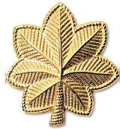
6. What rank is this (silver bars)? 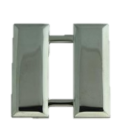
- Major
- Captain
- 2nd Lieutenant
- 1st Lieutenant

7. What AFJROTC rank has no rank insignia?
- Cadet Airman
- Cadet
- Cadet Airman First Class
- Cadet Airman Basic

8. What rank is this?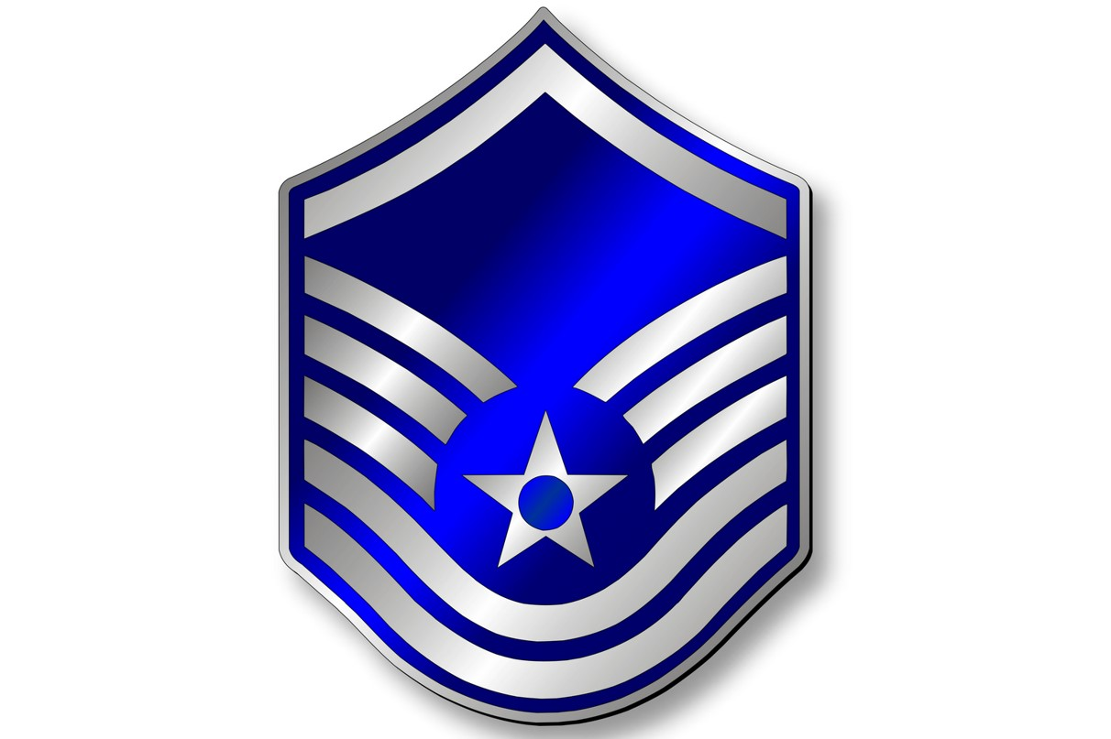
- Master Sergeant
- Chief Master Sergeant
- Master Chief Sergeant
- Technical Sergeant

9. What rank is this (thin stripe)?
- 1st Lieutenant
- Cadet 2nd Lieutenant
- 2nd Lieutenant
- Cadet Major

10. What rank is this? 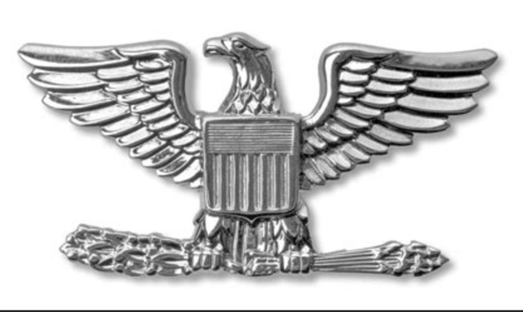
- Colonel
- General
- Lieutenant Colonel
- Major

- Major
- Captain
- Lieutenant Colonel
- 2nd Lieutenant

2. What rank is this?
- Senior Airman
- Cadet Staff Sergeant
- Cadet Airman First Class
- Cadet Senior Airman

3. What rank is this? 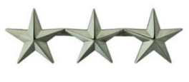
- General
- Major General
- Three Stars
- Lieutenant General
4. What rank is this (3 thin stripes)?
- Cadet Captain
- Cadet 1st Lieutenant
- Cadet Major
- Cadet Colonel
5. What rank is this? 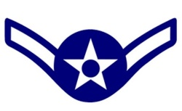
- Airman Basic
- Airman
- Airman First Class
- Senior Airman

11. What rank is this? 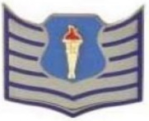
16. What does the diamond mean? 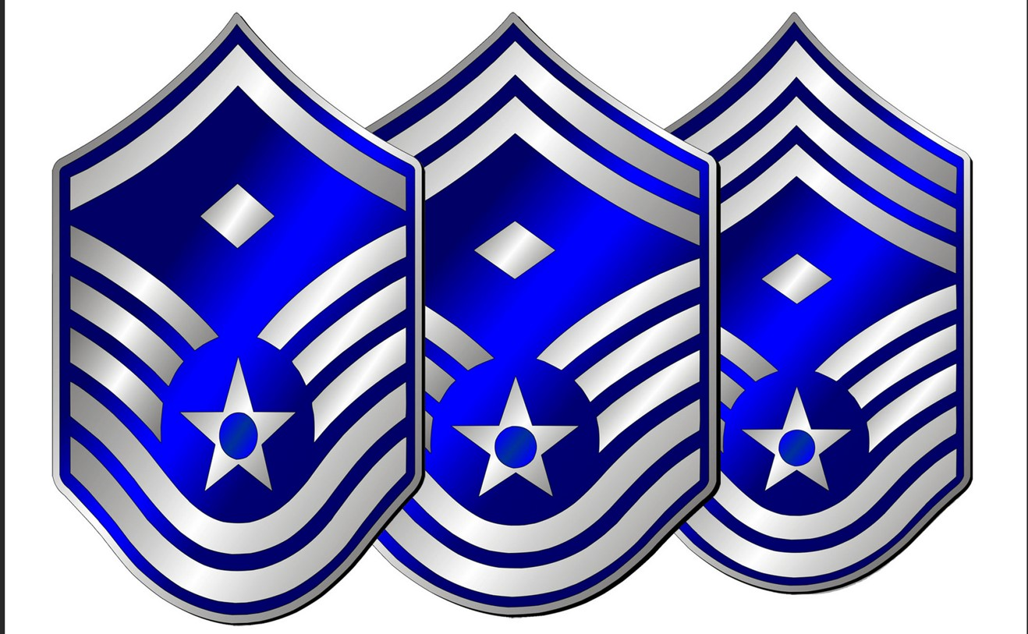
- First Chief
- First Command
- Command Sergeant
- First Sergeant
17. What rank is this (gold bar)? 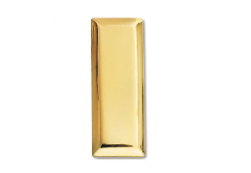
- Captain
- 1st Lieutenant
- 3rd Lieutenant
- 2nd Lieutenant

18. What rank is this?
- Airman
- Cadet Airman
- Cadet Airman First Class
- Airman First Class

19. What rank is this?
- Master Airman
- Staff Sergeant
- Airman First Class
- Senior Airman
20. What rank is this? 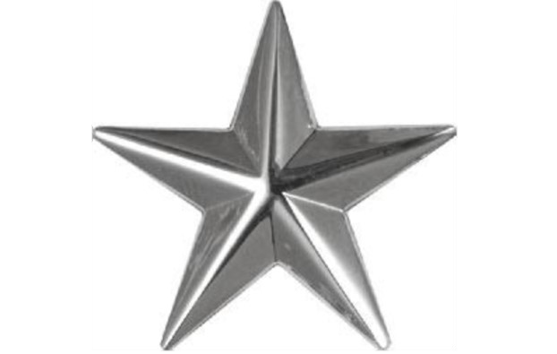
- General
- Major General
- Lieutenant General
- Brigadier General

- Cadet Staff Sergeant
- Cadet Technical Sergeant
- Technical Sergeant
- Cadet Master Sergeant
12. What rank is this (1 wide stripe)?
- Cadet Captain
- Cadet 2nd Lieutenant
- Cadet Major
- Cadet Lieutenant Colonel

13. What rank is this? 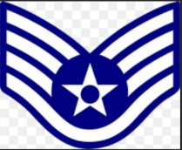
- Technical Sergeant
- Master Sergeant
- Staff Sergeant
- Senior Airman

14. What rank is this?
- General
- Major General
- Lieutenant General
- General of the Air Force

15. What rank is this?
- Cadet Senior Master Sergeant
- Cadet Chief Master Sergeant
- Cadet Master Sergeant
- Chief Master Sergeant
21. What rank is this? 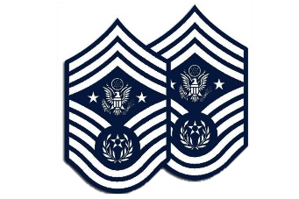

25. What rank is this?
- Airman First Class
- Senior Airman
- Airman
- Airman Second Class

26. What rank is this?
- Cadet Senior Airman
- Cadet Technical Sergeant
- Cadet Staff Sergeant
- Cadet Master Sergeant
27. What rank is this (one wide, one thin stripe)?
- Cadet Lieutenant Colonel
- Cadet Colonel
- Cadet Major
- Cadet Captain
28. What rank is this? 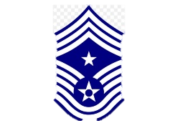
- Chief Master Sergeant of the Air Force
- Command Chief Master Sergeant
- Senior Master Sergeant of the Air Force
- Command Senior Master Sergeant
29. What rank is this (silver bar)?
- 1st Lieutenant
- Captain
- 2nd Lieutenant
- Major

- Chief Master Sergeant of the Air Force
- Chief Master Sergeant of the Army
- Command Chief Master Sergeant of the Air Force
- Command Chief Master Sergeant

22. What rank is this (one wide, 2 thin stripes)?
- Cadet Captain
- Cadet General
- Cadet Colonel
- Cadet Major

23. What rank is this? 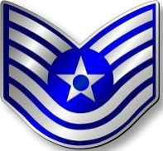
- First Sergeant
- Staff Sergeant
- Master Sergeant
- Technical Sergeant

24. What rank is this (silver oak leaf)? 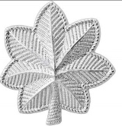
- Colonel
- Major
- Lieutenant Colonel
- Captain

30. What rank is this?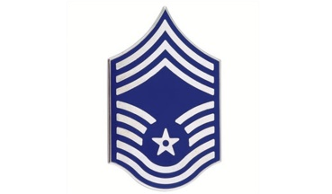
34. What rank is this? 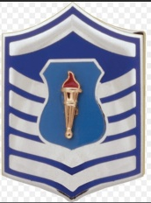
- Cadet Senior Master Sergeant
- Cadet Technical Sergeant
- Cadet Master Sergeant
- Cadet Chief Master Sergeant

35. What enlisted Air Force rank has no insignia?
- Airman
- Airman First Class
- Senior Airman
- Airman Basic

36. What rank is this? 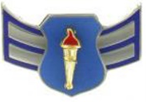
- Cadet Airman First Class
- Senior Airman
- Airman First Class
- Cadet Senior Airman

37. What rank is this? 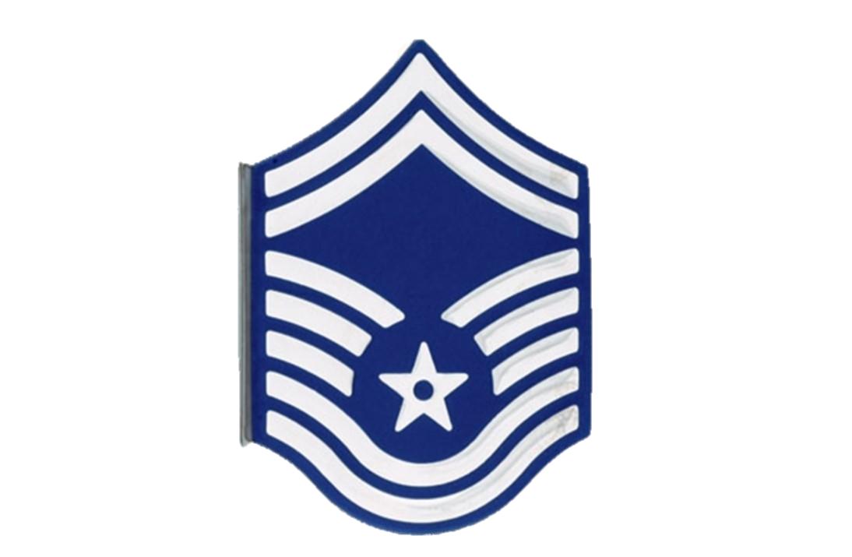
- Command Sergeant
- Chief Master Sergeant
- Master Senior Sergeant
- Senior Master Sergeant

- Chief First Sergeant
- Chief Master Sergeant
- Chief Sergeant
- First Sergeant

31. What rank is this? 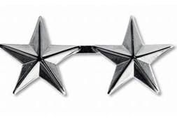
- Major General
- Brigadier General
- Lieutenant General
- General

32. What rank is this?
- Cadet Senior Master Sergeant
- Cadet Chief Master Sergeant
- Cadet Master Sergeant
- Cadet Senior Chief

33. What rank is this (two thin stripes)?
- Cadet Captain
- 1st Lieutenant
- Cadet 1st Lieutenant
- Captain

