NC-804
AIR FORCE JUNIOR ROTC
EASTERN WAYNE HIGH SCHOOL

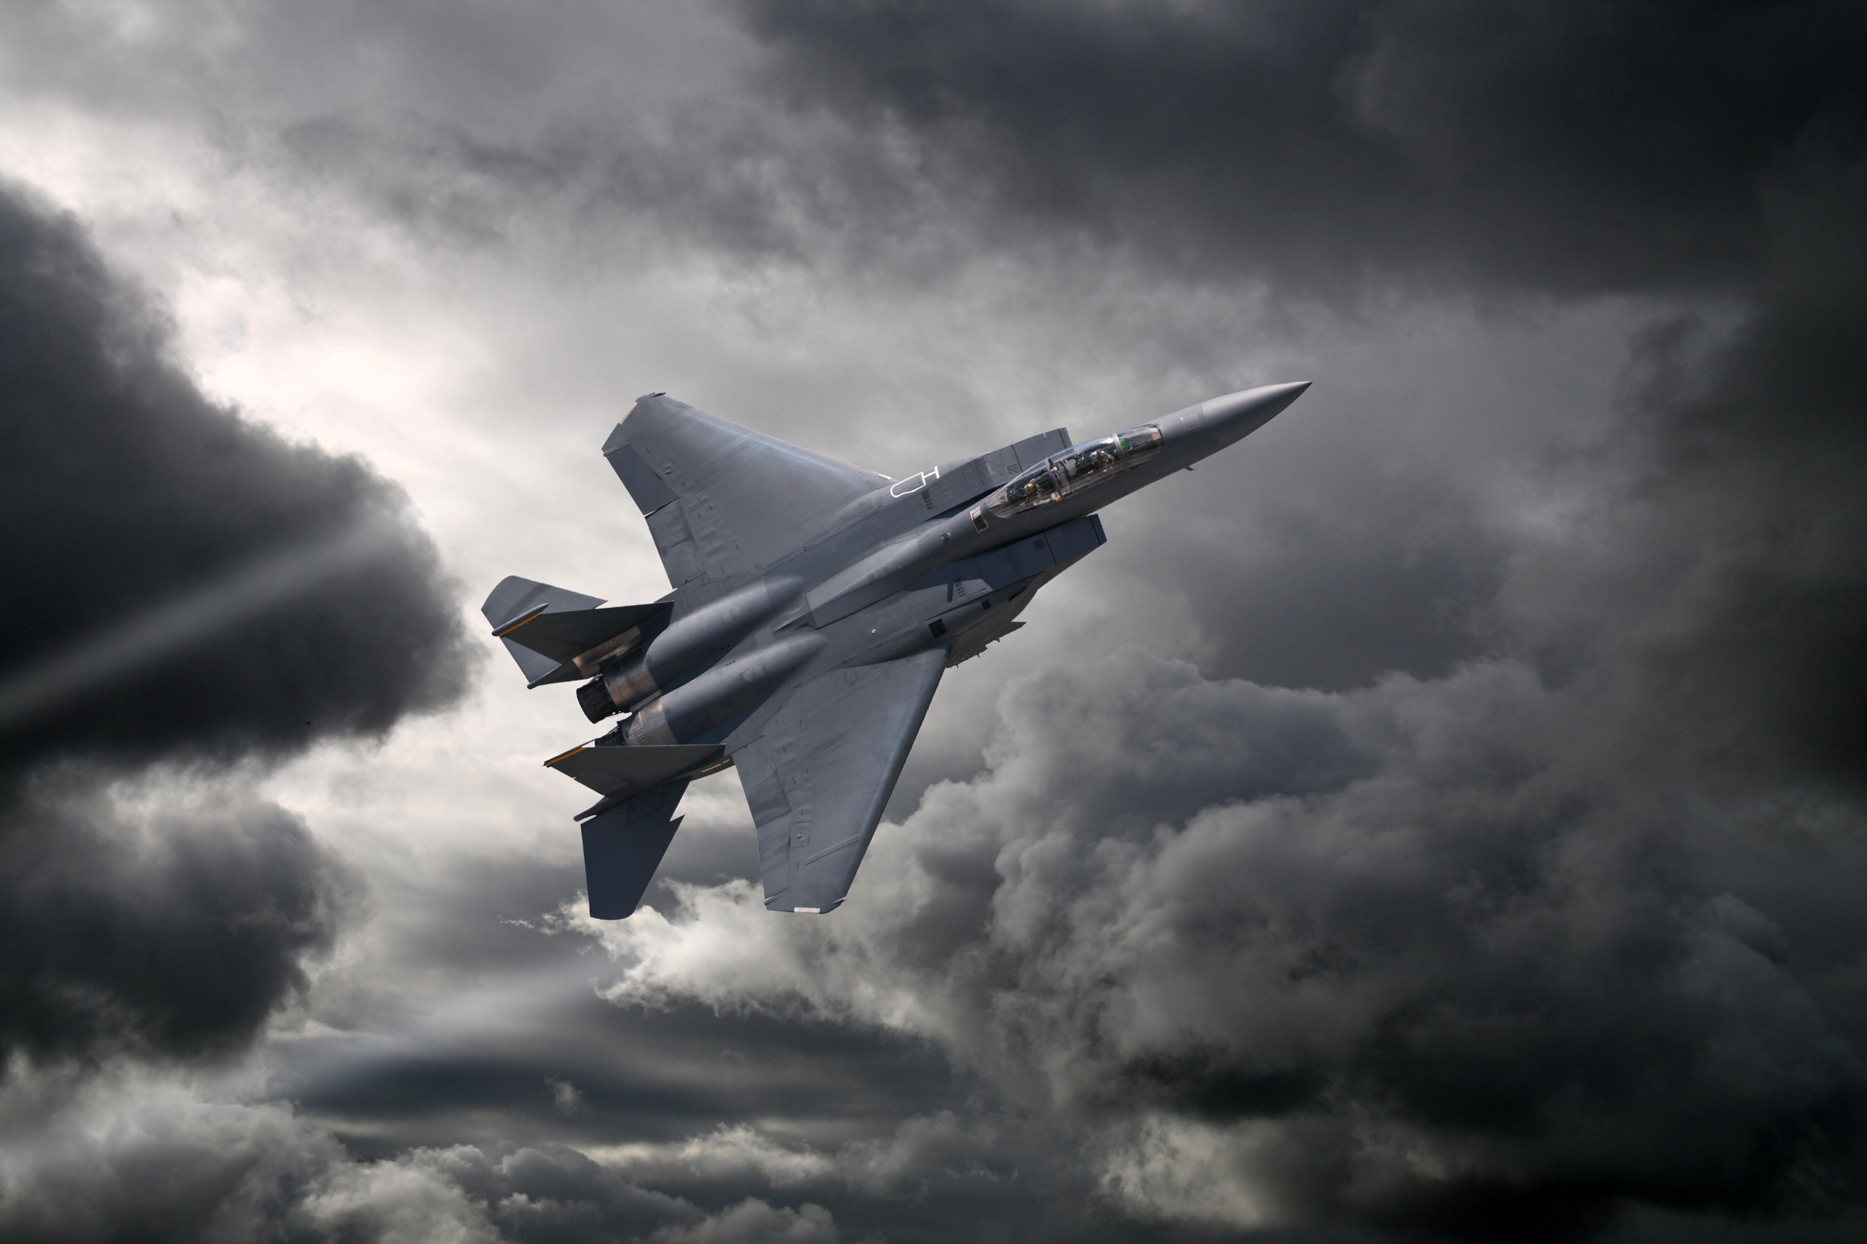
CADET GUIDE
2023-2024

CONTENTS
CHAPTER 1 – AIR FORCE JROTC PROGRAM OVERVIEW 5
AFJROTC History 5
Legal and Regulatory Basis 5
Enrollment Qualifications 5
Disenrollment 6
Curriculum 6
Program Benefits/Completion Certificates 7
CHAPTER 2 – MISSION, GOALS & OBJECTIVES 9
Mission 9
Goals 9
Motto 9
Objectives 9
CHAPTER 3 – CADET HONOR CODE OF CONDUCT 10
Code of Conduct 10
CHAPTER 4 – AIR FORCE CORE VALUES AND CADET CREED 11
Core Values 11
Cadet Creed 11
CHAPTER 5 – GRADING 12
CHAPTER 6 – CLASSROOM PROCEDURES & BEHAVIOR STANDARDS 14
Behavior Standards 14
Classroom Procedures 15
Conduct and Rules 18
Prohibition on Verbal or Physical Discipline, Hazing, and Unofficial Teams..21
CHAPTER 7 – CADET UNIFORM & PERSONAL APPEARANCE 22
Appearance of Cadets and Proper Uniform Wear 22
Uniform Day and Grading 22
Uniform Issuance and Responsibility 24
Care of Uniform 24
General Uniform Specific Guidelines 25
Cadet Appearance and Grooming Guidelines 27
Female Specific Grooming Standards 29
Male Specific Grooming Standards 33
Other Guidelines for Uniform Wear and Reminders 36
Uniform Enforcement 37
Uniform Inspection 38
CHAPTER 8 – Wellness/PT Program 39
Objective and Prerequisites 39
Importance 39
PT Training Day 39
Physical Fitness Program/PT Uniform 39
Physical Fitness Test 40
CHAPTER 9 – THE CADET CORPS 42
General 42
Goal 42
Organizational Chart 42
Chain of Command 43
Guide for Cadet Leaders 44
CHAPTER 10 – NC-804 JOB DESCRIPTIONS 45
Group Staff 46
Mission Support Squadron 48
Operations Squadron 51
Special Teams Squadron 53
CHAPTER 11 – PROGRAM OPPORTUNITIES 57
Special Teams 57
Clubs 58
Activities 58
CHAPTER 12 – PROMOTIONS 61
Rotations 62
Reductions in Grade/Demotions 63
Removal/Probation 63
Cadet Evaluation Board 63
CHAPTER 13 – AFJROTC AWARDS, DECORATIONS & BADGES 64
Special Awards 64
National Awards 65
AFJROTC Awards 68
Badges 72
Ribbon Chart 74
CHAPTER 14 – NC-804 RECOGNITIONS 75
CHAPTER 15 – TRAINING 78
CHAPTER 16 – MERIT DEMERIT SYSTEM 79
CHAPTER 17 – RESERVE CADET 82
ATTACHMENTS 83
ATTACHMENT 1: Air Force JROTC Badges & Officer/Enlisted Insignias 84
ATTACHMENT 2: Uniform Guidelines 87
ATTACHMENT 3: How to Tie a Tie 104
ATTACHMENT 4: Drill & 30-Step Drill Sequence Booklet 106

CHAPTER 1: AIR FORCE JROTC PROGRAM OVERVIEW

A. AFJROTC HISTORY:
JROTC had its origin in Cheyenne, Wyoming in 1911. The originator of this idea was Army Lieutenant Edgar R. Steevers, who was assigned as an inspector-instructor of the organized military of Wyoming. During his assignment, he envisioned a noncompulsory cadet corps comprised of high school students. His program was aimed toward making better citizens. He wanted to teach students the advantages of having a strong body and mind, the value of self-control and the importance of community service. Five years later, in 1916, The National Defense Action of 1916 authorized the Army JROTC program nationwide. In 1964, the ROTC Vitalization Act (Public Law 88-647) expanded JROTC programs to other services. The Air Force opened 20 AFJROTC programs in 1966. Today, we are approaching 900 AFJROTC units with over 121,000 cadets in high schools across the United States and selected Department of Defense Dependent Schools in Europe and the Pacific, and public schools in Puerto Rico and Guam. The AFJROTC program is headquartered at Maxwell AFB, Alabama.

B. legal and regulatory BASIS:
1. Public Law 88-647 (ROTC Vitalization Act of 1964): Directed the Secretaries of each military service to establish and maintain JROTC units for their respective services.
2. Department of Defense Instruction 1205.13: Prescribes polices for JROTC
3. Air Force JROTC Instruction (AFJROTCI) 36-2010. Prescribes policies and procedures for the organization, administration, and operation of the AFJROTC program.
4. The Superintendent of Wayne County Public Schools has entered into a contractual agreement with the Air Force to operate and support the AFJROTC program at Eastern Wayne High School. As stated in AFJROTCI 36-2010 this contract “clearly states that all AFJROTC cadets must be enrolled voluntarily and membership in the cadet corps must be limited to those cadets who meet and maintain all program requirements. Program requirements include: taking AFJROTC academic courses, participation in the cadet corps activities, properly wearing the prescribed uniform each required uniform day, meeting and maintaining Air Force grooming standards, and maintaining acceptable disciplinary standards. Cadets who are consistently deficient in one or more of the areas or demonstrate a negative pattern of behavior are disruptive to the overall corps operations and must be disenrolled.”
NOTE: IAW AFJROTCI 36-2010, “as the Air Force’s on-site representative, the SASI is personally charged with managing a fully compliant AFJROTC program and must be allowed to initiate or approve all enrollment and disenrollment actions. The SASI will ensure all students adhere to the minimum acceptable standards of conduct and personal appearance as required by the Air Force.”

C. enrollment qualifications: To enroll in the program, a student must be:
1. A volunteer.
2. Enrolled at Eastern Wayne High School and attending a regular course of instruction.
3. Physically able to participate in the PT program.
4. Of good moral character and willing and able to comply with all program requirements, rules and regulations. Program requirements include: taking AFJROTC academic courses, participation in the cadet corps activities, properly wearing the prescribed uniform each required uniform day, meeting and maintaining Air Force grooming standards while in uniform, and maintaining acceptable disciplinary standards.
5. Approved by SASI
CAUTION: A cadet may be refused re-enrollment in the program for reasons listed next under disenrollment.

D. DISenrollment rules and processes:

1. In accordance with AFJROTCI 36-2010, “the SASI must be allowed to disenroll an AFJROTC cadet at any time during the academic year with proper cause. Disenrollment is a last resort, preceded by documentation and corrective counseling. However, it is necessary in some cases, to maintain the morale and discipline of the unit. Instructors must work together with the cadets, their parents, unit cadet leaders, school counselors and administrators to resolve these issues. However, when these efforts are unsuccessful, the SASI must be allowed to remove the cadet from the AFJROTC program.”
2. “Membership in the cadet corps must be limited to those cadets who meet and maintain all program requirements. Program requirements include: taking AFJROTC academic courses, participation in the cadet corps activities, properly wearing the prescribed uniform each required uniform day, meeting and maintaining Air Force grooming standards, and maintaining acceptable disciplinary standards. Cadets who are consistently deficient in one or more areas (of the program) or demonstrate a negative pattern of behavior are disruptive to the overall corps operations and must be disenrolled.” AFJROTCI 36-2010
3. The following will result in disenrollment from AFJROTC:

a. Repeated failure to wear the Air Force uniform on uniform days, or repeated flagrant uniform and/or grooming violation(s) (i.e. pink hair, nose ring, etc.).
. b. Repeated failure to participate in PT/wellness activities without doctor’s note/medical reason.
c. Disciplinary problems (inside or outside of AFJROTC).
1) For example, continual ISS/OSS referrals from any class
d. Inaptitude, indifference to training (attitude), undesirable traits of character, or failing to remain enrolled in school.
e. Any other conduct related reason deemed appropriate by the SASI or the principal.

4. Disenrollment Processes (each step will be documented)
- Uniform (failure to wear/flagrant violation(s)) and PT (failure to participate) IAW 3-strike rule
  - 1st occurrence in semester:
1. Cadet counseling,
2. Documentation will be sent home for parent/guardian to sign
3. Contact parent/guardian
  - 2nd occurrence in semester:
- Cadet counseling
- The Cadet Evaluation Board will be convened (see Chapter 12)
3. Documentation will be sent home for parent/guardian to sign
4. Discussion with parent/guardian, counselor, school administration
  - 3rd occurrence in semester:
- Initiate disenrollment
- Discipline or other problems
  - Depends on circumstances. Will use counseling, evaluation board, discussion with parent/guardians/counselors/school administration as deemed appropriate.
5. SASI is the final authority on disenrollment procedures and cadet removal.
A NC-804 AFJROTC Cadet Contract stipulating expectations and disenrollment circumstances must be completed annually by each cadet and their parent(s)/guardian(s).
NOTE: All enrollment and disenrollment decisions will be free from any discrimination regarding race, religion, color, ethnicity, gender, sexual orientation, or national origin. Additionally, the principal and the SASI will ensure appropriate fitness of cadets to successfully participate in the AFJROTC Curriculum.

E. CURRICULUM:
1. Aerospace Science classes are elective courses. Cadets earn one elective credit per semester. Cadets normally take both semesters of AFJROTC per academic school year; however, cadets may elect to take only one semester of AFJROTC and are eligible to participate in JROTC activities for the entire year. The cadet must be recommended by the ASI and be approved by the principal. The program consists of eight courses, so cadets who make satisfactory progress can remain in AFJROTC for four years.
2. Class work is normally accomplished Monday - Thursday. Academics include lectures, individual and group work, and practical evaluations. The academic curriculum is team taught by the Senior Aerospace Science Instructor (SASI) and the Aerospace Science Instructor (ASI). Friday is normally devoted to physical training (PT) and/or team-building activities.
3. Wellness/Physical Training (PT) is accomplished on Fridays unless changed due to weather forecast, etc. On Wellness/PT day, all cadets are required to wear issued PT uniform(s) and participate in PT. (See Ch. 5/9 for more details)

F. PROGRAM BENEFITS: The most important benefit of AFJROTC is the self-esteem and self-confidence cadets gain from individual and group accomplishments. These accomplishments come from taking advantage of the opportunities the program offers for personal growth. Cadets who maintain a positive attitude and meet specific standards of performance in AFJROTC may receive special recognition and are eligible for tangible benefits after graduation. The program also offers many opportunities (See Chapter 12).
1. Cadet Rank. Cadets are given a minimum rank based on their time in the program. They earn increased rank based on participation and performance. The increased rank is a visible sign of the cadet’s level of performance and willingness to accept increased responsibility. (See Chapter 13)
2. Awards and Decorations. Cadets compete for awards and decorations. Several national organizations sponsor awards for superior performance in Junior ROTC programs. In addition, cadets earn ribbons that they wear on their uniforms based on their academic performance, demonstrated leadership skills, physical fitness, participation in service projects and participation in special AFJROTC activities, such as the Drill Team. (See Chapter 14)

3. Certificate of Completion. A Certificate of Completion is presented to cadets in good standing who have completed at least three years (4-by-4 curriculum: 3 semesters) of the program with SASI concurrence. To gain the benefits of successfully completing the AFJROTC program, a cadet must have this certificate in his/her possession when enrolling in college level ROTC program or when enlisting in the Armed Forces.
a. With the Certificate of Completion, the cadet may be excused from one year of the General Military Course (GMC) of the senior AFJROTC program. This privilege must be arranged with the Professor of Aerospace studies (PAS) at the time of enrollment.
b. After graduation, if the cadet elects to enlist in the Armed Forces, the Certificate of
Completion may provide for promotion to pay grade E-2 or E-3 when accepted by the service.
This promotion at the time of enlistment provides for an immediate monetary benefit. It also
places the cadet ahead of all other personnel enlisting at the time and, theoretically, makes the cadet eligible for promotion before other enlistees who enter at the same time.

4. Certificate of Training. This certificate is presented to cadets in good standing who complete two years (4x4: 2 semesters) of the program with SASI concurrence.
a. With the Certificate of Training, a cadet may be excused from one semester of the General Military Course (GMC) of the senior AFJROTC program. This privilege must be arranged with the Professor of Aerospace studies (PAS) at the time of enrollment.
b. Some recruiters may offer enlistment as E-2.

WARNING: The above two certificates are not awarded automatically. To be considered in good standing, consideration is given to total performance and achievement as a member of the unit. A cadet must attain satisfactory grades in both academic and leadership portions of the course and display the dedication, self-discipline, and personal values that make him/her deserving of increased rank.

5. ROTC College Scholarships. Cadets who complete a minimum of two years in the program are eligible for special consideration for AFROTC college scholarships. Participation in JROTC will increase the chance of winning a scholarship, assuming the cadet meets the minimum application requirements.

6. SERVICE COMMITMENT. There is NO requirement to enlist in the Armed Forces after completing any part or of the Junior ROTC program. Enlistment is strictly voluntary! If a cadet chooses to enter the military, he/she can enlist in any branch of military service.

CHAPTER 2: MISSION, GoaLS & OBJECTIVES

A. AFJROTC MISSION:
“Developing citizens of character.”

b. AFJROTC GoalS
“To instill in students the value of citizenship, service to the United States, personal responsibility, character, and a sense of accomplishment. “

C. AFJROTC motTo
“Building Better Citizens for America.”
d. Objectives
To educate and train high school cadets in citizenship; promote community service; instill responsibility, character, and self-discipline; encourage physical fitness; and provide instruction in air and space fundamentals.
The task or job of Air Force JROTC is simple. We want to help make high school students better citizens, and at the same time, acquaint them with the Air Force and the aerospace environment.
In accomplishing its mission and objectives, our Cadet Corps seeks to:
1. Exhibit a high degree of personal honor, self-discipline and leadership
2. Develop inner desire to serve others
3. Develop habits of orderliness and precision
4. Promote patriotism and strengthen character
5. Develop respect for constituted authority
6. Develop the ability to perform basic military skills associated with drill and ceremonies
7. Acquire broad-based knowledge of the aerospace age and environment
8. Promote a healthy lifestyle
9. Have fun
- Leadership objectives seek the cadets demonstrate the following:

- Knowledge and adherence of the uniform and grooming standards in accordance with DAFI 36-2903 and AFJROTC 36-2010
- Execute basic drill movements, positions, and facings as individual, flight, and squadron
- Demonstrate knowledge of Air Force customs and courtesies and conduct oneself in a socially acceptable manner in and out of uniform
- Perform the duties and role as assigned in Cadet Corps
- Demonstrate knowledge and respect for constituted (whole) authority
- Demonstrate knowledge of the procedures for honoring the American flag, the National Anthem, and To the Colors when participating in military ceremonies
- Develop exemplary habits of orderliness, self-discipline, leadership and precision to prepare oneself for life as a responsible adult life

CHAPTER 3: Cadet honor cODE OF CONDUCT
The following page may be the most important in this handbook. Read it carefully—think it over—re-read—and be sure you understand its meaning and message. If there is a question about the message, ask questions until the answer is clear to you; then make your decision about remaining in the corps.
These simple words provide the basis for a personal code of ethics that will last the remainder of your life. This Honor Code of Conduct is specific and clear in what it means. A cadet is expected to have complete integrity in both word and deed; to avoid quibbling or evasive statements; to do his/her own work in class; and yet to be willing to assist others in a sense of cooperation and in reaching common group goals.
The Code belongs to the cadets. Maintaining its high standards of trust is the responsibility of each cadet. This will require self-control and conscious effort at all times. Eventually it becomes an ingrained habit and part of the cadet’s ethical code and lifestyle. The Honor Code, by stressing that there can be no toleration of lying, cheating, or stealing, emphasizes that HONOR is a common standard of the Cadet Corps and provides a special bond between cadets.

AFJROTC CADET HONOR CODE OF CONDUCT(NC-804)

I AM AN AIR FORCE JUNIOR ROTC CADET. I believe in honesty, decency and diligence, all of which will help my community and country remain great. I will strive to be a good example for others to follow. I accept and pledge myself to obey the articles of the following Cadet Honor Code of Conduct:
ARTICLE 1: I will respect my country and show due benevolence to our flag.

ARTICLE 2: I will respect and follow the commands of the cadets and instructors placed in authority over me.

ARTICLE 3: I will not lie, cheat, nor steal, nor will I make excuses for failing to complete assigned assignments and tasks.
ARTICLE 4: I will not violate school rules or regulations, nor will I cause others to do so either.
ARTICLE 5: I will not participate in any activity which is illegal by law or directive.

ARTICLE 6: I will wear my uniform with pride and dignity at all times.
ARTICLE 7: I will strive for academic excellence in all of my classes.
ARTICLE 8: I will set the example in every action I undertake, remembering that they reflect on the AF JROTC program.

CHAPTER 4: air force core Values &
AFJROTC Cadet creed
The Air Force holds certain ideals…certain values that are at the heart and soul of the military profession. These concepts also provide a basis for conduct in our society.
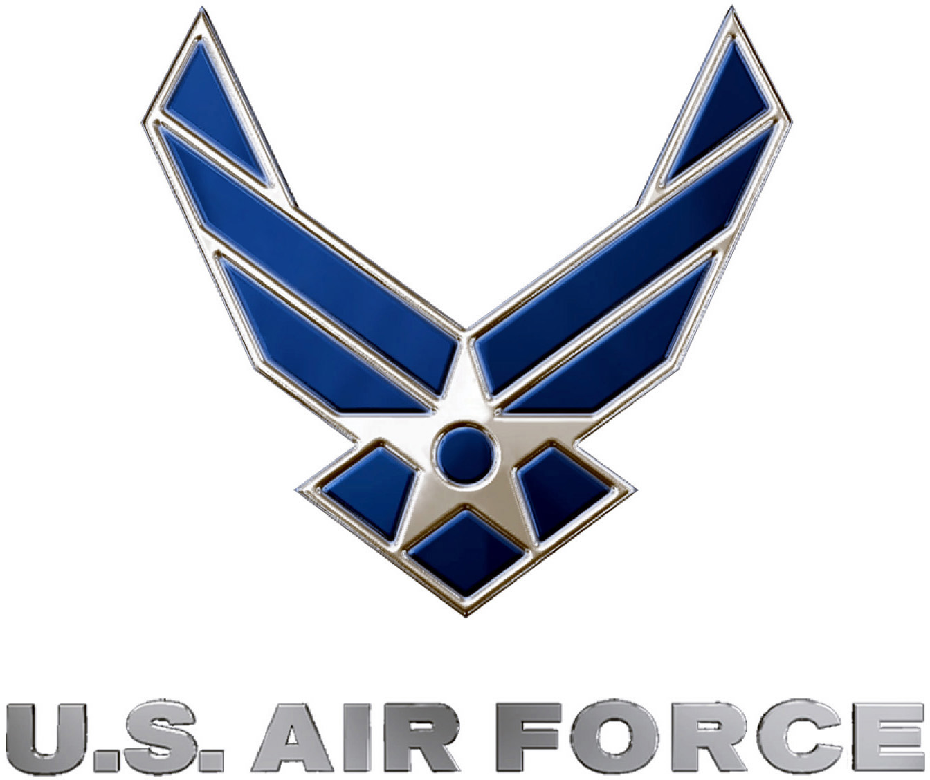
There are three core values that have been established for the Air Force. They are:

Integrity first

Service before self

Excellence in all we do
“Integrity First” is essential. It is the inner voice, the source of self-control, and the basis for the trust that is imperative to building individual character. It is doing the right thing when nobody is looking.
“Service before self” means that your professional duties take precedence over personal desires. In the military, every member realizes from day one, that his or her individual needs will be second to the needs of the nation. The cadet must follow this same rule-of-thumb. A leader unwilling to sacrifice individual goals cannot convince other unit members to do so. While personal goals often coincide with AFJROTC unit goals, there is no room for personal agendas at the expense of the unit and especially, one’s fellow team members who also stake their success on every member putting self last.
“Excellence in all we do” directs us to develop a sustained passion for continuous improvement that will propel you into an upward spiral of accomplishment and performance.
The present times call for values that serve as a beacon toward the right path. They set the standard for our behavior, our service to country, and our treatment of one another. These core values -- Integrity First; Service Before Self; and Excellence In All We Do – are the foundations upon which a truly quality Air Force JROTC unit is built.

AFJROTC Cadet Creed
- I am an Air Force Junior ROTC Cadet.
- I am connected and faithful to every Corps of Cadets who served their community with patriotism.
- I earn respect when I uphold the Corp Values of integrity first, service before self, and excellence in all we do.
- I will always conduct myself to bring credit to my family, school, Corps of Cadets, community, and to myself.
- My character defines me. I will not lie, cheat, or steal. I am accountable for my actions and deeds.
- I will hold others accountable for their actions as well. I will honor those I serve with, those who have gone before me, and those who will come after me.
- I am a patriot, a leader, and a wingman devoted to those I follow, serve, and lead.
- I am an Air Force ROTC Cadet.

CHAPTER 5: GRADING

GENERAL: This chapter specifies general requirements for successfully completing AFJROTC courses. Each course is designed for students to succeed. If cadets have a positive attitude, work hard, comply with course requirements and standards in this Cadet Guide, and see instructors when they need help, they should successfully complete AFJROTC.

GRADING POLICY: Cadets on graded on academics, uniform wear, physical training and merits (conduct).
- Academics: Academic performance is measured by tests, quizzes, class work, drill, and homework assignments. Academics account for 30% of the nine-week grade.
- Uniform Wear: Instructors will inspect cadets for compliance with uniform wear requirements and personal grooming standards one day each week. This grade accounts for 30% of the nine-week grade. See Chapter 7 for detailed guidelines.
  - Warning: Wear of the uniform one day per week is mandated by AFJROTCI 36-2010. As outlined in Chapter 7, wear of the uniform is considered so important that failing to wear the uniform when required or flagrant disregard for appearance and grooming standards could result in an automatic “F” for the semester and disenrollment (see Chapter 1). Cadets and parents must sign a contract acknowledging their understanding of this policy.
- Wellness/Physical Training: Cadets participate in physical training one day per week. Performance is measured by participation and wearing the proper PT uniform. This grade accounts for 20% of the nine-week grade. Warning: As outlined in Chapter 1, failing to participate in PT could result in disenrollment from JROTC. See Chapter 9 for more details.
  - Participation is 50% of grade, proper issued top is 25% of grade, and proper issued bottom is 25% of grade.
  - Warning: No athletic shoes will not permit participation and will result in a 0% for that day (not participating or in uniform). A bad attitude may result in a 0% for day and other consequences.
  - Note: If you are absent on PT day or present and unable to do anything, you must write a 1-page report on a wellness topic to receive wellness/PT grade for the week. Cadets absent are responsible to turn in the first day back, or 0% grade will be recorded.
- Conduct/Participation: This grade accounts for 20% of the nine-week grade. This grade will be determined by the merit and demerit system as detailed in Chapter 17.
- Semester Exam: AFJROTC must give a semester exam like all other academic classes. The final exam counts as 20% of the final grade, unless dictated otherwise by school.
GRADING SCALE:

90-100: A
80-89: B
70-79: C
60-69: D
0-59: F

EXTRACURRICULAR ACTIVITIES: AFJROTC offers a variety of after-school voluntary programs called LDRs (Leadership Development Requirements) (see Chap 11). Cadet participation in these activities is not a formal part of the cadet’s grade; however, cadets may receive quality points for participation. Participation is an important element in the awards program and in consideration for promotions.

TUTORING: If a cadet gets behind in his/her studies, has a problem comprehending the course material, or has difficulty applying leadership studies, he/she should see an instructor for extra help. Each instructor is available after school for tutorials and additional instruction/practice. However, the instructors expect the cadet to take the responsibility for asking for help.

EVALUATION REPORTS: Progress Reports are sent home with students as required by the school and upon parent request. Report Cards are sent home at the end of each 9-week grading period according to the WCPS schedule. Parents should ask for these reports from their cadet! Cadets are not required to return signed reports. However, signed reports will be awarded extra credit points for the grading period.

PARENT CONFERENCES: We encourage parents to call or visit the school to discuss their cadet’s progress. Call the EWHS front office (751-7120) to schedule an appointment.

CHAPTER 6: CLASSROOM PROCEDURES & BEHAVIOR STANDARDS

A. behavior Standards
GENERAL: The AFJROTC program expects cadets to display self-discipline, good manners, good grooming, appropriate dress, and proper military courtesy at all times. Whether you are the superior or the subordinate, complying with protocol is an act of discipline. Cadets will inspire others to follow them by setting examples of confidence, good judgement, decisiveness, initiative, intelligence, and maturity. Cadets’ behavior reflects upon themselves, their family, school, and unit. But most importantly, improper behavior reflects negatively on the programs sponsor, the United States Air Force.
Courtesy is a quality of human association that enables people to live in harmony and function efficiently. Military courtesy includes an outward display of mutual respect. In the AFJROTC environment, we teach military customs and courtesies and general politeness that every cadet must understand and support. This handbook reviews common practices cadets are expected to comply with daily. Actions that violate these rules will impact the cadet’s grades, rank, participation in extracurricular activities, and competition for awards. Significant and/or consistent acts of negative or disruptive behavior can result in disenrollment (see Chapter 1) and will eliminate a cadet from future JROTC courses. In addition, we expect our cadets to exhibit proper conduct not only in JROTC, but throughout the school and beyond. Cadets who are chronically in trouble in other classes, are regularly sent to In-School Suspension (ISS) or who have multiple Out-Of-School suspensions will jeopardize their opportunity to remain in current or enroll in future JROTC courses. You are a cadet 24-7.
ATTITUDE: Your attitude is a state of mind that affects your thoughts and actions. A positive attitude is the single most important ingredient for becoming a successful cadet. Come with an open mind, a willingness to learn, a desire to improve yourself, the courage to take risks and make mistakes, and you will excel in our program.

MILITARY COURTESY AND PROPER ETIQUETTE:
1. Use of Titles: Civilians are addressed as Mr., Mrs., Miss, Ms. Military personnel are addressed by their rank. Address the SASI as Colonel or Lt Colonel Smith. Address the ASI as Master Sergeant or Sergeant Turner. Cadets should address each other as Cadet, Mr. or Miss and last name.
2. Sir/Ma’am: Address the SASI, ASI, and all higher-ranking cadet officers as “Sir” or “Ma’am”.
3. Saluting: When in uniform and outdoors, salute the SASI, cadet officers of higher rank, and officers of United States Armed Forces. You must also salute when reporting in to the SASI, or senior cadet officer. Junior ranking person salutes first and holds until senior ranking person drops it. A salute is never given or returned while running. The cadet will come to quick time (to a walk) and render the salute when approximately 4 paces from the officer.
4. Conversation etiquette: Cadets should exhibit good etiquette by using the words “please” and “thank you” in discussions. Also, do not interrupt others when they are talking. Speak to others as you would like people to speak to you! Display friendliness and respect to others and greet each other in a pleasant manner.
5. Office Courtesy: When entering the SASI/ASI office, always knock and wait to be invited in. If told to report, you must report in. Never enter the office when the SASI/ASI has someone else in the office or if there is no one in the office.
6. Discretion: Cadets leadership will exercise discretion in enforcing military standards and courtesy. Cadets will not be placed in an embarrassing situation by a public reprimand. However, cadets have the responsibility to deal with violations of military customs or courtesies.
a. Cases of disrespect, insolence, insubordination, or refusal to comply with corrective instructions will be reported to the SASI/ASI immediately.
7. Cadets will follow procedures outlined in this cadet guide and will obey reasonable orders from those appointed over them (see Chapter 10).
8. Respect for Flag:
- Cadets are expected to render proper respect to the flag of the United States of America. Violation of this brings discredit.
- When cadets are in uniform, outdoors, stand at attention, render the hand salute and remain silent during flag raising and lowering ceremonies.
- When attending an outdoor sporting event or similar function, cadets in uniform will stand at attention, face the flag, and salute during the presentation of colors and/or playing of the National Anthem (if can’t see flag, face direction of music).
- When cadets are in uniform, indoors, stand at attention facing the flag and recite the Pledge of Allegiance. Do not render the hand salute.
- When cadets are in civilian attire, stand at attention with the right hand over the heart, face the flag and recite the Pledge of Allegiance.

B. CLASSROOM OPENING AND CLOSING PROCEDURES
PURPOSE: This section provides practical leadership training and experience.
GENERAL: Each class period will be organized as a flight with two to four elements. The Flight Commander (assisted by the Deputy Flight Commander, Flight Sergeant, and two to four Element Leaders) assists the SASI/ASI with the discipline, motivation, and leadership training of the flight.
SCOPE: This policy applies to all classroom conduct.
PROCEDURES:
- Classroom Leadership/Seating Arrangement:
  - The Instructor is the ultimate authority in the classroom (indoors or outside). No cadet holds a position higher than the instructor and will not make decisions without clearing them through the class Instructor. When in the class, the instructor has complete control unless he or she delegates that control to the Flight Commander or a cadet acting on behalf of the Flight Commander.
  - The Flight Commander(s) will sit in front of the classroom (or as assigned) and is responsible for the overall training and discipline of the flight at all times, except when the instructor assumes control. The Flight Commander is responsible for the overall supervision of classroom procedures and activities, ensuring that he or she as well as all other classroom leaders perform their duties in a fair and equitable manner and without favoritism. The Flight Commander will also help maintain classroom security and will notify the instructor whenever a visitor enters the classroom. Flight Commanders should be aware that it is school policy for ALL visitors to clear through the school’s main office before visiting the classroom. The Flight Commander (or first cadet to see them) will also monitor for distinguished visitors and call the flight to attention upon recognition. Distinguished Visitors will include but is not limited to: The superintendent, school principal, assistant principals, any commissioned officer higher in rank than Lt Col, and any other visitor designated by the SASI and ASI.
  - The Deputy Flight Commander (also doubles as the Flight Guide/Guidon Bearer during drill if assigned) will sit to the rear of the classroom on the flight’s right (or as assigned). The Deputy Flight Commander is responsible for performing all duties assigned to him or her by the Flight Commander. He or she will assume the role of Flight Commander whenever the Commander is absent from the classroom. The appropriate Deputy Flight Commander (1st period, 4th period, or as required on non-standard days) is also responsible for Flag Detail rotation. He or she will be responsible for clean-up on days when the Flight Sergeant is working with Uniform Inspection Score Sheets.
  - The Flight Sergeant will sit at the rear of the classroom on the flight’s left (or as assigned). The Flight Sergeant is responsible for the forming of the flight in all formations and is responsible for performing all duties assigned to him or her by the Flight Commander. The Flight Sergeant fills in for the Commander and Deputy when they are absent. He or she will also be responsible for Classroom Clean-up. Note: If no Deputy Flight Commander appointed, the Flight Sergeant assumes all Deputy Flight Commander duties and delegates to Element leaders as required.
  - Element Leaders will sit in first front of the classroom (or as assigned), with members of each element sitting IAW the seating chart established by the Flight Commander. If seating must be changed because of cadet behavior, a new seating chart must be created. A copy of all current seating charts will be kept in the Attendance Book on the podium in the classroom. Element Leaders will open the class and fill in as needed when two of the top three are absent beginning with the 1st Element Leader. Assistant Element Leaders will be assigned. These cadets will fill in when the Element Leader is fulfilling one of the Top Three roles or when the Element Leader is absent.
  - Each cadet is responsible for his/her own conduct and behavior. All cadets should strive to live by the Cadet Honor Code and the Air Force Core Values – Integrity First, Service Before Self and Excellence in All We Do. Each cadet must remember that he or she represents an old and honorable profession – The United States Air Force. Always treat your instructors, leaders and each other with respect. Each cadet is also responsible for his/her immediate area (your post). Keep your area neat and clean including the floor around your desk.
  - Seating arrangements will normally remain the same until revised by the Flight Commander, upon approval of the SASI/ASI. Flight Commanders will ensure that current Seating Charts are posted in the Attendance Book on the podium.
- Class Opening and Closing Procedures:
  - As they enter the classroom, the Flight Commander and Flight Sergeant will take their positions for the class opening ceremonies (Flight Commander – rear of classroom, behind flight (if only one flight, near door); Flight Sergeant – front center of classroom), go to the position of “Parade Rest” and monitor the cadets as they enter the classroom. Male cadets will remove earrings before entering the classroom. All cadets will spit out all gum prior to entering the classroom. NO FOOD ALLOWED IN CLASSROOM unless instructor gives permission. The Deputy Flight Commander (unless needed to fill one of the other positions) will take a position outside door of the classroom and monitor cadets coming along the hallway, insuring cadets do not linger and get into the classroom on time. He/she will ensure cadets who enter the class after the tardy bell sounds remain in the rear of the classroom and take part in class opening ceremonies. The Element Leaders will take their usual positions by their assigned seats, face their element at “Parade Rest”, and make note of element tardies and absences.
  - Cadets are to enter the classroom “At Ease” and go directly to their assigned seats. After putting books on the desk, they will stand at the position of “Parade Rest” facing front of classroom, ready to open class when the tardy bell rings. Cadets are not to talk or leave their posts. Under no condition will the cadet be anywhere else but their assigned post without permission. Element Leaders will ensure that cadets under their supervision comply with these procedures.
  - When the tardy bell rings, the Element Leaders will face the front of the classroom. The Flight Sergeant will command “Flight Attention. Face the flag and say the Pledge”, lead them in the Pledge of Allegiance, and call for the attendance “REPORT” from the Element Leaders (perform facing movement toward each element leader to take attendance). Each element leader will face the Flight Sergeant and state “Element __, __Flight is all present and accounted for.” If there is an absence, state the cadet’s last name. For example,” Element 1, D Flight is all present and accounted for with the exception of Cadet ___.” Once all Element Leaders have reported in, the Flight Sergeant will perform a facing movement towards the Flight Commander and say “Sir/Ma’am, ____ Flight is all present and accounted for.” If multiple cadets are absent, then state who is absent by saying “…with the exception of Cadet(s) ___.” The Flight Commander will admit Tardy Cadets to class and begin the class Routine Recital to include the Honor Code, Core Values, JROTC Creed, and anything else required, put the flight at “Parade Rest”, read all announcements, announce the instructor for the day. If the instructor is busy, the Flight Commander may take care of any business at hand, including reminding the cadets of any work that is due. He/she will keep the class at “Parade Rest” until he/she turns the class over to the instructor, unless told otherwise by the instructor. During this time, the Flight commander may make announcements such as details for the day, to include Flag Detail, Clean-up Detail, etc. When the instructor is ready to take the class, the Flight Commander will call the flight to “Attention”, command “Present Arms”, report to the instructor “Sir, __ Flight is ready for instruction (with exception of cadet(s) ___ if applicable),” and do as the instructor directs. When the instructor has finished the lesson, or must leave the classroom, the Flight Commander will assume command of the class. During the instructor’s class, the Flight Commander should keep all interruptions to a minimum.
  - If required, once the Flight Commander has been given permission by the instructor, he/she will quickly conduct a walk-thru inspection of the ROTC building and surrounding outside area, if the weather permits. He/she will use the Maintenance Checklist to insure the previous class did clean-up. He/she will check cleaning supplies to make sure they have enough supplies for the flight to do clean-up. Finally, the last period Flight Commander will make sure the flags are taken out/brought in for the day.
    - Tardies: Cadets who are tardy will have tardy slip IAW school policy (The school’s tardy policy will be strictly adhered to). Cadet will knock, enter class and stand at attention. Wait for person controlling the room (Flt CC or Instructor) to say “report.” Tardy cadet salutes the person in control of room, and says “Sir (Ma’am), Cadet _____________ requests permission to join the flight, sir (ma’am)!” Hold your salute until the Flight Commander/Instructor has dropped his/her salute and has said “Permission granted”.
  - Class Dismissal: Ten minutes prior to the dismissal bell ringing, the Flight Commander will give the Instructor a 10-minute warning. The Instructor will then have any paperwork passed in and, if necessary, have Element Leaders take up text/work books and any other training materials. Element Leaders will make sure that all books and training materials are put away neatly before the class is dismissed, and area clean. Prior to the dismissal bell ringing, the Flight Commander will make sure that all cadets are in their assigned seats. When the dismissal bell rings, the Flight Commander, with the Instructor’s permission, will call the flight to “Attention”, command “Present Arms”, salute the Instructor, and state “Sir/Ma’am, request dismissal”. After the Instructor commands “Dismiss the Flight” and returns the salute, the Flight Commander then commands “Order, Arms.” The Flight Commander will then make important reminders (announce the instructor for the next day, remind cadets of any assignments due/Uniform Day uniform/PT Day and uniform, bring books, homework, and/or materials for class, etc.) The Flight Commander will then dismiss the flight as a whole or by elements by commanding “Flight__/Element __, Dismissed”. Students will depart the classroom “At Ease”, all together or by element as directed. Flight Commanders will rotate the order in which elements leave the classroom each day. If an element has been exceptionally well-behaved, the Flight Commander may dismiss that element first. If the Flight has been exceptionally well-behaved, the Flight Commander may dismiss the entire flight at once by commanding “Flight Dismissed.” Caution: Element(s) will not be dismissed if anyone in element has made a mess and not cleaned it up.
Note: Cadets expected to wait until Flight Commander has dismissed them to begin picking up their personal belongings.
- Class Duties
  - Clean-up: At some point during class, the instructor may direct the Flight Commander to conduct clean-up and any other details or duties the instructor feels are necessary. The cadet staff may have a clean-up schedule. If cleaning up, the Flight Commander turns control of “Clean-up” over to the Flight Sergeant who makes sure that each Element Leader knows about the rotation clean-up schedule for each element. The Flight Sergeant will monitor the overall clean-up and each Element Leader will monitor the participation of each cadet in the element. Element Leaders make sure that details are assigned fairly, making sure that the difficult details are rotated among their people. ALL CADETS in each element, including the Element Leader, must take part in their element’s clean-up. NO HALL PASSES will be issued during clean-up. The only exemption during clean-up is the Flag Detail. Under the supervision of the Deputy Commander, the instructor may request that the Flag Detail go out during clean-up. Details must be finished in the time allotted by the instructor. Completion of details includes making sure all cleaning supplies have been returned to their proper place. Once clean-up is finished, the Flight Sergeant makes sure all cadets are back in their seats and will let the Flight Commander know what cadets did not take part in clean-up. The Flight commander makes note of this in the Merit/Demerit Log, if necessary. The instructor will resume control of the class and, if time allows, continue teaching activities.
  - Flag Detail: On a typical school day, 1st Period raises the flags and 4th Period lowers the flags. All flights will learn both raising and lowering the flag, both Reveille and Retreat. If two Flights in a class, Flight rotation will be on a weekly basis and a schedule developed. Normally just the Flag Detail will go out but sometimes the entire flight(s) will participate. The Flight Commander will check with the Instructor and relay this information to the Deputy each day. Deputy Flight Commanders are responsible for rotating cadets on flag detail teams (raising the flags – 4 cadets; lowering the flags – 4 cadets). Flag Detail teams will rotate each week. Deputy Commanders will make sure that every cadet is rotated on the flag detail and that the rotation is fair and equal. Deputy Commanders will set up and monitor the Flag Detail rotation schedule for each 9-week period. He/She will post the Flag Detail Roster in certain location and turn a copy in to the Flight Commander, who will monitor the program. NOTE: As stated before, if no Deputy Flight Commander assigned, falls on Flight Sergeant duties.

- CLASSROOM CONDUCT & RULES:
  - The Flight Commander and instructors are in charge of the room at all times. Cadets are required to follow all commands they give. If an instructor is not in the room, cadets follow the rules given to them by either the Flight Commander or Flight Sergeant.
  - Military courtesy will be observed at all times in the daily JROTC routine. Cadets will treat each other with respect at all times. When addressing a cadet of superior rank, or any instructor, cadets will use “Sir/Ma’am” as appropriate. Cadets will use proper titles while in the classroom or any formation, i.e. address cadets by their rank or Mr./Miss, or Cadet (i.e. “Cadet Major Jones, Cadet Airman Jones, Cadet Jones, Mr./Miss Jones”).
  - Cadets will be “At Ease” during class to provide a satisfactory atmosphere for learning.
  - Cadets are expected to respect others at all times. Talking at inappropriate times or interrupting someone will result in corrective action.
  - Cadets are expected to make good use of class time. Participate in all classroom activities, indoors and outdoors. When, they are not being instructed, cadets are expected to work on their cadet duties or engage in self-directed study. If a cadet is in charge of an activity, give them the same courtesy as you would the instructor.
  - It is each cadet’s responsibility to contact the instructor(s) to make up any assignments missed due to absence, no matter what the reason for the absence.
  - The following will not be tolerated:
    - Profanity, vulgar language or disruptive comments
    - Hazing of any kind
    - Walking around without permission
    - Leaving trash, food, or dirt behind
    - Mark, scratch or deface AFJROTC or school property.
    - Activities or behavior that disrupts or distracts the rest of the class.
  - Do NOT:
    - Talk at inappropriate times or interrupt
    - Engage in public display of affection (PDA) while in class or during JROTC activities.
    - Eat food, chew gum, or drink beverages in the classroom or JROTC area at any time unless allowed by SASI/ASI. (Clear see through water bottles with water are acceptable).
    - Use personal electronic devices without ASI/SASI permission.
    - Wear hats (or any form of headgear) or sunglasses in the JROTC area.
    - Sleep in class or put your head on your arms as if sleeping or rest. If sleepy, go to back of classroom and stand at ease (position limited to 10 minutes).
    - Write on whiteboards unless given permission by SASI/ASI.
    - Sit on top of tables (you will be cleaning top of all desk and tables as result).
    - Touch projector screen
    - Touch audio visual equipment unless given permission.
    - Place your feet on tables or chairs.
    - Place your feet on tables or chairs.
    - Tilt chairs back. Keep all four legs on the floor.

- INSTRUCTOR OFFICE, SUPPLY ROOM, & CADET WORKCENTER PROCEDURES:
  - Instructor Office: is “Off Limits” to all cadets. If you need to conduct any business in the JROTC office (i.e. to see an instructor, to use the phone, etc.), you must follow the guidelines listed below:
    - Get the classroom instructor’s permission first.
    - Knock ONCE firmly and loudly. Wait until you’re given permission to enter.
    - When entering, state your purpose. Follow the directions of the instructor who gave you permission to enter.
    - If reporting to the SASI, you must stand in doorway, salute, and remain at attention until told otherwise.
    - While in the office you will refrain from loud noise and horseplay. Do not distract any instructor. Do no rummage or lean on the desks, sit at an instructor’s desk, or sit down without being invited to do so.
    - The JROTC office phone is the property of Eastern Wayne High School and falls under the same guidelines as all other school phones. They are for emergencies and official use only. You must have the permission of an instructor to use the phones.
  - Supply Rooms: “Off Limits” unless a Logistics Officer or ASI/SASI grants you access. No food or drinks (unless water).
  - Cadet WorkCentre:
    - Internet and printer will only be used for JROTC duties.
    - No horseplay or loud noise
    - Must have permission to use from ASI/SASI
    - No food or drinks (water only)
    - Do not go into storage rooms unless have permission per above and a purpose,
    - Keep clean and pick up after yourself.
    - Report computer/printer problems ASAP.
    - Do not install programs, use your own hard drives, thumb drives, etc. unless have permission.
- HALL PASSES:
  - The Instructor is the only person who issues hall passes. NO cadet has the authority to issue a hall pass to another cadet, no matter what position or rank that cadet may hold. The Flight Commander assists the instructor in managing the “Student Leaving Classroom Log” and in controlling and recovering all hall passes. There will be no more than one cadet out of class on a hall pass at any one time, except in special circumstances. Hall passes will not be issued to use phones, or visit teachers, counselors, or administrators during class time unless it is an emergency. Cadets who will need to leave class for an appointment with a teacher, counselor, or administrator should bring a note to class from the person who has scheduled the appointment.
  - Whenever you leave the classroom no matter what the reason, you must always sign out in the “Student Leaving Classroom Log” and you must always sign back in upon returning to class. You will first get permission from the instructor who is in charge of the class. Then you will enter your name, destination, and time in the Log and leave the classroom with your pass. Remember, if you are caught in the halls without a valid hall pass, you will be considered skipping class and may receive In-School suspension. Under no circumstances will a cadet sign out until given permission by an instructor and under no circumstances will a cadet returning to class give his/her pass to another cadet. ALWAYS GET PERMISSION FROM AN INSTRUCTOR FIRST.
  - When you return to class, record the return time in the sign-out log and return your pass to the instructor. No cadet should be gone from class any longer than 5 minutes, unless permission has been given by the instructor or unless there is a verifiable emergency or special circumstance, which the cadet should tell the instructor before getting the hall pass. Do not go anywhere but the destination on your hall pass. If you do otherwise you will get in serious trouble if you are caught. We will also monitor how often a cadet asks for a hall pass and how long you are gone from class. These things may cause u to call your parent/guardian and make it hard for you to get a hall pass in the future. If you have a medical problem that will require you to leave class frequently, you should bring a note from your parent, guardian or doctor (preferably the doctor).
  - You should not ask to leave class to take care of personal things (i.e. go to locker, see someone in another class, make a phone call, etc.) during class. You need to make good use of your time between classes and your lunch time so that you will not need to ask to leave class (i.e. use the bathroom if needed). Remember, also, you will not be allowed to go out of class during clean-up time unless it’s verified that you have done your clean-up assignment. If you need to leave the classroom area to complete cleaning duties, such as take out the trash or find a janitor for cleaning supplies, you may be asked to carry a hall pass.
- CHARACTER TRAINING:
  - The instructor or the Flight Commander may begin each class period or formation by leading the assembled cadets in reading or reciting one or more memory selections (i.e. Cadet Honor Code, AF Core Values, etc.), reciting any posted classroom rules, “motivation checks”, singing jodies, practicing drill movements or any other character training he/she feels will enhance the cadets bearing and behavior.
At an appropriate time during each class period, with the permission of the instructor, the Flight Commander may read or have read an appropriate selection or may conduct other forms of training to build and strengthen the good character of the cadets or conduct activities that will instill teamwork in the flight.

8. PROHIBITION ON verbal OR PHYSICAL DISCIPLINE, HAZING, and unofficial teams
In accordance with AFJROTCI 36-2010, several prohibitions (listed below) are applicable to all AFJROTC events, activities, and/or practices. These prohibitions apply to AFJROTC instructors, AFJROTC cadets, and any other person who may be involved with, coaching, or otherwise participating with cadets, or attending or observing an AFJROTC event, activity, and/or practice.
- No person will encourage, allow, or condone the use of any type of physical act or abuse as an outcome, punishment, penalty, or corrective training for a cadet’s failure to achieve a specific result. These prohibitions include, but are not limited to physical exercises, menial tasks (e.g., cleaning bathrooms), or any physical exchange such as shoving, pulling, or hitting.
- No person will encourage, allow, or condone the use any type of psychological abuse as an outcome, punishment, penalty, or corrective training for a cadet’s failure to achieve a specific result. These prohibitions include, but are not limited to any effort to humiliate, tease, intimidate, or publicly reprimand or embarrass a cadet for failure to achieve a specific result..
- No person will encourage, allow, or condone the use of any form of hazing, whether physical or psychological, within any AFJROTC event, activity and/or practice. All persons involved will ensure any membership requirements or qualifications to join any approved AFJROTC team, event, or activity does not include anything humiliating, demeaning, or otherwise unapproved by this instruction.
- No person will encourage, allow, or condone the use of any device, gimmick, or game to select an outcome, punishment, penalty, or corrective training for a cadet’s failure to achieve a specific result.
- Unofficial groups, secret societies, private clubs, or any other unofficial entity within an AFJROTC program is prohibited.

9. HARASSMENT
Harassment, such as improper or abusive language, and coercion of lower class cadets for personal gain, are strictly forbidden. Misuse of authority will not be condoned nor tolerated.

CHAPTER 7: CADET UNIFORM & PERSONAL APPEARANCE/GROOMING REQUIREMENTS

Note: Information in this chapter is IAW DAFI 36-2903 (31 March 2023) and any supplemental HQ AFJROTC instructions and direction (including Chapter 7 of Ops Sup, 15 May 2022).

A. aPPEARANCE OF CADETS & proper uniform wear
Cadets wear the same basic uniform as active-duty Air Force Airmen and are expected to honor and wear the uniform properly and with pride. The uniform symbolizes a long and honorable tradition of devotion to duty in the service of one’s country. For countless veterans buried in cemeteries across the country and overseas, the uniform like you wear was the same type uniform they wore. Therefore, as an AFJROTC cadet, you WILL wear your uniform properly, proudly, and with dignity and respect no matter where you are. Excessively wrinkled and dirty uniforms, and/or flagrant grooming/appearance violations are a disgrace and will not be tolerated. Cadets are to maintain and enforce high standards for dress and personal appearance. Cadets must constantly strive to present a neat and clean uniform and military image (well-groomed appearance combined with proper demeanor). A professional military image has no room for the extreme, the unusual, or the faddish. The way you wear your uniform and carry yourself affects public opinion. Objectionable behavior in public can result in an unfavorable public reaction toward our program, school and the Air Force. However, proper conduct, actions, appearance, and attitudes can create a beneficial public opinion. Your appearance in uniform is a reflection of you, your flight, your unit, your school, your community, your personal pride, and your ability to accept responsibility. Always remember that cadets are expected to set the example for others to follow. Complete and full cooperation of every cadet is required in order for the entire Corps of Cadets to present a positive image at all times. Each cadet will be instructed on how to properly wear the uniform and required grooming standards. It is the cadet’s responsibility to ensure their appearance and uniform meets military standards. In most cases, parent(s)/guardian(s) have vital roles to help cadets maintain the required standards. Plan ahead and communicate to ensure cadets and their uniforms are ready for uniform inspections or activities. The uniform must be kept clean, maintained in serviceable condition, and inspection ready.
The standards for wearing the uniform consist of five elements: neatness, cleanliness, safety, uniformity and military image This chapter outlines personal grooming while wearing any Air Force uniform. SASI’s discretion may be used to determine if individual’s personal grooming is within standards of this instruction. The personal grooming standards listed are minimum standards that represent common appearance issues and are not all-inclusive. Although Cadets have the right, within established limits, to express their individuality through their appearance, the Air Force has defined what is and what is not an acceptable, professional military image for Cadets. Except for minor variations based on gender differences, all Air Force Junior ROTC cadets must comply with the same personal grooming standards. SASI/ASI have the responsibility to determine compliance with this instruction and to correct the obvious violations regardless of whether the situation identified is clearly written in this instruction.

b. UNIFORM DAY & grading
As required by the Air Force regulations, cadets must wear their Air Force uniforms a minimum of one day each week, unless otherwise announced. Additional days may be directed by the SASI/ASI for special circumstances.
- Standard uniform day is on Wednesday and cadets will be inspected for a grade. If uniform day is on a day other than Wednesday, sufficient advance notification will be given to ensure compliance. In the event of school cancellation (snow day, etc.), the uniform makeup day will be at the instructor’s discretion and notification will be given.
- The Uniform of the Day (UOD) will be announced prior to uniform day based on the forecasted weather. If you are not in the proper uniform, your uniform inspection grade will be adversely affected (attention to detail). For example, if UOD is Short Sleeve blue shirts with no tie, you are not in the proper uniform if you are wearing service dress (unless preapproved). One day per month, cadets issued OCPs/ABUs may wear them for a uniform grade. The specific day each month for OCPs/ABU wear will be designated by the Cadet Commander, with approval from the SASI/ASI.
- Plan ahead and communicate with parent(s)/guardian(s) on needs in advance! Maintain proper care of your various uniforms (i.e. trimming loose strings and frayed seams, replacing missing buttons promptly, dry cleaning, washing, etc.). You should have a complete and ready uniform(s) hanging and ready to go on the morning of uniform day (clean with insignia, rank, nametag, etc. placed precisely IAW standards). Shine and place your shoes/ socks under or near your uniform in a safe place. Put your hat nearby in a special place. This is your “ready” uniform; a uniform that is ready to wear on short notice without trying to put everything together.
  - If you need new or replacement items, make the arrangements with your flight commander to reissue the item(s) BEFORE uniform day. Your uniform is to be inspection ready at that time.
- Only the SASI/ASI can excuse a cadet from wearing the uniform on uniform day. The request must be made in advance and for a valid reason. A note from a parent/guardian is required to be excused for circumstances beyond the control of the cadet. Make-ups will be made on the next day the cadet is in school (not Friday since that is PT uniform day, unless PT day is changed due to weather forecast). Unusual circumstances, such as extended illness, may require special arrangements.
- WARNING: Cadets failing to wear the uniform on uniform day without a valid parent/guardian note approved by SASI/ASI, will receive a 0% grade for that day’s uniform inspection (having the uniform in the cleaners is not considered a valid excuse unless there are very special circumstances). Cadets with flagrant disregard for appearance and grooming standards (i.e. pink/blue hair, beard, gross bulk, nose ring, etc.) will receive an automatic 0% grade for that day’s uniform inspection. The first time this happens in a semester, the cadet will be counseled, and documentation will be sent home for a parent/guardian to sign. The second time this happens in a semester, the cadet will be counseled, documentation will be sent to the school administrators and home for a parent/guardian to sign. Parent/guardian will also be contacted. The third time this happens in a semester, the cadet has automatically “failed” AFJROTC (regardless of other grades) and disenrollment will begin IAW Chapter 1. Cadet will also be required to return the uniform. Note: Cadets with flagrant uniform and/or appearance violations (in uniform), will be asked to change into civilian clothes, if available. If not available, will call parent/guardian to bring cadet a change of clothes so Air Force uniform isn’t disrespected, and Air Force image tarnished. The SASI/ASI may request the return of the issued uniform at any time when a cadet’s performance is unsatisfactory, and parent(s)/guardian(s) will be contacted.
- The AFJROTC uniform is to be worn for the ENTIRE duration of the school day unless authorized in advance by the SASI/ASI. Any unauthorized violation of this will result in a 0% grade for that day’s uniform inspection and disciplinary actions IAW with above. This does not release cadets from the need to change for gym class, etc. Also, cadets are expected to protect the uniform by changing out of it or wearing protective clothing during shop, chemistry, or other classes if activities in that class may cause soiling or damage to the uniform. When in doubt, ask ASI/SASI.
- A cadet’s uniform grade will be modified if caught failing to wear the uniform properly any time throughout the day. Also, your military bearing plays into your grade.
- Hats are to be worn outside no matter where you are. May remove in a car or bus, but when you leave the vehicle, your hat must be on your head. The hat must be worn when outside, going to or from class.
- Only issued items will be worn on the uniform.

C. UNIFORM ISSUANCE AND RESPONSIBILITY
All uniform items (except shoes, t-shirts; sock; PT gear) are loaned to you by the Air Force and these items remain the property of the United States Government. One complete uniform set, with all the necessary accessories and insignias, is issued to each cadet. Additionally, you will be issued one complete set of PT gear (blue/gold NC-804 shorts, t-shirt, sweatpants and sweatshirt) to keep. When a cadet is issued a uniform item, he/she is required to sign and initial a Custody Receipt Form which includes the replacement costs of each item. At that time, the cadet becomes responsible for the care, cleaning (pay attention to dry clean only items), maintenance and protection of each uniform item. A copy of the Custody Receipt Form will be sent home for a parent/guardian to sign. It is extremely important that each cadet understands that all items issued to him/her must be returned or paid for before the end of the school year (unless returning to program the next school year). If an item is damaged or destroyed, it must be paid for if due to negligence. The uniform must be dry cleaned before turning it back in. When turned in, the service coat, blue trousers, and light weight blue jacket must still be in dry cleaner plastic wrap with receipt attached. If not returned dry cleaned, an additional $25 will be owed to cover the cleaning. As part of the “return or pay policy,” any cadet who fails to turn in their uniform or pay for items lost or damaged will be placed on the school’s financial obligation list and will not walk with their graduating class or be able to buy prom tickets, etc.
D. CARE OF UNIFORM
Cadet is responsible for keeping the uniform inspection ready and clean throughout the semester or year. Blue short sleeve shirts and ABUs should be washed in cold water, using mild detergent and NO bleach. Service Coat, lightweight blue jacket, blue trousers and flight cap must be professionally dry cleaned (do NOT wash and/or dry these at home!).
Any clothing item that becomes unserviceable should be turned in immediately to the ASI/SASI. If due to normal wear and tear, the item will be replaced at no cost. Note: your PT uniform is for unit PT. If you tore it playing flag football in the neighborhood, expect to pay for the replacement item. Additionally, any clothing that does not fit properly should be exchanged as soon as possible (in time for uniform day).
Suggestions to help safeguard your uniform:
- Do not place it in an unlocked locker or in an unsecure place.
- Do not lend your uniform or uniform items to another person or have someone turn in for you.
- Do not carry the flight cap around with your books. Put your name in your flight cap.
- Always be alert for uniform items left lying around or misplaced by another cadet. Assume responsibility for turning them in to the Logistics Officer or ASI/SASI.

E. GENERAL UNIFORM SPECIFIC WEAR GUIDELINES (on or off campus)
The following list outlines the guidelines for properly wearing the cadet uniform. See Attachment 3 for additional information and placement of insignias, etc. All cadets must maintain these standards of dress and personal appearance or as outlined in DAFI 36-2903:
- Short-Sleeve Blue Shirt
Can be washed and ironed prior to wear. The shirt should always be neatly tucked into the trousers. The shirt tail is pulled down into the trousers tightly and tucked at the sides to make it nearly form fitting. If wearing a tie/tie tab with the shirt, always button the top button of the shirt (leave top button unbuttoned otherwise). Always wear a clean and plain white V-neck undershirt under the blue shirt. White crew neck (unless wearing a tie) and/or non-white undershirts are prohibited. No items will be put in shirt pockets.
- Service Coat
Dry clean only. The service coat should be properly fitted so with arms hanging naturally, sleeves will end ¼ to ½ inch below the wrist. The bottom of the coat will extend 3 to 3 ½ inches below the top of the thigh. Must be dry cleaned when it becomes soiled or wrinkled. All buttons will be buttoned when wearing.
- Lightweight Blue Jacket (zip up)
Dry clean only. The jacket will be waist length and must be zipped at least ½ of the way up at all times. Must be dry cleaned when it becomes soiled or wrinkled.
- Blue Trousers
Dry-clean only. Trousers will be blue and trim-fitted with no bunching at the waist or bagging at the seat. The trousers will be full cut, straight hanging and without cuffs or
additional alterations to further taper the leg. The front of the trouser legs will rest on the front of the shoe with a slight break in the crease. The back of the trouser legs will be ⅞ inch longer than the front. Keep the pocket buttoned (male)and do not place bulky items in pockets. Items carried in pocket will not be visible. Always wear your belt with your trousers. Must be dry cleaned when it becomes soiled or wrinkled.
- Flight Cap
Dry clean only. Will be neat, clean, and wrinkle free. Cadets will write their last name and first initial on the inside of their flight cap with black permanent marker. Do NOT wear your hat indoors. Wear your hat outdoors. The flight cap will be worn slightly to the wearer's right with vertical creases of the cap in line with the center of the forehead and in a straight line with the nose. The cap extends approximately 1 inch from the eyebrows in the front and the opening of cap is to the rear (Rule of Thumb: two finger widths between the top of the nose and the bottom on the cap) . If not worn, tuck under the belt on wearer’s left side, between the first and second belt loops (cap will not fold over belt or be visible below service coat). Male cadets’ hair should not protrude in front of the cap.
- Tie/tie tab
Dry clean only. A tie/tie tab is mandatory with service dress and will be worn when uniform of day is short-sleeve blue shirts with tie/tie tab. The tie/tie tab will be either a blue polyester or silk, herringbone twill. The tip of the tie must cover a portion of the belt buckle but cannot extend below the bottom of the belt buckle. A tie tack or clasp may be worn with the tie. If worn, the tie tack or clasp will be the “wing and star” design, Air Force symbol. The tie tack or clasp will be centered between the bottom edge of the knot and bottom tip of the tie.
- Belt/Gig Line
The adjustable clamp on buckle allows the length to be changed and permits a proper fit. When you adjust the belt buckle, cut off any excess material hanging past the edge of the belt. The belt is threaded through the loops to your left for guy and right side for females. The silver tip of the belt will extend beyond the buckle facing the wearer’s left for men and wearer’s right for women; however, no blue fabric will be visible between the silver tip and silver buckle. (when buckled, only the metal on the tip of the belt should show outside of the buckle).
The “gig line” is formed by the alignment of the seam of the uniform shirt, curved edge of belt buckle, and uniform trouser fly-seam. These three should align to form a straight line down the front of a person’s body. Check it frequently all day.
- ABU (if issued)
Do not starch or hot press. Light ironing authorized. A desert tan t-shirt will be worn underneath. SASI may authorize standardized color undershirt. The top button of the ABU coat will not be fastened; however, all other buttons will be secured at all times. Exception: ABU patrol cap may extend outside when placed in the ABU trouser cargo pocket. Whether tucked in or bloused, the trouser must be evenly bloused (gathered in and draped loosely) over the top of the boot and must present a bloused appearance. SASI/ASI may authorize sleeves to be rolled up on the ABU coat; however, the cuffs will remain visible, and the sleeve will rest at, or within 1 inch of, the forearm when the arm is bent at a 90-degree angle. Regardless as to whether the sleeves are rolled up or unrolled, the cuffs will remain visible at all times.
- OCP(if issued)
Do not starch or press. Light ironing is authorized. Do not roll up sleeves. T-Shirt will be Coyote Brown and will be tucked into OCP trousers. OCP trouser are worn buttoned and with a belt (trouser waistband will rest on cadet’s waist. Pockets will be secured and items stowed in pockets will not be visible. When bloused, the trousers will not extend below the third eyelet from the top of the boot.
- Gloves
Black gloves may be worn with service dress, ABUs, or when wearing lightweight blue jacket. They will be all one color, leather, knitted, tricot or suede, or combination of leather, knitted, tricot, and suede. Sage green gloves may be worn with ABU.
- Undergarments (Mandatory)
Females: Proper and appropriate undergarments are required with all uniform combinations. Wear bra and underpants with all uniforms. Wearing plain white V-neck style or athletic tank top undershirt when wearing opened collar uniforms is authorized. Undershirt will be tucked into slacks or skirts. Undershirts will not have pockets.
Males: Appropriate undergarments are required with all uniform combinations. underpants and undershirt with all uniforms. Wearing plain white V-neck style or athletic tank top undershirt when wearing opened collar uniforms is authorized. The undershirt will be tucked into trousers. Undershirts will not have pockets.
- Insignias, Rank, Nametag, Ribbons
Proper placement on the uniform is illustrated on the Uniform Diagrams in Attachment 3. Contact the SASI/ASI for instructions on the order of precedence for your ribbon rack if question.
- Threads
Inspect your uniform for loose threads and carefully cut them off.
- Low quarter shoes
Issued with the uniform. Must be laced to the top and tied tightly. Shoes are to be polished to a high shine (check sides and heel) at all times and kept in good repair. Use regular black paste polish (KIWI brand is best) and a lot of elbow grease. Do use oil, paint on liquids or grease because will ruin the shoe. Extra credit given for cadets who have shoes more shinny than SASI (shoes you must shine only).
NOTE: Issued shoes will be worn by 1st and 2nd year cadets. Plastic shoes (corfam) may be worn at the cadet’s expense for 3rd and 4th year cadets.
- Sage Green or Coyote Brown Boots
Sage green boots will only be worn with the ABUs. Only Coyote Brown boots will be worn with the OCP, but they may also be worn with ABUs. Laces will either be tied and tucked in boot or tied and wrapped around the boot. No bowtie boot laces.
- Socks
Socks will be plain black without design/patterns, clean, and serviceable (no ankle socks). Black socks will be worn with low quarters. Plain white socks may be worn under the black socks as long as the white socks are not visible.
- PT Gear/Attire
During Cadet Corps PT days, cadets will wear issued PT gear. The short-sleeve PT shirt can be tucked or untucked into shorts at all times. See Chapter 8 for details.

CADET APPEARANCE AND GROOMING GUIDELINES

HAIR: male and female
  - Will be clean, well-groomed, present a professional appearance, allow proper wear of headgear. Will NOT contain excessive amounts of grooming aids (e.g. gel, mousse, pomade, moisturizer, etc.), appear lopsided, touch either eyebrow (Exception: female bangs), or end below an imaginary line across the forehead at the top of the eyebrows that is parallel to the ground. If applied, dyes, tints, bleaches and frostings must result in natural, human hair colors. Examples of natural hair colors are brown, blonde, brunette, natural red or black. All Cadets are authorized to wear natural color hair regardless of their natural born hair color, but when combined or frosted, the colors must blend together so as to not present an unnatural appearance between colors. For example, hair colors may be displayed as a “salt-and-pepper” look as this presents a naturally-blended hair color and is, therefore, authorized. In contrast, ombre (blending of one color to another with dyes, tints, bleaches and frostings) or black hair with blonde highlights and/or streaks and blonde hair with black highlights and/or streaks do not present a natural appearance as they display vastly different shades of natural hair colors and are, therefore, unauthorized for wear. Prohibited hair color examples (not all inclusive) are burgundy, purple, orange, fluorescent or neon colors.
  - Wigs/Hairpieces/Extensions: Are authorized and will meet the same standard required for natural hair, be of good quality, fit properly, and comply with safety, functionality, and professionalism. (Note: Extensions are still prohibited for males). Wigs/Hairpieces/Extensions will NOT be used to cover unauthorized hair styles.

- Tattoos, Brands, Body Markings
  - Unauthorized content: Whether you are in or out of uniform, tattoos, brands, body markings anywhere on the body are NOT allowed if they are obscene, commonly associated with gangs, extremist, or that advocate sexual, racial, ethnic or religious discrimination. Tattoos or brands that might harm good order and discipline or bring discredit upon the Air Force are also barred, whether you are in or out of uniform. The SASI may exercise discretion if a new cadet arrives with a tattoo that may not be in full compliance with the above guidance.
  - Unauthorized locations: Tattoos/brands/body marking will NOT be on head, face, tongue, lips, eyes, and scalp.
  - Tattoos/Brands/Body Markings (Authorized): Tattoos are authorized on chest and back (below open collar uniform), arms, legs, feet, hands, and neck. One tattoo on the neck is authorized and will not exceed 1” in measurement in any direction. The neck tattoo will only be placed behind a vertical line at the opening of the ear orifice around the back to a vertical line at the opening of the other ear orifice and includes behind the ear. Ring tattoos are limited to a single band, one finger of each hand, no more than 3/8 of an inch in width below the knuckle and above the finger joint (portion closest to the palm). In addition to the ring tattoo, a single tattoo is authorized on each hand; the tattoo will not exceed the size of 1” measured in any direction. Hand, arm, leg, neck, and ring tattoos can be exposed and visible while wearing any uniform combination(s). Chest and back tattoos will not be visible through any uniform combination(s) or visible while wearing an open collar uniform.

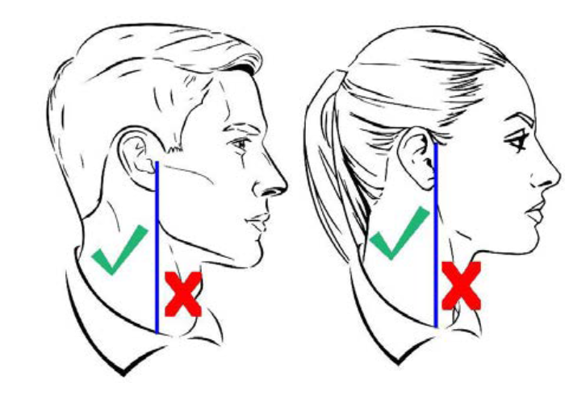
Cosmetic tattooing: Tattooing for cosmetic purposes is authorized when directed by licensed, qualified medical personnel to correct a medical condition, illness or injury for both men and women. When not medically directed, cosmetic tattooing is permitted for women if done to apply permanent facial makeup (i.e., eyebrows, eye liner); the cosmetic tattooing must have a natural appearance and be conservative, moderate, within reasonable limits, not excessive or extreme, and in good taste.

- Body Piercing/Ornamentation
  - In uniform with the exception of earrings for women, all members are prohibited from attaching, affixing, or displaying objects, articles, jewelry or ornamentation to or through the ear, nose, tongue, eyebrows, lips, or any exposed body part (includes visible through the uniform).
  - Cadets may NOT cover any of these articles with make-up, band aids, or wearing clear post pins to hide body piercings.
  - Plugs for gauge holes in the ear lobes are NOT authorized (regardless of color, i.e., flesh colored). There are no exceptions per DAFI 36-2903.
  - Dental ornamentation: Teeth, whether natural, capped, or veneered, will not be ornamented with designs, jewels, initials, etc. The use of yellow gold, white gold, or platinum caps (permanent or temporary) merely to add ornamentation to the teeth and not required by dental/medical necessity is prohibited.

F-1 “FEMALE SPECIFIC” CADET GROOMING GUIDELINES (see Figure 3-2, 3-3, and Figure 4 in couple of pages)
  - Hair - Female
    - No minimum hair length, to a maximum bulk of 4” inches from scalp and allows proper wear of headgear. Hair will end above the bottom edge of collar and will not extend below an invisible line drawn parallel to the ground, both front to back and side to side unless pulled back and secured or worn in an authorized ponytail or equivalent or long braid(s).
    - If hair is pulled back and secured behind the head, radius will NOT exceed 6 inches from the point where the hair is gathered (i.e., no more than 6 inches to the left and 6 inches to the right, 12 inches total width; and 6 inches protruding from where hair is gathered) and must allow for proper wear of headgear. One or two braids or a single ponytail or equivalent may be worn down the member’s back with length not extending below a horizontal line running between the top of each sleeve inseam at the under arm through the shoulder blades. The braid(s) or ponytail or equivalent cannot be worn over the shoulder or pulled in front of the body. They shall extend down the member’s back.
c. Pinned-up hair should be styled in a manner that prevents loose ends from extending upward on the head. When hair is in a bun, the bun must be a single bun; all loose ends must be tucked in and secured. When hair is in a ponytail or equivalent, it must be a single ponytail or equivalent that does not extend below a horizontal line running between the top of each sleeve inseam at the under arm through the shoulder blades.
- Bangs, or side-swiped hair, may touch eyebrows but will NOT touch or cover eyes. When in doubt, assess correct length of hair with the cadet standing in the position of attention. Exception: While wearing the Physical Training Gear (PTG), long hair will be secured but may have loose ends and may extend below a horizontal line running between the top of each sleeve inseam at the under arm through the shoulder blades.
- Locs, braids, twists, micro-braids, French braids, Dutch braids and cornrows are authorized. Locs are defined as portions of hair that have been intentionally or unintentionally fused together to form a loc or locs. A braid or twist is two or more portions of interwoven hair. If adding additional hair, it must be a natural-looking color (similar to the individual's hair color) and conservative (moderate, being within reasonable limits; not excessive or extreme). Multiple locs, braids, twists or cornrows may come together down the back in one or two braids or a single ponytail. Hair must not exceed length and bulk standard and headgear must fit properly.
- All locs, braids and twists, when worn will be of uniform dimension, no wider than one inch, with natural spacing between the locs, braids, and twists and must be tightly interwoven to present a neat, professional, and well-groomed appearance. When worn, multiple locs, braids, or twists shall be of uniform dimension, small in diameter (approximately ¼ inches), show no more than ¼ inch of scalp between the locs, braids, or twists and must be tightly interwoven to present a neat, professional appearance.
- A braid/twist must continue to the end of the hair without design and following the contour of the head and may be worn loose or in a secured style within hair standards. Exception: Micro-braids or twists are not required to continue to the end of the hair.
- Unauthorized: Mohawk, mullet or etched design.
  - Hair Accessories - Female
- Hair accessories. If worn, hair accessories (e.g., fabric scrunches, hairpins, combs, clips, headbands, elastic bands, barrettes, etc.) must match hair color. Black hair accessories are authorized regardless of hair color. Invisible hairnets are authorized; hairnet must match hair color. Hair must still comply with bulk and appearance standards. Headgear must fit properly. Headbands or fabric scrunches will not exceed two inches in width. Ornaments are not authorized (i.e., ribbons, beads, jeweled pins).

3. Fingernails – Female
a. If worn by females, nail polish will be a single color that does not detract from the uniform, nor can the nail polish be extreme in color. Some examples of extreme colors include, but are not limited to, purple, gold, blue, black, bright (fire engine) red and florescent colors. Do not apply designs to nails or apply two-tone or multi-tone colors; however, white-tip French manicures are authorized. Fingernails must not exceed ¼ inch in length beyond the tip of the finger and must be clean and well groomed. Fingernails must not interfere with the performance of assigned duties. Fingernails must not hinder proper fit of prescribed safety equipment or uniform items.
- Cosmetics – Female
  - Female Cadets may wear cosmetics; however, if worn, they will be conservative (moderate, being within reasonable limits; not excessive or extreme) and in good taste. Eyelash extensions are authorized, however will be Cadet’s natural eyelash color and will not exceed 14 millimeters in length. Female Cadets will not wear shades of lipstick that detract from the uniform, or that are extreme colors. Some examples of extreme colors include but are not limited to, purple, gold, blue, black, bright (fire-engine) red, and fluorescent colors. Male Cadets are not authorized to wear cosmetics.

F-2 “MALE SPECIFIC” CADET GROOMING GUIDELINES (see Figure 3-1 in couple of pages)
- Hair - Male. Tapered appearance on both sides and the back of the head, both with and without headgear. A tapered appearance is one that when viewed from any angle outlines the member's hair so that it conforms to the shape of the head, curving inward to the natural termination point without eccentric directional flow, twists or spiking. A block-cut is permitted with a tapered appearance. Hair will not exceed 2 ½ inches in bulk, regardless of length and ¼ inch at natural termination point; allowing only closely cut or shaved hair on the back of the neck to touch the collar. Hair will not protrude under the front band of headgear. Cleanly shaven heads, military high-and-tight or flattop cuts are authorized. Prohibited examples (not all-inclusive) are Mohawk, mullet, cornrows, dreadlocks, or etched shapes and/or design. Cadets may have one (cut, clipped or shaved) front to back, straight-line part, not slanted or curved, on either side of their head, above the temple. Part will not exceed 4 inches or ¼ inch width. Men are not authorized hair extensions. See Figure 3.1
- Mustaches
  - Male Cadets may have mustaches; however, they will be conservative (moderate, being within reasonable limits; not excessive or extreme) and will not extend downward beyond the lip line of the upper lip or extend sideways beyond a vertical line drawn upward from both corners of the mouth.
- Beards
- Beards are NOT authorized unless for medical reasons, when authorized by a medical official, or as authorized pursuant to a request for a religious accommodation. Beard wear authorized for religious reasons are governed by AFJROTCI 36-2010. When authorized for medical reasons, members will keep all facial hair trimmed not to exceed ¼ inch in length. Individuals granted a shaving profile may shave or trim their facial hair to present a neat, clean, professional image.
- Sideburns
- If worn, sideburns will be straight and even width (not flared) and will not extend below the bottom of the orifice of the ear opening. Sideburns will end in a clean-shaven horizontal line.
- Other facial hair: Beside above, any other facial hair is not authorized unless for medical / religious reasons. Cadet must submit medical / religious facial hair waiver request to SASI for authorization. SASI will submit waiver request in WINGS for review by HQ AFJROTC Waiver Review board.
- Fingernails
- Male Cadets are NOT authorized to wear nail polish.
- Cosmetics
- Male Cadets are NOT authorized to wear cosmetics.
- Undergarments (Mandatory)
- Appropriate undergarments are required to be worn with all uniform combinations. Wear undershirt and underpants with all uniforms. Wear the plain white V-neck undershirt when wearing opened collar service uniforms only. Undershirts will be tucked into trousers. Undershirts will not have pockets.
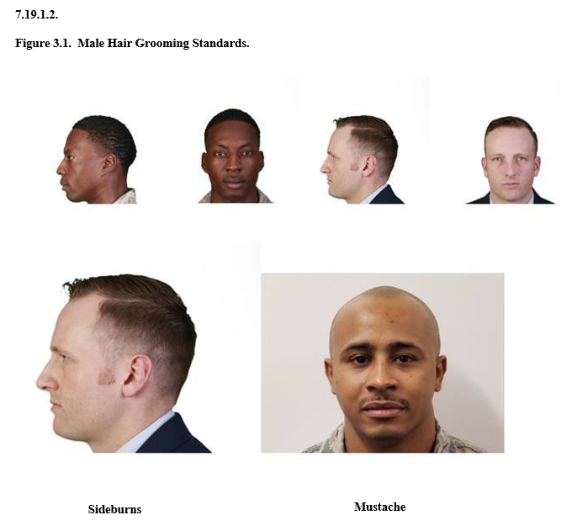

F-3 Jewelry, Eyewear, Electronics, Backpacks (see Figure 3-1 in couple of pages)
- All jewelry
  - While in uniform will be plain and conservative (moderate, being within reasonable limits; not excessive or extreme) as determined by the SASI.
- Watches
a. Must be conservative and only one can be worn around wrist while in uniform. Conservative examples are solid black, brown, silver or gold. Prohibited examples are diamond-covered, neon, bright colors, and band that exceed 1” width.
- Rings
- Cadets may wear a total of no more than three rings; wedding sets count as one ring when worn as a set. Rings will be worn at the base of the finger and may be worn on the thumb.
- Earrings
- Male cadets are not authorized to wear earrings while in uniform or in civilian attire for official duty. Female cadets may wear small (not exceeding six mm in diameter) conservative (moderate, being within reasonable limits; not excessive or extreme) round or square white diamond, gold, white pearl, or silver earrings as a set with any uniform combination. If member has multiple holes, only one set of earrings are authorized to be worn in uniform and will be worn in the lower earlobes. Earrings will match and fit tightly without extending below the earlobe unless the piece extending is the connecting band on clip earrings. When not wearing earrings, male and female cadets are authorized to wear transparent piercing spacer(s) in lower earlobes while in uniform. Transparent spacers are not allowed in ear holes outside of the lower earlobes or any other piercing holes visible in uniform (nose, lip, eyebrow etc). Piercing holes will not be large enough to permit light to shine through.
- Necklaces
- Will not be visible at any time. If worn, will be concealed under a collar undershirt.
- Bracelets
- Ankle bracelets are not authorized. Cadets may wear one bracelet around their wrist. If worn, the bracelet will be conservative (moderate, being within reasonable limits; not excessive or extreme) in design, no wider than ½ inch, gold or silver in color, and will not have any inappropriate pictures or writing. Medical alert/identification bracelets are authorized. If worn, medical alert/identification bracelets will be conservative and moderate. Bracelets will not be excessive or extreme, which is defined as plain, not drawing inappropriate attention. Gemstones/tennis bracelets may only be worn with the mess dress uniform. Bracelets espousing support for cause, philosophy, individual or group are not authorized (Exception: Traditional metal POW/MIA/KIA bracelets, which come in colors besides silver, bronze, or gold, remain authorized). No rubber or fabric type bracelets are allowed.
- Eyeglasses/Sunglasses
- Will be worn in the manner for which they are made. Eyeglasses and sunglasses will not be worn around the neck or on top/back of head or exposed hanging on the uniform. Eyeglasses and sunglasses may have conservative ornamentation on non-prescription sunglasses or eyeglasses, frames may be black or brown material or gold or silver wire. Brand name glasses may be worn with small logo on frames or lenses. Logo may contrast with frame color or lenses (conservative colors/small logos; black, brown, matte silver/gold). Conservative wrap-around sunglasses may be worn. Conservative, clear, slightly tinted, mirrored or photosensitive lenses are authorized. Sunglasses (to include darkened photosensitive lenses) are not authorized in formation. Exception: Sunglasses are not authorized in formation, unless for medical reasons, e.g., PRK/Lasik surgery and when authorized by a SASI or commandant on the advice of a medical official.
- Backpacks
  - Cadets may wear a backpack on the left shoulder or both shoulders (not to interfere with rendering the proper salute).
- Headphone and earphones
  - Wear/use of an earpiece, any blue tooth technology or headphones, while in uniform, indoors or outdoors, is prohibited, unless specifically authorized for the execution of official duties. Exception: Headphones and earphones (iPods, MP3-type players, etc.) are authorized during travel on public transportation i.e., bus, train or air travel.
- Other items
- Wallets, pencils, pens, jewelry, combs, sunglasses, and so forth are not to be exposed from pockets while in uniform. An item may be placed in a pocket if it does not detract from the military image.

OTHER GUIDELINES FOR UNIFORM WEAR & REMINDERS
- Hands in pockets are now allowed while standing or walking (however, try not to do it unless cold).
- Do not consume food while walking in uniform. Beverage consumption is authorized.
- Cadets are permitted to remove service coats within any classroom to avoid binding and wrinkling. It will never be worn unbuttoned. When the service coat is removed in the classroom, it will be carefully draped over the side or back of the chair (ensure will not be dirty first). The service coat will be put on and buttoned before leaving the classroom.
- Replace missing buttons promptly. They may be obtained from logistics officer, ASI or SASI. Buttons may be positioned temporarily with a safety pin until they can be permanently sewn in place.
- Buttons and insignias are made of oxidized silver and are not to be polished.
- Do NOT wear AFJROTC uniforms:
  - While hitchhiking, participating in marches, rallies, or other public demonstrations or disrespectful activities which give an observer an unfavorable impression of the Cadet Corps, Eastern Wayne High School, or the United States Air Force. Keep in mind you represent all these organizations.
  - Seeking employment, working at civilian job, participating in public speeches or interviews, participating in court proceedings.
  - Other than the designated uniform days without prior approval from SASI/ASI. You should wear your uniform directly to school in the morning and directly home in afternoon, unless approved by SASI/ASI.
    - Cadets may wear the uniform to church, wedding, baptisms, funerals, or other special events when approved by the SASI or ASI. The uniform will be worn only from home to school or the site of special event and return directly home.
  - While assigned to In-School Suspension (ISS) (if able unless same day and no change of clothes). It does not reflect a proper military image to be worn in a disciplinary setting.
  - While participating in sporting activities, such as gym. You are expected to dress out for gym. But after gym is over, the cadet will dress back into his/her uniform to wear for the remainder of the day (exception; if gym class is the last block of the day, one is not required to dress into the uniform again).
  - When participating in an activity that will damage the uniform.
  - With civilian attire.
- No vaping, smoking or use of tobacco products on or off school grounds or at JROTC functions or on campus, or while wearing the AFJROTC uniform or AFJROTC T-shirt.
- Bulky objects should be kept out of pockets.
- Keep all buttons buttoned and zippers zipped.
- Never mix military and civilian clothing.
- When not being worn, the garrison cap may be tucked in the belt on either side between the first and second belt loop. Be careful, however, as cadets often lose the cap by carrying it this way (why you put name in it).
- Trim all loose strings off the uniform.
- Note: For dry clean only items, light pressing can be done if a steam iron and wet pressing cloth is used. Never use an iron on the material of uniform directly.
- Prior approval of any hairstyle and/or color, tattoo, or piercing is HIGHLY recommended. AFJROTC determines correctness by comparing to the appropriate Air Force Instruction and can’t deviate from it. Grade and viability in the program could be affected.
- The Air Force uniform represents one of the most respected traditions of our country and must be worn in a manner to honor the heritage it represents. If you don’t want to wear it correctly, then don’t be in the program. It is a voluntary program.

H. SEMI-FORMAL UNIFORM
See attachment 2

I. UNIFORM ENFORCEMENT
a. It is the responsibility of all cadets to make spot corrections when cadets are not wearing the JROTC uniform properly. All corrections will be made in a non-threatening and non-hostile manner. Cadets making corrections should address individuals the way they would like to be spoken to.
b. When making corrections, it should be done in private and as discreetly as possible. Those receiving corrections are encouraged to accept it in the proper spirit. Any cadet who feels he/she has been treated unfairly has the right and duty to report the incident to the SASI/ASI who will investigate the incident. On the other hand, higher-ranking cadets have a responsibility to report non-compliance by cadets to the SASI/ASI.

J. UNIFORM INSPECTION PROCEDURES
PRIMARY: OUTDOORS ON DRILL PAD
- On uniform days, cadets are to be inspected by the Flight Commander or the highest ranking
cadet present in the classroom.
- After attendance procedures have concluded, the Flight Commander is to obtain an inspection
form from the ASI/SASI. The Flight Commander must confirm that the names of all cadets in
his or her flight are present on the inspection form.
- The Flight Commander will announce “Prepare for Inspection” and allow the flight a
prescribed amount of time to correct any discrepancies prior to inspection. Use the mirror and do buddy checks. The Flight Commander or First Sergeant will then direct the flight to go to the drill pad if the weather allows. Flight will march out to drill pad by Elements.
- He or she will then command the flight to “Fall In” on the drill pad.
- The Flight Commander and the Flight Sergeant will stand at the front of the flight after the
flights falls in. The Flight Commander will give the command “Open Ranks March”. On the
command “March”, the fourth element stands fast and automatically executes dress right dress.
The third element takes one pace forward and executes dress right dress. The second element
takes two paces forward and executes dress right dress. The first element takes three paces
forward and executes dress right dress.
- The Flight Commander will then check the alignment of the flight by marching on the right
flank to each of the element leaders using proper pivoting motions. He or she will then perform a
“Right Face” and check the element’s alignment. If the alignment of the elements is incorrect,
the Flight Commander will command “Element _____. Dress Right, Dress.” After checking the
alignment of the flight, the Flight Commander will march to the front of the flight and command
“Ready Front.” He or she will then command “Elements Two, Three, and Four, Parade Rest.”
- The Flight Commander will march to the element leader of the first element and begin
inspections. The Flight Sergeant will march on the left side of the Flight Commander and mark
discrepancies on the provided uniform inspection form as the Flight Commander calls them out.
- The Flight Commander will identify discrepancies on the front side of the cadet and then
command the cadet to do an “About Face” to identify discrepancies on the rear side of the cadet.
He or she will then command the cadet to do another “About Face” and then move to the right to
inspect the next cadet in the element.
- After the Flight Commander inspects an entire element and moves on to the next one, the
Element Leader will command “Element _____, Parade Rest.” When the Flight Commander has
inspected the entire flight, he or she will march to the front of the flight with the Flight Sergeant
and command “Flight, Attention” followed by “Fall Out.” The cadets are then required to return to the classroom in an orderly fashion.

SECONDARY: IN CLASSROOM
Will be conducted in front of classroom, one Element at a time. Elements waiting to be inspected will be at Parade Rest by assigned seats. Once Element complete with inspection, Element will march back to seat and be commanded to Parade Rest. Detailed procedure will be briefed, and policy put in place

CHAPTER 8: WELLNESS/PT PROGRAM

A. OBJECTIVe & PREREQUISITES
Wellness is a mandated portion of the AFJROTC program. Failure to participate in the program will make you ineligible for the JROTC Program or may result in disenrollment (see Chapter ). The objective is to motivate cadets to lead active, healthy, lifestyles beyond the program requirements and into their adult lives. Before participating in the AFJROTC Wellness program or performing assessment, all cadets are required to complete the Parental Participation Consent Form with Health Screening Questionnaire. IAW, AFJROTC Instruction 36-2010, “the principal and SASI will ensure appropriate fitness of cadets to successfully participate in the AFJROTC curriculum.” Prior to conducting the unit Wellness Program, the Wellness/PT officer (SASI/ASI) will conduct and loas the cadet Physical Fitness Test (PFT) initial assessments into WINGS within the first 45 calendar days of school to determine each cadet’s fitness level.

B. IMPORTANCE
Cadets are encouraged to participate in a personal physical fitness program to help maintain their physical and mental well-being. Physical fitness is maintained through exercise and diet. Diet is just as important because eating the right foods is the key to controlling your weight. A balanced diet is one that provides the body with all the required nutrients in the right amounts. Cadets should try to exercise independently at least 3 times per week.

C. Cadet Corps WELLNESS/pt day
Friday is the designated physical training (PT) day for the JROTC program unless weather forecast and/or other reasons dictate a move to a different day. This will be coordinated in advance and ample reminders will be given to cadets. For Cadet Corps PT Day, cadets are required to wear the issued PT uniform. The issued PT uniform consists of blue/gold NC-804 athletic shorts, T-shirt, sweats and sweatshirt. Cadets can pick the top and bottom based on weather, however if wear sweats and get hot, must have issued short and T-Shirt underneath.
PT uniform: The PT T-shirt can be tucked or untucked into shorts at all times. PT undershirts, short and long-sleeved solid white, black or light gray form fitting undershirts, (i.e. Spandex, Lycra™ or elastic material) may be worn and visible under the short-sleeved PT shirt. Undershirt must be tucked in. There is no color restriction on the form fitting undershirt; undershirt may have visible small trademark logo. The PT shorts waistband will rest at or within two inches of the natural waistline. Socks are mandatory. Socks will be white or black and may have small trademark logos. Athletic style shoes are mandatory. There are no restrictions on the color of athletic shoes. Headgear: The SASI may authorize wear of an optional solid color, that is conservative and in good taste, baseball/sport cap with the PT uniform. If authorized, caps are to be worn outdoors only and cadet officer rank will be worn. Enlisted cadets will not have any rank on their headgear.
Failure to participate or wear issued PT uniform will lower one’s grade as outlined in Chapter 5. Failure to participate without an approved reason (i.e. medical); will result in following actions below, much like failure to wear the uniform in Chapter 7. Note: If cadet can’t participate in exercise due to sickness or pain, he/she will be set to the school nurse (if available) or to office to call parent/guardian. If this is a repeat occurrence, will call parent/guardian to discuss. Safety is primary consideration in program.
1. WARNING: Cadets failing to participate in PT (i.e. don’t want to or didn’t bring athletic shoes) without a valid medical reason or note approved by SASI/ASI, will receive a 50% or 0% grade for that day (depending on uniform and shoes). The first time this happens in a semester, the cadet will be counseled, and documentation will be sent home for a parent/guardian to sign. The second time this happens in a semester, the cadet will be counseled, documentation will be sent to the school administrators and home for a parent/guardian to sign. Parent/guardian will also be contacted. The third time this happens in a semester, disenrollment will begin IAW Chapter 1.
2. If you are absent on PT day or present and unable to do anything, you must write a 1-page report on a wellness topic within 24 hours to receive wellness credit for the week. Cadets absent are responsible to turn in the first day back, or 0% grade will be recorded.
3. Females and males are to remove all jewelry prior to exercises including but not limited to; dangly earrings, necklaces, and bracelets, rings are not to be on the person. Safety is a primary concern.

4. Bad attitude may result in 0% grade for day and other consequences.

d. CADET Physical Fitness Test (PFT)
As mandated by Air Force, prior to conducting the unit Wellness Program, a mandatory Cadet PFT initial assessment will be performed to determine each cadet’s fitness level. The PFT consists of push-ups, sit-ups, v-sit reach, the shuttle run and a 1-mile run. Assessment results will be recorded for Air Force no later than 45th calendar days into school semester. Additionally, a PFT final assessment will be performed NLT 30 calendar before end of semester/school year to determine cadet’s overall improvement (cadets who will complete both semesters may defer their final PFT assessment to the end of the second semester.) Cadets are to show improvement over the course of the year. Participation is part of academic grade and results play part in Honor Flight competition. Score will be based on the number of items completed and the mile run time. Cadets should not wait until test time to get in shape. You must start well in advance to do your best during the testing.

e. uNIT WELLNESS Program
The Wellness Officer on cadet staff is in charge of the Unit Wellness Program and planning detailed PT schedule of events each week (posted by Wednesday). These “wellness scripts” will be passed to trained Flight Wellness Representatives who will be chosen in every flight. The Flight Wellness Representative will conduct weekly wellness events/workouts as directed unless given opportunity to execute Flight choice for week. The Flight Wellness Representative is in charge of executing the flight wellness/PT day and directing cadets. They are responsible for recording all scores and are to give each and every cadet score to the Wellness Office on Staff.
Cadets participating in the wellness Program/Unit Fitness Program will be awarded a ribbon. For each additional year of participation, they will receive an oak leaf cluster to be placed on the initial ribbon. A second ribbon, with accoutrements, will be awarded if a cadet wants to be tested on the 4 core exercises (1-mile run, push-ups, sit-ups, and v sit reach). Based on their score they can earn the bronze, silver, or gold star. The stars will be placed on the second ribbon as they are earned; however, only one star per year may be awarded. There is no timeline to test the cadet for this portion of the wellness program.

CHAPTER 9: the Cadet cORPS

- GENERAL: All cadets enrolled in AFJROTC are essential members of the cadet corps. The Eastern Wayne High School AFJROTC is designed North Carolina 804 (NC-804). This means we were the 4th unit created in North Carolina in 1980. The cadet corps is structured along the lines of an active Air Force unit. The overall unit is designated a Group. The Group is divided into three Squadrons (Operations Squadron, Mission Support Squadron, and Special Teams Squadron). Each class period is a Flight in the Operations Squadron (large classes may be divided into two Flights). Each flight is further divided into two or more elements. Each level of organization has specified leadership and staff positions. Each leadership and staff position has a maximum rank authorized (Chapter 12). The general rule is: the higher the rank, the more responsibilities and authority the cadet has--and the more accountable the cadet is.

- GOAL: The goal of the Group is a cadet corps that is governed, cadet owned and led by the cadets at all levels. That means cadets must gain the required knowledge, experience, self-discipline, motivation, maturity, and work ethic to plan, organize and execute all cadet activities.

- Organizational Chart: The organizational chart below reflects how the NC-804 AFJROTC Group is organized. This organization breaks down the functions of the Group into specialized tasks. The responsibilities associated with these tasks are defined in detail in the following pages. To gain a more complete understanding of how the various functions relate to the total function or mission of the Group, cadets should familiarize themselves with all the job descriptions (Chapter 11) as they relate to the organizational chart.

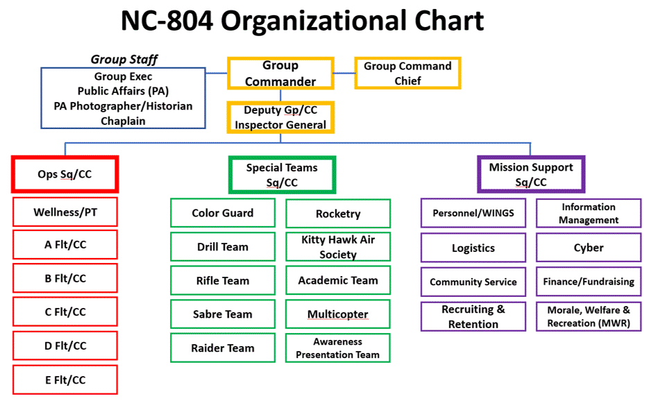
- To progress up this “chain of command”, each cadet should strive to learn the duties and responsibilities of each position on the chart. If you are selected for a leadership position, fulfill that position to the best of your ability and there will be room for you to move “up” the chain of command.

- Examination of the organizational chart demonstrates not everyone can be a leader at the same time. A system exists (the promotion system) to ensure cadet leadership roles are chosen carefully. Information relative to promotions is spelled out in detail in Chapter 12.

- Chain of Command: The Air Force (and generally speaking, American business and society) has a hierarchical structure. That means the people in positions of leadership and at higher staff levels have more rank, power, and responsibility than individuals at lower levels of the organization. Age and school class-level does not have priority in a military structure, only rank and time in ROTC. Therefore, cadets are expected to pay proper respect to higher-ranking cadet officers and enlisted personnel. A closer examination of the chart above shows a “Chain of Command” reflected by the black lines connecting the cadet functions or positions. In any organization, it is necessary to assign responsibility and authority to some members to ensure that all the organization’s goals are met. At the top of our local chain of command is this school principal. Below the principal are the Instructor (SASI/ASI), followed by the cadet staff, flight commanders, and noncommissioned cadet officers (NCOs). Cadet Officers and Cadet NCOs are given the amount of authority to perform their primary duties and to assist the instructors in maintaining discipline.
  - Information, guidance and decisions should flow “down” through all intermediate levels of the chain of command in the form of orders, either oral or written. Information, advice and recommendations should flow “up” the chain of command through all intermediate levels of command. Moreover, there is a lateral flow of information between staff elements. Unless there is this flow of information “up”, “down” and “across” the chain of command, the organization will quickly become ineffective and cease to function as a unit. Keep this in mind as you strive to complete your duties and responsibilities
  - Some cardinal rules about operating in a military environment are:
a. Always follow the orders of a higher-ranking cadet unless the order violates the law or customary ethical and moral standards.
b. If a cadet disagrees with an order, he/she should carry it out and then take the issue up with an instructor.
c. Never be disrespectful to a higher-ranking cadet.
d. Higher-ranking cadets will never abuse their authority. When giving an order, the order must not violate legal, ethical, or moral standards. Orders must be related to AFJROTC and must be official, not personal in nature. In other words, cadets must use their authority only in the realm of AFJROTC business and affairs, not for personal gain or to boost their ego. Increased rank (power) translates to more responsibility and accountability. Abuse of authority is a serious offense and will result in loss of rank and position and possible disciplinary action by school administration.

  - AFJROTC CHAIN OF COMMAND:
- President of the United States (Commander-in-Chief)
- Secretary of Defense
- Secretary of the Air Force
- Chief of Staff of the Air Force
- Commander, Air Education and Training Command
- Commander, Air University
- Commander, Air Force Officer Accessions and Training
- Commander, Air Force Reserve Officer Training Corps
- Commander, Air Force Junior ROTC
- Regional Director, HQ Air Force Junior ROTC
- Principal, Eastern Wayne High School
- Senior Aerospace Science Instructor
- Aerospace Science Instructor
- NC-804 EWHS Cadet Squadron Commander and Staff
- Flight Commander or Deputy
- Flight Sergeant
- Element Leader
- Cadet
  - Note: A cadet may also have additional chains of command within the cadet corps. For example, a cadet in the Mission Support Squadron reports to the Mission Support Sq/CC for his functional duties. Also, a Drill Team member reports to the Drill Team Commander for matters related to the Drill Team.

Guide For Cadet Leaders
This guide is designed to assist you, the cadet leader, in accomplishing your mission. Leadership is not an inherent characteristic, rather, it is something that can be learned providing YOU are willing to come to terms with yourself and the mission. By utilizing the leadership techniques listed below, you will be able to accomplish your mission effectively and efficiently, as well as maximize achievement of organizational goals and objectives.

1. Unity of Command: Within the command structure, or any level of command, there can be only one commander. Commanders are responsible for everything their unit does or does not do. The commander’s responsibilities are matched by the authority necessary to carry out his/her mission. Commanders can delegate authority to complete a task, but they are ultimately still responsible/accountable for task completion.

2. Span of Control: One commander can only effectively control a given number of subordinates. Normally, the minimum is three subordinates and the maximum is seven. The ideal span of control is five subordinates.

3. Chain of Command: The succession of leaders through which command is exercised is called the chain-of-command. It enables commanders to retain unity of command within the maximum span of control. The Group Commander assigns tasks to the Squadron Commanders, who in turn delegate specific duties and responsibilities to their subordinate officers and NCOs.

4. Staff Authority and Responsibility: The unit staff consists of those officers and noncommissioned officers who assist the commander in the exercise of his/her command. They are advisors only within the specific area assigned to them by the commander. Staff officers will keep the commander informed on matters within their specific areas of responsibility which may require his/her attention.

CHAPTER 10: nc-804 job descriptions
Similar to the active duty Air Force, responsibilities and duties increase with an increase in rank. Cadets are expected to be capable of assuming the duties and responsibilities of the position to which they are appointed. The following job descriptions define the major elements of each command and staff position:

The Group Commander (GP/CC) is responsible for:
- Command and control of the Corps, and establishment and maintenance of a high degree of
esprit-de-corps using members of his/her staff and subordinate commanders.
- Ensuring professional appearance, discipline, effectiveness, training, and conduct of the Corps meet all AFJROTC standards.
- Leading the cadet corps to identify, establish, track and fulfill cadet corps goals.
  - These goals must meet (hopefully exceed) Air Force requirements.
- Overseeing the cadet staff to ensure all staff members are performing their duties in a satisfactory manner.
  - Ensuring cadets receive timely and accurate feedback and counseling (if required) which is properly administered and documented and routed.
  - Ensuring all members of the cadet corps have the opportunity to develop leadership commensurate with their individual abilities and effort.
- Ensuring recognition programs are operational to identify and reward great cadets.
- Planning and coordinating all group activities, facilities, and resources.
- Developing, maintaining and presenting the NC-804 mission briefing as required
- Conducting staff meetings-minimum of one per month.
- Coordinating with and/or assisting the SASI or ASI as required.
  - Immediately inform the SASI/ASI of any cadet who is injured or is seriously ill.
  - Immediately informing the SASI/ASI of any incident involving a cadet that could discredit or embarrass the AFJROTC program.
- Training one or more cadets on the responsibilities of the position and creating a continuity folder to help the replacement with the job the following year.
  - Establishing goals for your positions within two weeks.

The Group Commander (GP/CD) is responsible for:
- Commanding the group during absence of the Cadet Group Commander.
- Ensuring professional appearance, discipline, effectiveness, training, and conduct of the Corps meet all AFJROTC standards.
- Assist the commander to identify, establish, and track cadet corps goals.
  - Track group goals and present progress to group staff each nine-week period.
- Assisting the Group Commander as required and supervising the cadet staff.
  - Identifying and establish goals to be attained by the staff, subordinate leaders and members of the unit.
- Convening cadet boards and staff meetings as necessary.
- Managing the officer promotion system
- Coordinating with and/or assisting the SASI or ASI as required.
- As Inspector General (IG)
  - Ensures group is standardized and adheres to all AFJROTC and school regulations and procedures.
  - Ensures weekly uniform inspection procedures and grading are standardized with all cadets and inspectors properly trained
    - In a timely manner, posts results, identifies trends and formulates plan to diminish all negatives
  - Serves as the primary project officer for all Unit Evaluations (UE).
  - Conducts a UE self-inspection of the cadet corps once at halfway period of academic year and briefs results to cadet staff and SASI/ASI.
  - Ensure all continuity books are appropriate and up-to-date.
  - Open lines of communication between cadet corps and senior staff
- Coordinating with and/or assisting the SASI or ASI as required.
- Administering unit activities according to Air Force principles and procedures.
- Training one or more cadets on the responsibilities of the position and creating a continuity folder to help the replacement with the job the following year.
  - Establishing goals for your positions within two weeks.

The Command Chief (CCM) is responsible for:
- Directly supporting the Group Commander in the conduct of corps activities
- Ensuring the professional appearance, discipline, efficiency, training and conduct of the cadet enlisted Corps.
- Providing recommendations to the Group Commander based on inputs from lower class cadets and acting as a liaison between the corps and group staff.
- Advising the Group Commander on problems with the corps and suggesting possible solutions.
- Ensuring recognition programs are operational to identify and reward great cadets.
- Managing and administering the Merit/Demerit Program
- Managing the enlisted promotion system
- Performing other duties as assigned by the Group Commander.
- Training one or more cadets on the responsibilities of the position and creating a continuity folder to help the replacement with the job the following year.
  - Establishing goals for the position within two weeks of assuming the position.

Group Support Staff

The Public Affairs Officer is responsible for:
- Establishing an active and meaningful Public Affairs program.
  - Establishes Public Affairs goals/metrics for staff members to attain
  - Overseas and supervises the Public Affairs Photo/Historian
  - Ensure cadet activities and individual cadet accomplishments are recognized through school and local media sources
    - Submit the squadron script and pictures to the school yearbook staff
      - Ensures yearbook coverage reflects a thorough, professional and accurate portrayal of cadet group activities
    - Publicize AFJROTC activities and accomplishments on Channel One and in local newspapers.
  - Publish a cadet newsletter at least once a semester.
  - Ensure newsworthy activities and events are forwarded to AFJROTC HQ for publication in the “Air Force Junior ROTC Newsletter.”
  - Use photos and videos to document cadet activities. This should be completed by 1 Dec (for 1st semester) and 30 days prior to annual awards ceremony
    - Record the current history of the unit using photos and video tape.
      - Should be organized and accessible on staff computer(s)
    - Provide pictures for bulletin boards, newspaper articles, and television spots
  - Creating announcements to give summary of upcoming events.
  - Updating various social media outlets to advertise corps accomplishments.
- Performing other duties as assigned by the GP/CC.
- Training one or more cadets on the responsibilities of the position and creating a continuity folder to help the replacement with the job the following year.
  - Establishing goals for the position within two weeks of assuming the position.

The Public Affairs Photographer/Historian is responsible for:
- Assists the Public Affairs in all duties & responsibilities
- Categorizes/logs all AFJROTC events into a database used to build cadet resumes Example: “AFJROTC Cadets assisted in providing hydration, nutrition and support to over 1,200 marathon participants in an event supporting the Raleigh Children’s Hospital”
- Creating/maintaining the “End of Year” video presented at Annual Awards Banquet
- With help of Recruiting Officer, creates and maintains the unit “recruiting” video
- Creates and maintains a legacy wall
- Gives historical presentations to flights to support cadet operations and activities
- Training one or more cadets on the responsibilities of the position and creating a continuity folder to help the replacement with the job the following year.
  - Establishing goals for the position within two weeks of assuming the position.

- Flight Public Affairs Technicians will:
  - Submit photos, videos, and scripts to Public Affairs for all flight activities and accomplishments to be used for newsletters, website, scrapbooks, school yearbooks, Channel One, local newspaper publicity, etc. They will be responsible to the PA Officer for maintaining current photos for the cadet bulletin board.

The Executive Officer is responsible for:
- Maintains and updates the Master Tasking List (MTL)
  - Posts the MTL on the classroom info board
- Assisting the Group Commander with administrative functions
- Maintains/publishes meeting minutes from Command and General staff meetings
- Performing other duties/assignments as assigned by the GP/CC.
- Training one or more cadets on the responsibilities of the position and creating a continuity folder to help the replacement with the job the following year.
  - Establishing goals for the position within two weeks of assuming the position.

The Group Chaplain is responsible for:
- Representing the group at all formal functions and present the invocation and benediction as appropriate
- Maintain liaison with the school and other religious organizations to ensure cadets are aware of healthy activities in the community
- Advise the GP/CC, SASI, and ASI of the health, morale and welfare of the cadet squadron.
- Notify the GP/CC and ASI of cadets who are in the need of personal counseling.
  - Assist the ASI and GP/CC in counseling cadets as needed.
- Manage cadet projects that concentrate on giving to “those less fortunate.”
- Plan, coordinate, and supervise the end-of-year squadron picnic.
- Performing other duties as assigned by the GP/CC.
- Training one or more cadets on the responsibilities of the position and creating a continuity folder to help the replacement with the job the following year.
  - Establishing goals for the position within two weeks of assuming the position.

Mission Support Squadron

The Mission Support Squadron Commander (MSS/CC) is responsible for:
- Ensuring the professional appearance, discipline, efficiency, training and conduct of cadets in mission support squadron
- Ensuring desirable operational status of the entire Mission Support Squadron. Ensures:
  - Entire squadron is trained and knows and adheres to all AFJROTC regulations and procedures.
  - All squadron tasks are completed on time and to high standard.
  - Effective communication and routing procedures are in place and properly utilized.
  - Functional areas have detailed and effective Operating Procedures in place
- Resolving any issues that may arise regarding individuals and tasks performed within the Mission Support Squadron.
- Supervising subordinates.
  - Ensures subordinates receive timely and accurate feedback and counseling (if required) which is properly documented and routed.
  - Holds periodic meetings to ensure actions are being taken to accomplish all taskings and conduct training.
- Effectively highlighting all individual/group accomplishments.
- Assisting the Group Commander/Deputy Group Commander/ASI/SASI as necessary.
- Training one or more cadets on the responsibilities of the position and creating a continuity folder to help the replacement with the job the following year.
  - Establishing goals for the position within two weeks of assuming the position.

The Personnel/WINGS Officer is responsible for:
- Organizing and accurately maintaining all cadet personnel records (both in and outside of WINGS).
  - Ensures records are kept secure and each cadet reviews and verifies his/her records at least once per quarter.
  - Promptly posts all applicable paperwork into cadets’ personnel files
- Becoming the cadet corps expert on WINGS
  - Ensures cadets requiring access to WINGS have access and are properly trained to use it
- Accurately entering all cadet corps events into WINGS in a timely manner as required by AFJROTC (within one week).
  - Trains and ensures cadets accurately fill out event forms
  - Keeps accurate track of current community service hours
- Communicating with other cadet leaders to ensure all cadets have proper rank, badges, ribbons, etc.
- Ensuring all staff job descriptions are current and accurate
- Maintaining the Unit Manning Document (UMD)
- Keeps organizational chart current
- Training one or more cadets on the responsibilities of the position and creating a continuity folder to help the replacement with the job the following year.
  - Establishing goals for the position within two weeks of assuming the position.

The Logistics Officer is responsible for:
- Organizing, accurately maintaining and operating cadet supply rooms and property in accordance with AFJROTC policies and procedures.
  - Must know all AFJROTC regulations that pertain to logistics.
  - Responsible for the issue, turn-in, inventory, and maintenance of accountable and non-accountable property utilizing WINGS.
  - Maintain order receipt log and keep receipts through academic year—update constantly.
  - Maintain security of both logistics rooms and ensure only authorized personnel have access
  - Ensure the supply area is always kept clean, neat, and orderly
  - Conduct and record accurate inventory counts as directed
  - Forward thinking to ensure logistic ready for future demands or needs
- Developing, maintaining and adhering to local logistics Operation Procedures
- Being expert in WINGS as pertains to logistics
- Ensuring other logistic officers/technicians are properly trained and logistics team communicates and works as a team
- Training one or more cadets on the responsibilities of the position and creating a continuity folder to help the replacement with the job the following year.
  - Establishing goals for the position within two weeks of assuming the position.

The Community Service Officer is responsible for:
- Helping to determine and fulfill cadet corps goals pertaining to community service
- Determining best ways the cadet corps can serve the school and community given limited time and resources and competing mission priorities.
- Planning, organizing, coordinating and executing Group community service projects to meet/exceed goals
  - Develop a community service plan in advance
  - Coordinate/work with group leadership and Instructors well in advance to establish event dates
- Promoting flight, club and team service projects and joint efforts with other school organizations
- Keeping community service hours updated on bulletin board.
- Training one or more cadets on the responsibilities of the position and creating a continuity folder to help the replacement with the job the following year.
  - Establishing goals for the position within two weeks of assuming the position.

The Cyber Officer is responsible for:
- Maintaining all staff, logistic, and classroom computer equipment (to include printers).
  - Will notify Instructors of any problems ASAP
  - Will work with school to get school computers fixed
  - Will ensure procedures and rules are in place to minimize risk of computer threats
  - Will keep track of supplies related to computer operations (paper, ink, projector bulbs, etc.)
- Setting up computer equipment for any events (staff meeting, etc.)
- Maintaining and updating the cadet corps website (except calendar and announcements)
- Training one or more cadets on the responsibilities of the position and creating a continuity folder to help the replacement with the job the following year.
  - Establishing goals for the position within two weeks of assuming the position.

The Information Management Officer is responsible for:
- Managing the flow of information in the squadron
  - Keeping the Group Calendar updated and brief at staff meetings
  - Ensure announcements on website are current, complete, and ready to be announced daily
  - Record, maintain and post minutes of cadet staff meetings
  - Acts as the primary maintainer of the social media “Remind” application that updates all cadets via text messaging on upcoming events and other pertinent information
- Training one or more cadets on the responsibilities of the position and creating a continuity folder to help the replacement with the job the following year.
- Establishing goals for the position within two weeks of assuming the position.

The Recruiting and Retention Officer is responsible for:
- Working with cadet leadership and instructors to develop a strong and vibrant yearly recruiting and retention plan
- Establish recruiting goals/metrics
- Recommend ways cadets can be active, visible and lead the school (to include feeder schools)
  - Work with commanders and pertinent staff personnel (i.e. Public Affairs, etc.)
- Determine which activities cadets like and want they want to support and make recommendations to instructors and staff
- Plans, organizes, and executes recruiting events at school and feeder schools before student registration (works with Special Teams Sq/CC to schedule teams)
  - Creates, maintains, and updates all applicable recruiting materials to ensure accurate and useful materials (FAQs, benefits, expectations, etc.) are available to give to potential cadets
    - Ensure website optimized to support recruiting and retention efforts with recruiting information posted
- Training one or more cadets on the responsibilities of the position and creating a continuity folder to help the replacement with the job the following year.
  - Establishing goals for the position within two weeks of assuming the position.

The Finance/Fundraising Officer is responsible for:
- Requesting budget input from the cadet staff and compile a working budget for the cadet corps each semester.
- Planning, coordinating, and supervising all unit fund-raising activities.
- Being the project officer for all fund-raisers.
- Assisting the ASI as required in establishing financial management procedures and in maintaining financial records.
- Helping monitor all budget expenditures/income and monitor all club expenditures.
- Training one or more cadets on the responsibilities of the position and creating a continuity folder to help the replacement with the job the following year.
- Establishing goals for the position within two weeks of assuming the position.

The Morale, Welfare, and Recreation (MWR) Officer is responsible for:
- Boosting the morale and camaraderie within the cadet corps.
- Scheduling, planning, and running all recreational activities.
  - As a minimum have one fun event a quarter.
- Arranging food and drink at recreational activities.
- Training one or more cadets on the responsibilities of the position and creating a continuity folder to help the replacement with the job the following year.
- Establishing goals for the position within two weeks of assuming the position

Operations Squadron

The Cadet Operations Squadron Commander (OPS/CC) is responsible for:
- Ensuring professional appearance, discipline, effectiveness, training and conduct of the Operation Squadron. Ensures:
  - All daily activities are conducted in accordance with current regulations, directives, policies, and procedures. If required, effective operating procedures are developed and utilized.
  - All squadron tasks are completely on time and to required standard.
  - Effective communication and routing procedures are in place and properly utilized.
- Supervising Flight Commanders, Wellness Officer, and Rockery Commander.
  - Ensures subordinates receive timely and accurate feedback and counseling (if required) which is properly documented and routed.
  - Holds periodic meetings to ensure actions are being taken to accomplish all taskings and conduct training.
- Effectively highlighting all individual/group accomplishments.
- Assisting the Group Commander/Deputy Group Commander/ASI/SASI as necessary.
- Training one or more cadets on the responsibilities of the position and creating a continuity folder to help the replacement with the job the following year.
  - Establishing goals for the position within two weeks of assuming the position.

The Wellness/PT Officer is responsible for:
- Planning, organizing, coordinating, and executing the unit wellness/PT program. This program includes:
  - Weekly PT, team sports, flight competitions, field days, etc.
    - Inform Flight PT Techs of planned activities for weekly PT sessions NLT one day prior
  - Scheduling and executing a minimum of two PFTs per year IAW AFJROTC guidance
    - Log data in WINGS and keep WINGS updated at all times.
    - Maintain records for each cadet on the PFT and run Mass assessments in WINGS
  - Updating the PT Board
- Maintaining criteria for the Health and Wellness Ribbon under the supervision of the ASI.
- Evaluating cadets for award of the Health and Wellness Ribbon
- Training one or more cadets on the responsibilities of the position and creating a continuity folder to help the replacement with the job the following year.
  - Establishing goals for the position within two weeks of assuming the position.

- Flight Physical Training Technicians will conduct weekly PT sessions for their flights using planned activities received from the Physical Training Officer. They will assist in evaluating all cadets in their flights for the Health and Wellness Ribbon and verify grades for weekly PT based on dress and participation.

The Flight Commander (FLT/CC) is responsible for:
- Leading and directing the flight at all corps and flight functions.
- Training, disciplining, and motivating cadets in the areas of academics, inspections, drill, service projects, physical training and cadet military appearance and bearing.
- Monitoring the morale of their respective flights.
- Ensuring flight members maintain proper discipline, appearance and conduct.
- Conducting uniform inspections when directed and promptly rectifying discrepancies
  - Track cadet uniform wear and ensure cadets are aware of make-up procedures. Monitor all uniform violations and major write-ups.
- Ensuring flight members are treated fairly and equally in all situations.
- Performing opening and closing procedures; ensuring accurate attendance is taken.
- Assisting and supporting the instructor in all classroom activity.
  - Ensures proper media and materials are distributed to all cadets prior to start of instruction and returned
  - Collecting assignments for SASI/ASI.
  - Ensures cadets who are absent from class receive any handouts, etc. that they missed.
  - Ensures the cleanliness of the ROTC building by assigning and supervising clean-up.
- Ensuring flag is properly raised and lowered each school day as required
- Appointing project managers for flight projects and monitor progress to ensure proper planning, coordination, and execution.
- Providing drill and ceremonies training IAW AFI as directed by the SASI/ASI.
  - You need to be a drill expert
- Ensuring flight members are recognized for outstanding achievement and given credit for participation in unit activities.
- Supervising all cadets in Flight.
  - Ensures subordinates receive timely and accurate feedback and counseling (if required) which is properly documented.
  - notify cadet leadership and SASI/ASI of chronic attitude or behavior challenges
- Ensuring group and squadron goals are being met and promote the AFJROTC mission.
  - Reports directly to Operations Squadron Commander
- Planning, organizing and executing Flight activities (minimum of one per quarter)
- Training one or more cadets on the responsibilities of the position and creating a continuity folder to help the replacement with the job the following year.
  - Establishing goals for the position within two weeks of assuming the position.

The Flight Sergeant is responsible for:
- Commanding flight in the absence of the flight commander.
- Assisting the flight commander in his/her duties and performing other duties assigned by the flight commander.
- Beginning class opening procedures promptly at the tardy bell.
- Taking attendance.
- Assisting the flight commander in maintaining order and discipline in the flight.
- Preparing the flight for inspection.
- Assisting the ASI and flight commander in teaching drill and ceremonies.
- Supporting the instructors, cadet staff and Flight Commander in all matters pertaining to the flight.
- Supervising and monitoring classroom clean-up when assigned by the Commander

The Element Leader is responsible for:
- Wingman check within element for inspection.
- Leading elements in drill and ceremonies.
- Assisting in teaching drill and ceremonies to the element.
- Assisting the flight commander in maintaining high morale, order and discipline.
- Ensuring their cadets are recognized for outstanding performance.
- Ensuring the fair and equal treatment of all cadets under their supervision.
- Handing out or collecting items as directed by Flight Commander or Instructor

Special Teams Squadron

The Special Teams Squadron Commander (STS/CC) is responsible for:
- Ensuring desirable operational status of the Special Teams Squadron by offering consolations and meetings with those positions that fall under this squadron.
- Posting a weekly training approved by SASI/ASI NLT Thursday of the week prior to training
  - Develops a schedule for after school activities that permits member to participate on multiple teams and takes mission priorities into consideration.
- Supervises Team Commanders
  - Ensures subordinates receive timely and accurate feedback and counseling (if required) which is properly documented and routed.
- Effectively highlighting all individual/group accomplishments.
- Finding competition opportunities and ensures all cadets are properly trained and ready to excel
- Finding way to utilize teams to support group recruiting and retention efforts and support goals.
- Training and managing new Special Teams members.
- Resolving any issues that may arise regarding individuals and tasks performed within the Special Teams Squadron.
- Receiving questions and finding/providing answers for all Teams:
- Training one or more cadets on the responsibilities of the position and creating a continuity folder to help the replacement with the job the following year.
  - Establishing goals for the position within two weeks of assuming the position.

The Color Guard Commander is responsible for:
- Plans organizes, coordinates, directs and trains the Color Guard to ensure the Color Guard is highly proficient and prepared for all parades, competitions, assemblies, sporting events, etc.
  - Must be the expert on all matters related to the flag and procedures
  - Works with STS/CC to register and prepare for events/competitions.
- Maintaining a high degree of esprit de corps and discipline within the Color Guard
- Immediately reports any discipline problems to the SASI/ASI through the cadet chain of command; this
includes tardiness and/or absences from practices
- Coordinating with STS/CC to build and post practice schedule and for all competitions/performances
- Scheduling teams to present the colors at all requested school activities, JROTC activities and selected community service events
  - Making sure that at least 4 cadets are present for every Color Guard (unless more required)
- Relaying crucial information to the Color Guard pertaining to the event at which the colors will be presented, uniform wear, permission slips, etc.
- Maintaining and properly caring for Color Guard equipment.
  - An inventory of the Color Guard equipment must occur before and after every practice/event.
  - Follow AFJROTC guidance and local procedure IAW transportation and security
- Keeps up to date attendance records and determines which cadets will be awarded Color Guard ribbon and devices
- Coordinates with the STS/CC and Instructor for purchase of required equipment

The Rifle & Drill Team Commander is responsible for:
- Plans organizes, coordinates, directs and trains the Team to ensure the Team is highly proficient and prepared for all parades, competitions, assemblies, sporting events, etc.
  - Must be the expert on all matters related to drill
  - Works with STS/CC to register and prepare for events/competitions.
- Maintaining a high degree of esprit de corps and discipline within the Team
- Immediately reports any discipline problems to the SASI/ASI through the cadet chain of command; this includes tardiness and/or absences from practices
- Coordinate with STS/CC to build and post practice schedule and for all competitions/performances
- Scheduling teams to perform at all requested school activities, JROTC activities and selected community service events
- Relaying crucial information to the team pertaining to events (uniform wear, permission slips, etc.)
- Maintaining and properly caring for Team equipment.
  - An inventory of the equipment must occur before and after every practice/event.
  - Follow AFJROTC guidance and local procedure IAW transportation and security
- Keeps up to date attendance records and determines which cadets will be awarded Drill Team ribbon and devices
- Coordinates with the STS/CC and Instructor for purchase of required equipment

The Saber Team Commander is responsible for:
- Plans organizes, coordinates, directs and trains the Team to ensure the Team is highly proficient and prepared for all parades, competitions, assemblies, sporting events, etc.
  - Must be the expert on all matters related to drill/saber
  - Works with STS/CC to register and prepare for events/competitions.
- Maintaining a high degree of esprit de corps and discipline within the Team
- Immediately reports any discipline problems to the SASI/ASI through the cadet chain of command; this includes tardiness and/or absences from practices
- Coordinate with STS/CC to build and post practice schedule and for all competitions/performances
- Scheduling teams to perform at all requested school activities, JROTC activities and selected community service events
- Relaying crucial information to the team pertaining to events (uniform wear, permission slips, etc.)
- Maintaining and properly caring for Team equipment.
  - An inventory of the equipment must occur before and after every practice/event.
  - Follow AFJROTC guidance and local procedure IAW transportation and security
- Keeps up to date attendance records and determines which cadets will be awarded Saber Team ribbon and devices
- Coordinates with the STS/CC and Instructor for purchase of required equipment

The Raider Team Commander is responsible for:
- Plans organizes, coordinates, directs and trains the Team to ensure the Team is highly proficient and prepared for all competitions.
  - Develops a work out plan tailor to varying fitness levels
- Maintaining a high degree of esprit de corps and discipline within the Team
- Immediately reports any discipline problems to the SASI/ASI through the cadet chain of command; this includes tardiness and/or absences from practices
- Coordinate with STS/CC to build and post practice schedule and for all competitions
- Relaying crucial information to the team pertaining to events (uniform wear, permission slips, etc.)
- Keeps up to date attendance records and determines which cadets will be awarded Saber Team ribbon and devices
- Coordinates with the STS/CC and Instructor for purchase of required equipment

The Rocketry Club Commander is responsible for:
- Select members each semester under the guidance of the advising instructor.
  - Prepare lesson plans/videos for teaching rocket classes to new students.
- Following the school club rotation schedule, will publicize dates for meetings and launches and prepare meeting passes for the SASI/ASI’s signature and give to each member.
  - In charge of the safety for all rocket launches.
- Ensuring that, through the Logistics Officer and instructor, supplies are available for each meeting and serve as the custodian of the supplies and equipment.
  - Inventory rockets and rocket badges and order rockets/engines/igniters needed for the current year.
- Recording meetings and activities or assign a cadet to be the recorder and turn in records to the STS/CC.
- Ensuring that guidelines are established and followed to allow members of the organization the opportunity to earn the Rocketry Badge each semester.
  - Track test scores and launches for issuance of rocket badges.
- Ensuring the assignments, training, accomplishments and awards pertaining to the members of the organization are properly documented by turning all information in to the Personnel Officer.
- Maintaining a continuity book

The Kitty Hawk Air Society Commander is responsible for:
- Planning, organizing, coordinating and directing all KHAS activities
  - Conducting an efficient and timely induction once a semester.
  - Coordinating with the SASI on all inductions, probations and removal of members from the program.
- Ensuring the KHAS chapter is administered according to the chapter bylaws
- Ensuring certificates are prepared for all active and honorary memberships.
- Maintaining inventory of KHAS badges and requisition badges through the Logistics Officer.
- Creating multiple school/corps service opportunities for KHAS members throughout the year.
  - Completing at least one service project per semester.
- Monitoring supplies needed for conducting Kitty Hawk activities.
- Overseeing initiation procedures of new members each semester, insuring each potential inductee has been assigned a Big Brother or Big Sister and has received the initiation package.
- Assist with recruiting of feeder schools to promote the NC-804 AFJROTC program.

The Academic Team Commander is responsible for:
- Picking team and prepares them to compete in academic competitions (i.e. JLAB)
- Keeping a corps tutoring program operational throughout the school year
- Finding way to help cadets succeed in their academic goals (i.e. ASVAB, SAT, etc.)

The Awareness Presentation Team Commander is responsible for:
- Coordinating trips to middle and elementary schools to make presentations about JROTC, drugs and alcohol safety, and patriotic themes.
- Soliciting cadets and training them for functions and details.
- Coordinating criteria for earning APT Badge.
- Coordinating team presentations with operations commander and SASI/ASIs.
- Directing the recruitment of new cadets into the AFJROTC program.

The Multicopter Club Commander is responsible for:
- Knowing all rules and regulations WRT drones.
- Knowing how to safely and correctly fly and maintain the drone.
- Developing an academic and training program for new members.
- Safety during drone operations.
- Using the drone to support cadet operations and recruitment and retention

CHAPTER 11: PROGRAM OPPORTUNITIES

LDR (Leadership Development Requirements) activities are what help make our cadet corps successful and more like a family. These activities are the “bread and butter” of the AFJROTC programs. LDR activities are AFJROTC-sponsored and school-approved teams and/or committees that normally plan or participate in events conducted outside classroom hours (before school/after school). These activities offer cadets the opportunity to use the knowledge and skills they have learned in class. They add interest and prestige to the program while helping cadets to meet a variety of people, from classmates to members of the community. Cadets who participate in these activities improve their management, team building and leadership skills; gain self-confidence and self-esteem; and earn awards. Each cadet is encouraged to find one or more of these activities that interest him/her and give it his/her all. The following are brief descriptions of the LDRs the NC-804 program offers its cadets. These are subject to change based on the interests and desires of cadets.

Note: All LDR events are planned, organized, and executed by the cadets while being supervised by a AFJROTC Instructor. This is where cadets put their knowledge, experience, human relation skills, and leadership abilities to the test. Instructors supervise, mentor, console and advise.

Special Teams
Note: Teams are groups of cadets that meet on a regular or recurring basis to practice or participate in team-related activities, events, and/or competitions.

- Color Guard: Is a group of select cadets who present and post the Colors at formal and informal events (school and community), compete in drill competitions, and participate in parades. This elite team demonstrates patriotism. Color Guard members wear a white shoulder cord.
- Drill Team: A drill team is typically made up of nine to twelve cadets and a commander who marches outside of the “flight.” Is a formal group of select cadets that join together to polish and refine the complicated skills of regulation military drill. The Drill Team attends local drill competitions, parades, recruiting trips and other extra-curricular activities in order to promote esprit de corps.
  - Exhibition Drill team: Like the drill team, the exhibition drill team has nine to twelve cadets and a commander who may or may not march outside of the flight. However, this team performs a series of usually silent and very complex movements at the drill competitions.
- Rifle Team: A rifle team consists of either six to twelve cadets and a commander who marches outside of the “flight.” This team will also perform at drill competitions, parades, recruiting trips, and school events. Rifle Team members wear a royal blue shoulder cord.
  - Exhibition Rifle Team: This team is set up the same way as the rifle team, however, the rifle movements are usually done on silent commands and are much more difficult (spinning rifles, etc.). A certain deal of strength is required to be on this team, which also marches at drill competitions, parades, recruiting trips, and school events.
- Saber Team: The Saber Team learns the Manual of the Saber and performs duties in activities where the sabers are used. This Team performs at school events (i.e., EWHS Homecoming, Miss EWHS Pageant, Military Ball, EWHS Prom, etc.). Saber Team members wears a red shoulder cord.
- Raider/Fitness Team: The Raider Team promotes physical fitness. They complete challenges and high intensity workout. This program is built to keep you physically and mentally fit as well as push you toward progression. Raider Team members wears a black shoulder cord.
- Parade Team: A big part of our community service in the fall semester is the Goldsboro Veterans Day Parade and Christmas parade. Being a county with a military base (Seymour Johnson Air Force Base) and five JROTC units (Air Force and Army), we want our program to stand out as the best. To accomplish this, plan on attending a few Saturday parade practices before these parades. Do not worry, we will do other things on these days to make these days fun too (cookout, sports, etc.).
- Academic Team: Organized to compete in academic competitions (i.e. JLAB).
- Awareness Presentation Team (APT): A small group of cadets visit our feeder schools and provide positive role models for elementary and middle school students (sometimes high school students when deemed necessary). It is composed of cadets approved by the AFJROTC instructors based on demeanor, verbal abilities, and professional appearance. Although not considered experts, they should be prepared to deliver brief presentations/skits on a topic of current interest that can include, but is not limited to, high school dropouts, drug and alcohol abuse, teenage suicides, peer pressure, bullying, etc. All APT presentations must be cleared and approved by the high school principal. To earn the APT badge the Awareness Presentation Team member must successfully complete at least one service project each semester.

  - Cyberpatriot: The Cyber Team is for those cadets who have an interest in cyber warfare.
  - StellarXplorer: The StellarXplorer competition is an AFA national high school space event designed to introduce youth to science, technology, engineering and mathematics, or STEM careers.
  - Remote Aircraft Team: The RC Club is designed to enhance and promote awareness and knowledge of all aspects of aviation science. Cadets study the science of flight and aerodynamics. They then get to develop their flight skills on a computer flight simulator and with RC planes.
Clubs
- Kitty Hawk Air Society (KHAS): KHAS is a nationally recognized AFJROTC academic honor society. The objectives of KHAS is to promote higher academic standards, to be of service to the school and community, promote self-confidence and initiative, develop leadership abilities, and to encourage academic excellence in high school.
  - Cadets must be offered an invitation to pledge into the KHAS. To be offered an invitation, a cadet must meet the following requirements:
    - Good character
    - The cadet must be an AS-II, AS-III, or AS-IV cadet.
    - The cadet must possess an “A” average in AFJROTC, if the cadet is currently enrolled in an AFJROTC course.
    - The cadet must possess an un-weighted GPA of 3.0 (with no filing grades).
  - Note: These standards must be maintained by the cadet to remain an active member. Induction ceremonies are usually planned for the fall and spring semesters.
- Rocketry Club: The Rocket Club is designed to enhance and promote awareness and knowledge of all aspects of rocketry, and the technology involved. Cadets build, launch and display various types of model rockets and study the associated aerodynamics. Cadets may attend rocket meets to compete and exchange ideas. Cadets who meet all the requirements are presented the Model Rocketry Badge.
- Gaming Club: Play school appropriate games.
- Flying Club: Learn the basic of flight using flight simulator, etc.
- Rogue Club: Basic weight training.
- Multicopter Club: Learn how to fly and operate a quad propeller drone IAW rules and regulations. Learn about aerial drones and aerial photography.
- Chess Club: Learn how to play chess and compete.

Activities
- Community Service: We perform some community service during school hours. However, some events are scheduled on weekends, and cadets are encouraged to volunteer and participate to better the community. The cadet staff schedules service projects with the approval of the SASI/ASI.
- Curriculum in Action (CIA) Trip (aka Field trip): Cadets are eligible for typically one-day CIA trips. CIA trips are normally limited in size so we must be selective about who goes. To be eligible for trips, cadets must have excellent conduct records, wear their uniform properly, have 4 or less unexcused absences, have a passing grade in JROTC, and turn in required forms. Cadets may be required to pay for meals and transportation. Our CIA trips focus on life in the military, aerospace subjects, and self-esteem building activities. A field trip may even include the opportunity to fly on a military aircraft or small Civil Air Patrol aircraft depending on funding and status of programs. In some respects, scope of field trip depends on how well cadets have done at fundraising during the year.
- Fund Raising: The cadet corps needs to raise money to support its many activities. Funds go to defray the costs of such activities as drill meets, the Military Ball, field trips, Annual Awards Banquet, special events, etc.
- Other events/activities: Several activities take place throughout the school year. These include the Military Ball and Awards Banquet in the spring. Also, cadets often plan fun things on some weekend like Capture-the-Flag; Sports Day; movie night; picnic, parades, drill competitions, etc. The program is as fun as you and the cadet corps make it. Cadets are responsible for planning, organizing, coordinating, funding, and/or leading these events. Often this is done with planning committee.
  - Field Meets: Each year cadets participate in a squadron field meet, where they compete against the other flights in the squadron in drill and/or physical fitness events. Cadets also compete against other JROTC units at field meets. Teams are selected based on demonstrated physical fitness ability.
  - Special Project Committees: The Military Ball, Open House, and Field Day are social highlights of the school year. Cadets are needed for design, mail invitations, decorating, arrangement, programs and many other details associated with corps social activities and community service.
  - Public Affairs Staff: A cadet newsletter will be published as a means of keeping all group members and the regular student body advised of corps activities. If you like to type, write articles, draw cartoons, take photos, edit or are interested in journalistic activities and have an eye and ear for what is going on, this activity will be rewarding and fun.
- Recruiting: We are always trying to recruit new cadets who like want to be a part of a program like ours. In the spring, cadets visit each of the middle schools and promote the program. We perform (Color Guard, Drill Team, Rifle Team) and tell students about our program.
- Cadet Summer Leadership Course (CLC): Cadets can attend a week-long summer leadership course sponsored by JROTC. We typically participate in a 6-day CLC at Fayetteville State University during June of each year. CLC emphasize discipline, teamwork, and leadership. Cadets are challenged both physically and mentally. Cadets earn the Leadership School Ribbon upon completion and can attempt to go back again as cadet cadre.
CHAPTER 12: promotionS
Note: This is only a guide and does not address all situations. The SASI will evaluate and approve all unique situations based on the cadet’s own merit.

PHILOSOPHY: The purpose of the Air Force JROTC organizational structure is to provide the means for cadets to:
- Understand the duty, responsibility, and authority that accompany a job, title or rank.
- Practice leadership, management, task accomplishment and personal responsibility in a controlled and supervised environment mirroring the active duty Air Force organizational structure.
- Understand the organization and workings of an Air Force Group and the interrelation of the component organizations within it.
- Every effort will be made to ensure that cadets are selected for leadership positions they want and they are capable of performing in.

CRITERIA: The following criteria will be used in selecting cadets for leadership positions:
- Will the Cadet Corps improve with this cadet holding this position?
- Is the cadet capable of performing in the position (has one been faithful to corps mission?)
- Will the position improve the cadet’s leadership potential?
- Is the cadet available to assume responsibility (school, sports, job, personal, etc.).
- How is cadets grades/citizenship (JROTC & school).
- Involvement – active or passive, is this cadet a team player?
- Class/JROTC rank.
- Performance in other held positions.
- What has the cadet done for the school overall?
- SASI and ASI recommendations based on personal observations in and out of class.

ELIGIBILITY: NC-804 promotions are based on demonstrated maturity and leadership abilities, performance (to include academic), esprit de corps, participation in cadet and school activities. It is earned and is evidence of promotion and standing along cadets. It reflects a cadet’s increase in maturity, ability, and willingness to accept additional leadership responsibility. Promotions can occur throughout the year based on performance and position vacancies. They will be made with the recommendation of the cadet chain of command, concurrence of the ASI’s, and approval of the SASI. Items considered in reviewing cadets for promotion are: academic grades, demonstrated leadership potential; extra and co-curricular activities; motivation and desire for increased responsibility; and the cadet’s performance and acceptance of responsibility.

PERMANENT PROMOTION: Cadets will earn permanent rank according to the number of years of AFJROTC successfully completed. Cadet Airman can be earned and awarded during the first year of AFJROTC. Cadet Airman First Class during the second year, Cadet Senior Airman the third year, and Cadet Staff Sergeant the fourth year. Permanent rank will be awarded based on satisfactory performance and is not absolute.

TEMPORARY PROMOTION: Cadets may also receive a promotion to a temporary grade based on the level of assignment and position with the unit. These are, as the word implies, temporary, and will normally be removed if the cadet is no longer assigned to the position. The SASI may approve an exception to this AFJROTC policy for seniors in good standing who may then retain their “temporary” rank through graduation. Maximum rank authorized is shown in the following table:
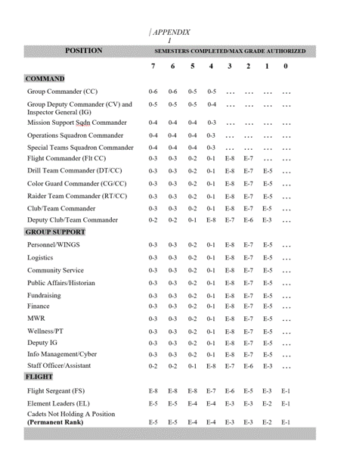

GROUP COMMANDER SELECTION: The SASI and ASI will select the Cadet Group Commander. The Cadet Group Commander will select all other leadership positions with the approval of the SASI/ASI.

NCO AND OFFICER POSITIONS
- Whenever possible, all cadet officer positions will be filled by AS-III and AS-IV cadets.
- Top NCO positions, whenever possible, will be filled by AS-III cadets.
- Exceptions may be made at the discretion of the SASI.

SENIORITY: Eligible AS III or AS IV cadets will be considered for staff positions before eligible ASI or ASII cadets.

ROTATIONS
- Examination of the UMD and Organization Chart will quickly reveal that the number of leadership positions authorized is limited.
- To give every cadet the opportunity to experience an active leadership role, a system of rotation may be employed depending on the size of the cadet corps and worthy candidates within it.
- Rotation may be lateral, i.e. moving to another leadership position with the same grade where the leadership already demonstrated by the cadet will benefit the corps. Or the cadet could be rotated to a lower position or grade (not as a demotion) to permit other cadets to have the opportunity to earn a higher grade.
- Every cadet must understand and cooperate with the rotation system if cadets are going to gain maximum leadership practice.
- Every cadet is asked to give their successor the same degree of loyalty and cooperation they expected and received when they held that position.
- Note: AS-III or AS-IV Seniors who are assigned cadet officer positions and rotated will normally not be reduced in grade.

REDUCTION IN GRADE/DEMOTIONS: Reasons for demotion may range from failing grades, repeated disciplinary problems, or failure to uphold the standard of the corps. Cadets can be recommended for demotion by cadet officers or NCOs or may be demoted on the spot by the Aerospace Science instructors. Recommendations for demotion will be reviewed by a Cadet Evaluation Promotion Board. The SASI will be the final authority on demotions.

REMOVAL FOR DUTIES
- Cadets may be relieved of duty in a particular position at any time by the instructors, and any senior ranking cadet may recommend removal to the instructors. Again, the SASI is the final authority.
- Reasons for removal are the same as for demotion, but may also be voluntary on the part of a cadet who simply asks to be relieved for personal reasons. Additionally, a cadet may be removed from a position if he/she doesn’t adequately perform his/her job or isn’t available due to other priorities.

PROBATION
- A cadet officer who receives a grade lower than a “C” for the current nine weeks in
AFJROTC will be put on probation for the next nine-week period.
- If their grade is not at least a “C” at that time, they will meet a Cadet Evaluation Board.

CADET EVALUATION BOARD
- The responsibility of the Cadet Evaluation Board is to make recommendations concerning
cadet promotions/awards & decorations, disciplinary actions or failure to maintain standards, adverse trends in the group, and other personnel boards that affect the morale of the Group. Recommendations are subject to approval of the SASI/ASI.
- The cadet evaluation board will consist of a board president, members, and a recorder; these
positions will be filled with the following cadets (either the SASI or ASI will be present):
  - President: Group Commander
  - Members: Deputy Group Commander/IG; Squadron Commander(s) of cadet; Flight Commander
  - Recorder: as directed
- Cadets appearing before the board will be notified and will report to the president, in a
military manner, in uniform and at the time and place announced.
- Findings and recommendations will be submitted in writing for signature by the Cadet Group
Commander. The report will be reviewed and endorsed by the SASI/ASI signature.
- The SASI or ASI will sit with the board and will act as an advisor on procedural matters.
- Findings and recommendations of the board, after review and approval of the SASI/ASI, will
be published by special orders and become a part of the Group personnel records.

CHAPTER 13: AFJROTC awards, decorations & badges

People like and expect to be recognized for the work they do. In effect, recognition says, “I know you are there and what you are doing is important to the Eastern Wayne High School Air Force JROTC program. Thanks for your loyalty and effort.”

OBJECTIVE: We know that recognizing people for what they do produces positive effects. This concept is the basis of an effective AFJROTC Awards and Decorations Program. The objectives of the Cadet Awards and Decorations Program are to foster morale, esprit de corps, and recognize achievements of AFJROTC cadets.

GENERAL: The Cadet Awards and Decorations Program fosters morale, esprit de corps, and recognizes achievements of AFJROTC cadets. Cadets can earn ribbons and compete for awards in AFJROTC. Each decoration recognizes outstanding performance in academics, leadership, service and citizenship. The Senior Aerospace Science Instructor (SASI) and Aerospace Science Instructor (ASI) select cadets for awards and decorations (with the input and help of senior cadet leadership). Decorations are presented at appropriate ceremonies during the academic year. All national awards and AFJROTC ribbons that are limited by percentages are presented at the Annual Awards Banquet near the end of the spring semester.

Proper Wear of Badges and Medals: See attachments 1 & 2 for the proper wear of all earned uniform insignias, ranks, badges, etc. Shoulder cords are in Chapter 14. Ribbons will not be worn with medals. Medals may be worn with the service dress uniform for formal and semi-formal occasions of a limited nature (such as dining ins/outs, military ball, change of command ceremonies, awards ceremonies, picture days, or other formal events as specified by the SASI.) Medals may not be worn on regular uniform days. Place medals on the mounting rack in the proper order of precedence (in order of precedence below…1-63).
Special Awards
1. Gold Valor Award. Awards consist of a medal, ribbon, and certificate. The Gold Valor Award recognizes the most outstanding voluntary acts of self-sacrifice and personal bravery by a cadet involving conspicuous risk of life above and beyond the call of duty.

2. Silver Valor Award. Awards consist of a medal, ribbon, and certificate. The Silver Valor Award is awarded to a cadet for a voluntary act of heroism which does not meet the risk-of-life requirements of the Gold Valor Award.

3. Cadet Humanitarian Award. Award consists of a ribbon and certificate. It is intended to recognize cadets who provide aid in response to a singular extraordinary event such as a natural disaster or other catastrophe that has placed or has the potential to place a hardship on their fellow citizens. This award is not to be used to recognize day-to-day service in the community.

4. Silver Star Community Service with Excellence Award. Award consists of a ribbon with silver star device and certificate. The Silver Star Community Service with Excellence Award will be an honor that emphasizes the value of community service, and establishes a greater sense of pride within the corps.
- The award will be given to cadets in the Top 5% of units (approximately 45 units) who have the highest "per cadet average" community service hours.

5. Community Service with Excellence Award. Award consists of a ribbon and certificate. It is intended to recognize those individual cadets who provide significant leadership in the planning, organizing, directing, and executing of a major unit community service project that greatly benefit the local community. This is not an award given to participants but to the key leader(s) of the project.

National-level Awards
6. Air Force Association (AFA) Award. This AFA-sponsored award is presented annually to the outstanding third-year cadet (in a 4-year program). The award recipient must possess/meet the following personal characteristics and eligibility criteria:
- Top 1% of the cadets in the following areas: academics, leadership, and professionalism.
- Positive attitude (toward AFJROTC and school).
- Outstanding personal appearance (uniform and grooming).
- Display personal attributes such as initiative, judgment, and self-confidence.
- Courteous demeanor (promptness, obedience, and respect for customs).

7. Daedalian Award. The Order of Daedalians is a fraternity of commissioned pilots from all military services. It is named after the legendary figure, Daedalus, and was organized by WWI military pilots who sought to perpetuate the spirit of patriotism, love of country, and the high ideals of self-sacrifice which place service to the nation above personal safety and position. This award is offered to encourage the development of these traits in cadets and to interest them in a military career. The medal is fashioned after an ancient Grecian plaque discovered by a Daedalian in the village of Lavadia, Greece and depicts Daedalus and his son Icarus fabricating their legendary wings of wax and feathers.
This annual award recognizes one outstanding third-year cadet at each unit that meets the following criteria:
- Demonstrate an understanding and appreciation of patriotism, love of country, and service to the nation.
- Indicate the potential and desire to pursue a military career.
- Rank in the top 10% of their AFJROTC class.
- Rank in the top 20% of their school class.

8. Daughters of the American Revolution (DAR) Award. This award is presented annually to one fourth- year cadet (in a 4-year program) that meets the following criteria:
- Rank in the top 25% of their AFJROTC class.
- Rank in the top 25% of their high school class
- Demonstrate qualities of dependability and good character.
- Demonstrate adherence to military discipline.
- Possess leadership ability and a fundamental and patriotic understanding of the importance of JROTC training.

9. American Legion Scholastic Award. This award consists of a bronze medal accompanied by a ribbon with a distinctive miniature attachment depicting a scholastic scroll.

This award is presented annually to a third- or fourth-year cadet (in a 4-year program) based on the cadet’s overall scholastic achievements. Each cadet must:
- Rank in the top 10% of the high school class.
- Rank in the top 25% of their AFJROTC class.
- Demonstrate leadership qualities.
- Actively participate in student activities

10. American Legion General Military Excellence Award. This award consists of a bronze medal accompanied by a ribbon with a distinctive miniature attachment depicting a torch.
This award is presented annually to a third- or fourth-year cadet (in a 4-year program) based on the cadet’s general military excellence. Each cadet must:
- Rank in the top 25% of their AFJROTC class.
- Demonstrate outstanding qualities in military leadership, discipline, character, and citizenship.

11. Reserve Organization of America (ROA) Award. This award is presented annually for military and academic achievement to an outstanding fourth-year cadet in a 4-year program. The recipient must possess individual characteristics contributing to leadership such as:
- Be in the top 10% in the AFJROTC program
- Be in the top 25% in academic grades
- Be recognized for having contributed the most to advancing the objectives of the AFJROTC program, which include outstanding dedication to citizenship, knowledge of civic responsibility, military orientation, self-discipline and sound work ethic.

12. Military Officers Association of America (MOAA) Award. This award is formerly known as The Retired Officers Association Award.
This award is presented annually to an outstanding third-year cadet in a 4-year program who shows exceptional potential for military leadership. Each cadet must:
- Be a member of the junior class.
- Be in good academic standing.
- Be of high moral character.
- Show a high order of loyalty to the unit, school, and country.
- Show exceptional potential for military leadership.

13. Veterans of Foreign Wars (VFW) Award. This award is presented annually to an outstanding third- or fourth-year cadet in a 4-year program who is actively engaged in the AFJROTC program and who possesses individual characteristics contributing to leadership. Each cadet must:
- Have a positive attitude toward AFJROTC.
- Must be enrolled as a 10th-12th grade AFJROTC student.
- Must maintain a “B” in AFJROTC with an overall average grade of “C” in all remaining subjects with no failing grades in the previous semester.
- Active in at least one other student extracurricular activity (music, athletics, government, etc.)
- Not have been previous recipients of this award.

14. National Society United States Daughters of 1812 Award. This award is presented annually, at the SASI’s discretion, for academic excellence, leadership, military discipline, dependability, patriotism and upright character in speech and habits.

15. National Sojourners Award. This award is presented annually recognizing an outstanding second or third-year cadet in a 4-year program who contributed the most to encourage and demonstrate Americanism within the corps of cadets and on campus. Each cadet must:
- Be in the top 25% of their academic class.
- Encourage and demonstrate ideals of Americanism.
- Demonstrate potential for outstanding leadership.
- Not have previously received the award.

16. Scottish Rite, Southern Jurisdiction Award. This award annually recognizes an outstanding third-year cadet in a 4-year program. Each cadet must:
- Contribute the most to encourage Americanism by participation in LDR activities or community projects.
- Demonstrate academic excellence by being in the top 25% of class.
- Demonstrate the qualities of dependability, good character, self-discipline, good citizenship and patriotism.
- Not have been previous recipients of this award.

17. Military Order of the Purple Heart Award. This award annually recognizes an outstanding underclassman (first, second, second-or third-year cadet) who is enrolled in the AFJROTC program and demonstrates leadership ability. Each cadet must:
- Have a positive attitude toward AFJROTC and country.
- Hold a leadership position in the cadet corps.
- Be active in school and community affairs.
- Attain a grade of “B” or better in all subjects for the previous semester.
- Not have been a previous recipient of this award.

18. Sons of the American Revolution (SAR) Award. This award recognizes an outstanding third year cadet in a 4-year program who is enrolled in the AFJROTC. The recipient must exhibit a high degree of leadership, military bearing, and all-around excellence in AS studies and not have previously received the award. Each cadet must:
- Be currently enrolled in the AFJROTC program.
- Be in the top 10% of their AFJROTC class.
- Be in the top 25% of their overall class.

19. Military Order of World Wars Award. This award is presented annually to an outstanding cadet who has committed to continue the aerospace science program the following school year. Selection is based on outstanding accomplishments or service to the AFJROTC unit.

20. American Veterans (AMVETS) Award. This award is presented annually to one qualified cadet that possesses individual characteristics contributing to leadership such as:
- A positive attitude toward AFJROTC programs and service in the Air Force.
- Personal appearance (wearing of the uniform, posture, and grooming, but not physical characteristics per se).
- Personal attributes (initiative, dependability, judgment, and self-confidence).
- Officer potential (capacity for responsibility, adaptability, and maintenance of high personal standards).
- Obtained a grade of “A” (or the numerical equivalent) in their AS class.
- Be in good scholastic standing in all classes at the time of selection and at the time of presentation.

21. Air Force Sergeants Association (AFSA) Award. This award recognizes an outstanding third- or fourth-year cadet in a 4-year program. The recipient must demonstrate outstanding qualities in military leadership, discipline, character, and citizenship. Each cadet must:
- Be in the top 10% of the AFJROTC class.
- Demonstrate outstanding qualities in military leadership, discipline, character, and citizenship.
- Not have been a previous recipient of this award.

22. Tuskegee Airmen Incorporated (TAI) Cadet Award. This award is presented annually to two cadets. Cadets may be first-year, second-year, or third-year cadets (in a 3- or 4-year program) and must meet the following criteria:
- Attain a grade of “B” or better in their AS class.
- Be in good academic standing.
- Actively participate in cadet corps activities.
- Participate in at least 50% of all unit service programs.

23. The Retired Enlisted Association (TREA) Award. Awarded annually, at the SASI’s discretion, for exceptional leadership to the most outstanding AFJROTC cadet while serving in an Enlisted Rank. The selected enlisted cadet must have shown outstanding leadership throughout the course of the school year. This award consists of a medal set with ribbon and a certificate from TREA.
24. The Celebrate Freedom Foundation (CFF) Award for Excellence in Academic Programs. Cadets may only receive this award once. The awards program recognizes 9th, 10th, 11th and 12th grade students (including home-schooled students) enrolled in AFJROTC programs. Cadets must demonstrate the following personal characteristics to be eligible for nomination.

  - Outstanding personal appearance (uniform and grooming)
  - Display personal attributes such as initiative, judgment and self-confidence
  - Courteous demeanor (promptness, obedience and respect for customs)
  - Growth potential (capacity for responsibility, high productivity and adaptability to change)
  - Possess the highest personal and ethical standards and strong positive convictions
  - Shows the potential and desire to pursue a military career
  - Rank in the top 5% in his/her AS class with a grade average of A or numerical equivalent
  - Rank in the top 15 % of his/her academic class
  - Demonstrates a positive attitude (toward AFJROTC and school)

25. Air Commando Association Award. Awarded annually at the SASI’s discretion for completing a one-page essay based on a historical AF Special Operations Mission possessing the 13 critical attributes of success: integrity, self-motivation, intelligence, self-discipline, perseverance, adaptability, maturity, judgment, selflessness, leadership, skilled, physical fitness and family strength.

AFJROTC Awards
26. Distinguished Unit award with Merit (DUAM). Awarded to cadets enrolled during the same academic year in which 1) the unit receives a HQ AFJROTC evaluation with an overall rating of Exceeds Standards and 2) the unit is selected by HQ AFJROTC to receive the DUA. Both criteria must occur during the same academic year.

27. Distinguished Unit Award (DUA). Awarded to cadets enrolled during the academic year when a unit is selected by HQ AFJROTC to receive the DUA. The unit will receive a congratulatory letter and a certificate of recognition which will be posted in WINGS.

28. Outstanding Organization Award. Awarded to cadets enrolled during the academic year when a unit is selected by HQ AFJROTC to receive the OOA. The unit will receive a congratulatory letter and a certificate of recognition which will be posted in WINGS.

29. Outstanding Flight Ribbon. Awarded each semester to members of the outstanding flight. Flights are rated based on academic grades, uniform grades, attendance, participation, attitude, physical fitness scores, merits/demerits, and the overall quality of the flight’s contribution to program. This selection will be made by the Group Commander (approved by SASI and ASI).
30. Top Performer Award. The Cadet Top Performer Award is a Headquarters, AFJROTC award presented to a maximum of 2% of the current unit cadet corps population (unduplicated headcount). This award is only presented during a formal Staff Assistance Visit or Unit Evaluation conducted by HQ AFJROTC personnel. The award consists of a certificate and a ribbon, which is presented by the Region Director during the visit, unless personal observation of the cadet warrants otherwise. Once awarded, the ribbon may be worn for the duration of a cadet’s tenure in AFJROTC.
All currently enrolled cadets may be considered, but specific consideration should be given to cadets not previously recognized for superior performance. SASIs may nominate a maximum of 2% of their cadets to their Region Director based on a cadet’s performance in the following key areas:
- Leadership and job performance: in primary duty and specifically in preparation for the unit’s assessment.
- Leadership qualities: involvement and positions held in Leadership Development Requirement activities.
- Academic performance: nominee must be in good academic standing in all high school course work.
- Significant self-improvement.
- Community involvement.
- Other accomplishments.

31. Outstanding Cadet Ribbon. Awarded annually at the SASI’s discretion to the outstanding first-year, second-year, third-year, and fourth-year cadet. The recipient from each class must be of high moral character, demonstrate positive personal attributes, display outstanding military potential, and attain academic and military excellence.

32. Leadership Ribbon. Awarded at the SASI’s discretion for outstanding performance in a position of leadership as an AFJROTC cadet in corps training activities. Ensure recognition of cadets who have consistently displayed outstanding leadership ability above and beyond expected performance. Limited to 5% of group.

33. Superior Performance Ribbon. Awarded annually (no more than the top 10% of the cadet corps annually) at the SASI’s discretion for outstanding achievement or meritorious service rendered specifically on behalf of AFJROTC. Present the ribbon for a single or sustained performance of a superior nature. Ensure award is presented in recognition of achievements and services which are clearly outstanding and exceptional when compared to achievements and accomplishments of other cadets.

34. Achievement Ribbon. Awarded for a significant achievement in AFJROTC or other school activities/events as deemed appropriate by the SASI. Individuals may not receive more than one ribbon during a 1-year period.

35. Academic Ribbon. Awarded for academic excellence as signified by attaining an overall grade point average of at least “B” for one academic term, in addition to an “A” average in AFJROTC.

36. Cadet Leadership Course Ribbon. Awarded for completion of an approved leadership school program of at least 5 days duration. For each additional Leadership School completion additional bronze star will be awarded. Silver Star will be awarded for outstanding performance or leadership ability at a Leadership School instead of the Bronze Star. Limit the Silver Star to 10 percent of the class.

37. Special Teams Placement Ribbon. Awarded to team members for placing 1st, 2nd or 3rd in an Air Force or Joint Service Competition (local, regional, state or national-level) to include Color Guard Teams, Rifle Teams, Drill Teams, Saber Teams, Academic Bowl Teams, CyberPatriot, etc.

38. All Services National Competition Ribbon. Awarded to team members who competed at a Joint/All Service national-level competition to include Drill Teams, Color Guard Teams, Marksmanship Rifle Teams, Saber Teams, Academic Bowl Teams, CyberPatriot, StellarXplorers etc.

39. Air Force Nationals Competition Ribbon. Awarded to team members who competed
at an Air Force only national-level competition to include Drill Teams, Color Guard Teams, Marksmanship Rifle Teams, Saber Teams, Academic Bowl Teams, CyberPatriot,
StellarXplorers etc.

40. Orienteering Ribbon. Awarded to team members for completing unit specific Orienteering Program as part of unit curriculum

41. Leadership Development Requirement (LDR) Ribbon. Awarded at the SASI’s discretion for leadership in AFJROTC co-curricular activities (such as dining-in chairperson, team commander, military ball chairperson, etc.). The recipient must have demonstrated exceptional leadership in achieving objectives through the coordinated efforts of others.

42. Drill Team Ribbon. Cadet must be on the drill team for an entire year/drill season to be eligible to qualify and must have competed in at least 3 drill performance events (i.e. competitions, special school events, community demonstrations (cumulative).

43. Color Guard Ribbon. Awarded for participation in at least 75 percent of all Color Guard practices/events, and/or direct participation (carried flag or rifle) in a minimum of 5 Color Guard events in an academic semester, whichever is lower. Will be a cadet in good standing.

44. Saber Team Ribbon. Must perform at least 3 saber events to receive this ribbon amd participate in 75% of practices.

45. Marksmanship Team Ribbon. Cadets must be on the marksmanship team for an entire year/season to be eligible to qualify and must have competed in at least 1 marksmanship competition event (cumulative).
46. Joint Leadership Aacademic Bowl (JLAB) Ribbon. Cadets must be a member of the JLAB team and compete in competition.
47. Cyber Patriot Ribbon. Cadets must be a member of the Cyber Patriot team. Criteria for ribbon TBD.
48. StellarXplorers Ribbon. Cadets must be a member of the StellarXplorers team. Criteria for ribbon TBD.
49. Raiders Team Ribbon. Cadets must be a member of the Raiders team. Criteria for ribbon TBD.
50. Military Model Building Team Ribbon . Cadets must be a member of the Military Model Building Team. Criteria for ribbon TBD.
51. Unmanned Aircraft Systems (UAS) Ribbon . Cadets must be a member of the UAS Team. UAS vehicles include multi-copters, drones, and remote-controlled aircraft/vehicles. Criteria for ribbon TBD.
52. Robotics Ribbon . Cadets must be a member of the Robotics club/team. Criteria for ribbon TBD.
53. Good Conduct Ribbon. Can only receive one award annually. During semester:
- No ISS/OSS (reviewed on individual basis) or excessive unexcused absences from school (3 per semester)
- No adverse reports from staff or faculty
- No excessive demerits during the semester as deemed appropriate by SASI/ASI/Cadet Commander (higher standard for upperclassmen)
- Adherence to uniform standards as deemed appropriate by SASI/ASI/Cadet Commander (higher standard for upperclassmen)

54. Service Ribbon. Awarded at the SASI’s discretion for distinctive performance in school, community, or AFJROTC service projects. Typically limited to members whose active participation in 3 or more service projects in a semester (or as deemed appropriated by SASI based on available opportunities) contributed significantly to the goals of the organization. (NOTE: Participation in Drill Teams, Saber Teams or Color Guard Teams alone does not qualify for the Service Ribbon (see above criteria for these other ribbons) unless community service hours are also awarded. Cadets also earn additional service ribbons for every 30 hours of community service accomplished.
Service ribbons will typically be awarded at the end of each semester.

55. Health and Wellness Ribbon. Awarded by the SASI for participation in the unit health and wellness physical fitness program. All cadets who participate in the unit’s wellness program may receive the Health and Wellness Ribbon. Subsequent yearly award of the Health and Wellness Ribbon will be denoted by the addition of a Bronze Oak Leaf cluster to the ribbon for each additional year of award. Cadets who score in the Physical Fitness Test’s 75-84 percentiles will receive a Bronze Star device; 85-95 percentile will receive a Silver Star device; and 96-100 percent will receive a Gold Star device. These cadets, if already wearing the ribbon with oak leaf cluster(s), will receive and wear an additional Health and Wellness Ribbon with the highest-level Star Device(s) affixed. Duplicate awards of the Bronze, Silver or Gold percentile will be denoted by the addition of another star on this ribbon. Should a cadet subsequently score in a higher percentile, only the star representing the higher percentile will be worn. In no case will a cadet mix different color stars, or star(s) and oak leaf cluster(s) on the same ribbon. (NOTE: The Physical Fitness Test percentiles are computed automatically under the PFT-Mass Assessment in WINGS.)

56. Recruiting Ribbon. Awarded for outstanding effort in support of unit recruiting activities. Cadets may earn this award by actively participating in programs and activities designed to encourage other high school and feeder school students to enroll in the NC-804 AFJROTC program. In addition, this award may be presented to cadets who can show they personally recruited at least 2 students who are successful in the program.
57. Activities Ribbon. Is a ribbon awarded for participation in Leadership Development Requirement (LDR) activities other than those that qualify for a ribbon on the ribbon chart. These include, but are not limited to, model rocketry clubs, sports teams, and any other LDR team event that does not currently have a ribbon on the ribbon chart. An oak leaf cluster will be added to this ribbon for each year of membership beginning with the second year. Criteria for this award will be published in the unit’s Cadet Guide. For each additional ribbon earned an additional bronze oak leaf cluster will be awarded. A single silver oak leaf cluster will be used for the award of the fifth bronze oak leaf cluster.

58. Attendance Ribbon. Awarded to cadets with no more than 3 excused absences (no unexcused) during the semester and passing AFJROTC. Additionally, no excessive tardies at the SASI’s discretion. Cadet may only receive one award annually.

59. Dress and Appearance Ribbon. During semester:
- Wears the uniform on all designated uniform days
- Conforms to all AFJROTC dress and appearance standards (typically defined as a 90% or better inspection average; 95% for ROTC III/IV & Cadet Management) with no flagrant uniform violations as deemed by SASI/ASI.

60. Longevity Ribbon. Is a ribbon awarded for successful completion of each AFJROTC school year or semester. Cadets may only receive one award annually. Cadets in a 4X4 block schedule taking AFJROTC and SFJROTC classes both semesters during a school year may only receive one ribbon and/or cluster for that school year

61. Bataan Death March Memorial Hike Ribbon. To honor and remember the sacrifices of the victims and survivors of World War II’s Bataan Death March, AFJROTC units may conduct an optional 14-mile Bataan Death March Memorial Hike. This event must be accomplished on a locally-determined 14-mile course (trails, road courses, tracks, etc.). Units may complete the full hike in a span of one to no more than three days. Cadet safety must be monitored at all times and advanced planning for any first aid/medical attention is paramount. Cadets who fully complete the 14-mile hike are authorized to wear the ribbon.
Additionally, no fees can be charged to participate in the Memorial March. However, units are encouraged to collect donations which will be given to reputable organizations that benefit disabled veterans such as The Air Force Association’s Wounded Airman Program, the Wounded Warrior Project, Special Operations Warrior Foundation, etc.

62. Patriotic Flag Ribbon. Is a ribbon awarded for participation in non-color guard events specifically designed to honor our nation’s flag. Such events include flag raising ceremonies, flag retirement ceremonies, flag folding ceremonies, and historical flag demonstrations. In order to receive this award, cadets must have participated in a minimum of 5 flag events.

63. COVID-19 Ribbon. Ribbon awarded by the SASI to any cadet who was enrolled in an AFJROTC and SFJROTC course of study from 1 March 2020 to 30 June 2022. A course of study is defined as any cadet who was enrolled, participated and completed in an on-line, virtual, or on campus in person, AFJROTC and SFJROTC course during this period.

Badges
A complete list of the badges is available for all AFJROTC cadets to earn. Images of these badges are shown in Attachment 1. Please note that wearing badges from other services beyond their intended purpose, badges from the regular Air Force, or other organizations on the AFJROTC uniform is prohibited. Example: Unit cannot designate Army Signal Corps or Infantry badges to signify membership in the unit color guard or drill team. However, badges earned by cadets enrolled in a sister service JROTC program may be worn on the AFJROTC uniform in the location specified by the sister service. The AFJROTC badge location will always take precedence over the sister service badge.

1. Aviation Ground School Badge. Awarded for successful completion of the FAA Private Pilot Practical Test (Powered or Glider).
2. Flight Solo Badge. Awarded to any cadet possessing a solo flight certificate signed by a FAA certified flight instructor for either powered or non-powered aircraft.
3. Flight Certificate Badge. Highest aviation badge awarded to any cadet who possesses a valid FAA pilot’s certificate for either powered or non- powered aircraft.
4. Unmanned Aircraft Badge. Awarded for successful completion of the Remote Pilot Certification Test..
5. Awareness Presentation Team Badge. Awarded for participation on an Awareness Presentation Team. Criteria for becoming a member of the team is recommendation by APT commander and approval of SASI/ASI.
6. Kitty Hawk Air Society Badge. Awarded to cadets who are members of the Kitty Hawk Air Society as outlined in the charter.
7. Distinguished AFJROTC Cadet Badge. This annual award consists of a certificate and the Distinguished AFJROTC Cadet badge. The award recognizes one outstanding third-year cadet (in a 4-year program) selected at the end of each school year. This allows the recipient to wear the award their final year in the AFJROTC program. The recipient must be of high moral character, demonstrate positive personal attributes, display outstanding military potential, and maintain consistent academic and military excellence.
The SASI, in coordination with the ASI and with the concurrence of the principal, selects the recipient of this award. The recipient should hold the following awards prior to selection:
- Leadership Ribbon, Achievement Ribbon, Superior Performance Ribbon, Academic Ribbon, Leadership Development Requirement Leadership Ribbon, Service Ribbon
8. Aerospace Education Foundation (AEF) Academic Cadet Badge. Awarded to rising Junior and Senior cadets for academic excellence as signified by attaining an overall 3.3 grade
point average with no grade below 2.0 GPA on their transcript.

- Model Rocketry Badge. Awarded to cadets who have fulfilled model rocketry program requirements.

AFJROTC Ribbon Chart
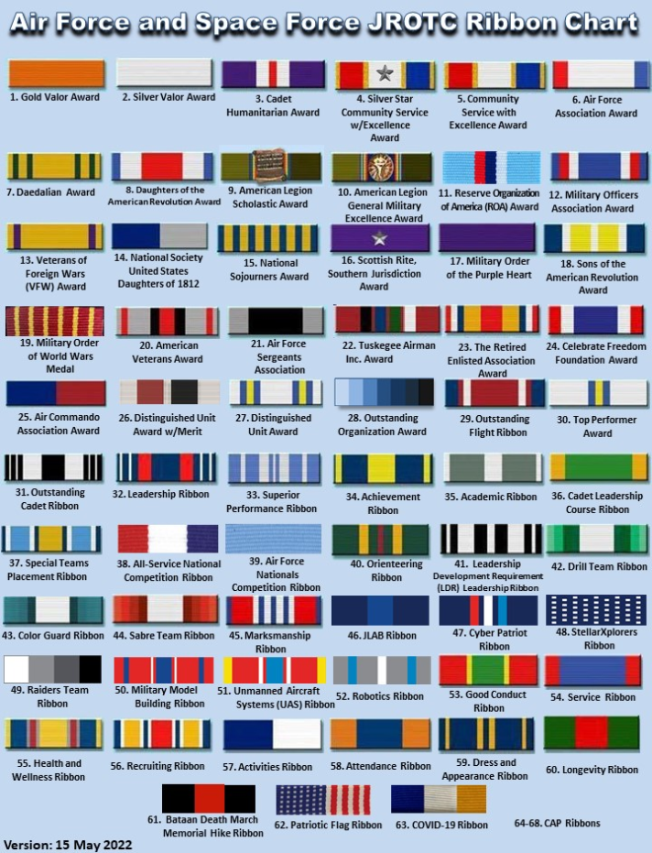
CHAPTER 14: NC-804 RECOGNITIONS

Annual awards
- ANNUAL HONOR FLIGHT AWARD: An annual Honors flight choice is made just prior to the JROTC awards ceremony which takes place near the end of the school year. The flight which garners the award will have proven, by consistently exceeding the standards, that they are truly the best in the corps. This award is presented at the annual AF JROTC awards ceremony. Once received, the awarded streamer becomes a permanent attachment to the flight guidon.
- Purpose: The honor flight competition is a very important part of the Cadet Corps. It plays an extremely important role in building morale, esprit de corps, discipline, and overall mission effectiveness. Competition between flights motivates the cadets to perform to the best of their ability and to work together as a team to achieve flight goals.

- AREAS OF COMPETITION
- Flights will compete in the following areas:
- Mastering of 30 command regulation flight drill sequence
- Wear of uniform on assigned days and exceeding personal appearance guidelines
- Highest overall flight academic grades
- On time and completeness of homework
- Collective physical fitness participation and scores
- Average volunteer hours for the flight.

- Warrior Award: Presented to the male and female cadets with the highest Physical Fitness score for the year.
- Afterburner Award: Presented to the male and female cadets with the fastest mile times for the entire school year.
- Outstanding Uniform Award: Presented to the top 1st-year and 2nd-year cadest and upper-class cadet in uniform dress and military appearance. Cadets will first be selected as finalists based upon their overall dress and military appearance and inspection scores in their individual flights. Selected cadets from each flight will come together in a dress off competition and the 1st-year and upper-class winner will be determined by the instructors.
- Special Team Commander’s Award: Presented annually to the cadet who has the greatest impact on the success of the teams; this cadet is selected by the Special Team Commander with the approval of the SASI/ASI.
- Outstanding Team Award: Presented annual to Team with the greatest impact over the course of the year.
- Outstanding Service Award: Awarded to the one cadet each year who contributes the most to the school/community service program.

Semester awards
- Outstanding Cadets of the Semester. The senior cadet staff and SASI/ASI will select the top performing cadet in each flight on staff for each semester based on the whole person concept -- military performance, physical fitness, and extracurricular activities -- and the quality and quantity of the cadet’s contributions to AFJROTC for the semester.
- Outstanding Flight Commander of the Semester. The SASI/ASI will select the top performing Flight Commander for each semester based on the whole person concept, leadership ability, flight teamwork and motivation and the quality and quantity of the commander’s contributions to AFJROTC for the semester.
- Outstanding Team of the Semester

Quarterly awards
- Outstanding Cadets of the Quarter: AS1, AS2 and Staff categories
1. Academic performance in AS class.
2. Demonstrate leadership qualities.
3. Outstanding personal appearance (uniform wear and grooming).
4. Participation (class and extracurricular).
5. Self-discipline and self-control.
6. Positive attitude (toward JROTC and school).
7. Courteous demeanor (promptness, obedience, and respect for customs).
8. Job performance
- Volunteer of the Quarter

Monthly Awards
- Uniforms of the Month: Presented to top uniform in each AS1 Flight, AS2 Flight, and among Staff officers. Uniform score averages are determined for month to determine winners. Winners get to wear a special cord for the month. Winner can compete for Best Dressed Award.

Shoulder Cords/Tabs
1. Shoulder Cords. Cadets are authorized to wear one shoulder cord (double knot, single cord “infantry” style shoulder cord. Cords will be worn on the left shoulder, grounded to the shoulder seam, with no metal tips, and no wider than 1-inch (no aiguillettes or citation cords). On the service dress coat, the cord will be grounded to the left shoulder seam and pinned to the shoulder with the pin hidden beneath the cord. On the blue shirt, the cord will be under the epaulet, grounded to the left shoulder seam and pinned to the shoulder with the pin hidden beneath the cord. Cords can’t be worn with ABUs/OCPs. Cadets will only be issued one shoulder cord (highest position has priority), so will have to transfer between service dress coat and blue shirt (depending on uniform).
Cadet commanders/SASI will designate criteria on who may wear shoulder cords. Colors designate different leadership positions and teams/clubs. The Group Commander, Deputy Group Commander, Ground Command Chief and all Squadron commanders wear certain Old Gold/Navy Blue Cords. Group staff members wear Old Gold Cords. Certain teams/clubs have shoulder cords as outlined in Chapter 11.
2. Shoulder Tabs. Shoulder tabs are either cloth or metal arches denoting participation in an AFJROTC activity. Shoulder tabs are optional. If worn, cadets are authorized to wear one shoulder tab on the right shoulder of the service dress coat, lightweight blue jacket and the light blue shirt, centered between the unit patch and the shoulder seam. Tabs will have the name of the activity on them (e.g., drill team, saber team, honor guard, etc.). If no unit patch is worn, tab should be worn no lower than 1 inch below the shoulder seam. If a unit patch is worn, shoulder tab should be centered between the unit patch and the shoulder seam. The SASI will designate which activities will be denoted by shoulder tabs and set the criteria for each.

CADET GUIDE Part 2
2023-2024

CHAPTER 15: training
ER 20: TRAINING
A. PURPOSE
The purpose of this chapter is to explain expectations and standards for the cadet corps training program. It is the responsibility of each cadet to know the material outlined in this chapter and to follow it during any JROTC activity, on or off campus, whether in or out of uniform. It is highly recommended that cadets follow it during non-JROTC activities
B. MISSION
The training program supports the overall JROTC mission of developing citizens of character, dedicated to serving their nation and community. Specifically, the objectives of the training program are to develop esprit de corps to develop the self-discipline necessary to follow and abide by rules and regulations, to understand the military customs and courtesies, and to enhance military bearing and self-confidence.
C. REQUIREMENTS
The cadet training program is designed to provide you with the knowledge and skills you will need to be successful in the JROTC program. The following is an outline of the required knowledge for all first-year cadets and upper-class cadets. Study and learn this information and be prepared to demonstrate your knowledge and proficiency. Cadets should know the following:
1. Chain of Command Starting with the President of the United States
2. Pledge of Allegiance
3. Honor Code
4. Core Values
5. Group/Squadron/Flight Staffs
6. Flight Drill Sequence
7. AFJROTC Rank
8. Air Force Rank
9. Proper Uniform Wear
10. NC-804 Organizational Chart

CHAPTER 16: merit & demerit system
Reminder: Conduct/participation = 20% of grade.
Purpose:
- Positive and negative reinforcement of JROTC program policies and standards
  - Serves as a leadership tool
- Motivate and encourage development of self-discipline, accountability, responsibility, pride, honor and spirit-de-corps among cadets
- Serve as documentation tool (for good and bad)

General
- Each cadet starts semester with 100%
- Merits: awarded for positive actions that result in above standards of performance. Merits also play a role in promotions.
- Demerits: awarded for negative actions that result in below normal standards of performance.
- Merits and demerits have equal value
- Merits and demerits may also influence jobs, awards, rank, letters of recommendations, and the ability to participate in extracurricular activities (to include field trips).
- Merit/demerit scores are posted weekly

Documentation Tool (NC-804 FORM 341)
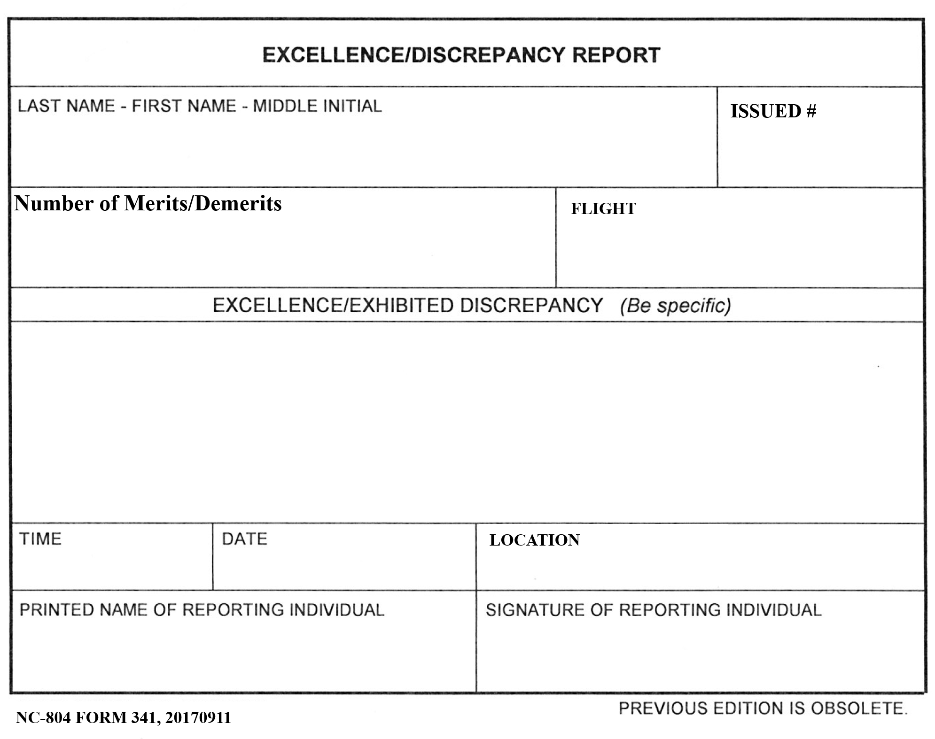
All cadets will be issued two 341S
- Cadets are responsible for having two 341s on them at all times (Except during PT)
  - i.e. in their possession (nearby)…treat like a $100 bill
- 341s are “documentation” tool
- Name and flight, pre-filled out
- If required, instructor/cadet leader will ask you for your 341
- Cadet turns over 341 for instructor/leadership to fill out and turn in
- If 341 taken, ask ASI/SASI for another ASAP
- If lose 341 or don’t have one, except to be issued demerits

Merits: Awarded for positive actions that results in above standards of performance.
Examples:

Leader of cadet projects

Participating in non-mandatory activities such as fundraisers, school/community activities, etc.

Special recognition (in and out of JROTC)

Get word/email from another teacher

Any other activity as determine by SASI/ASI

Demerits: Awarded for negative actions that result in below normal standards of performance.
- Amount issues based on severity of offenses (CATEGORY) & if repeat offenses
- Certain number (30) will result in Cadet Evaluation Board

Category 4: Major offenses that are detrimental to the image of the Corps (10-50 demerits)
Examples:
- Disrespect to the US Flag or the uniform
- Failure to wear uniform, disrespecting uniform or repeat uniform violations
- Disrespect to instructors, guest speakers, other faculty members
- Skipping
- Cheating
- Stealing
- Any severe violation is WCPS Handbook

Category 3: Serious offenses that result in serious damage to the image of the Corps (5-10 demerits)
Examples:
- Profanity/vulgar comments
- Failure to to execute a written or verbal order
- Disrespect to cadet officer or NCO
- Leaving a formation without permission
- ISS
- Skipping
- Wear of earring in uniform (male)
- Multiple offenses in uniform
- Improper wear of uniform
- Misconduct including public display of affection (PDA)
Category 2: Offenses resulting in damage to the image of the Corps (3-5 demerits)
Examples:
- to salute SASI/ASI when outdoors in uniform or when asked to report (Off Campus Only or when necessary)
- Failure to salute all higher-ranking cadet officers (Off Campus or when necessary)
- Neglect of duty
- Wearing earbuds in uniform

Category 1: Offenses resulting in minor damage to the image of the Corps (1-3 demerits)
Examples:
- Late to class without a pass
- Chewing gum in class
- Eating in class without permission
- Writing on desk tops, classroom or school walls
- Talking in formation or classroom

Appeals
- If cadet feels demerits are unjust, they may be appealed by written request through chain of command within 2 days after receiving the demerit
- Request must state why demerits unjustified
- Cadet Group Commander will review appeals and make recommendation to SASI

Excessive Demerits
- Once hit 30, SASI may direct Cadet Evaluation Board to convene & summon cadet to appear (see Chapter 13)
- Board will hear case and report findings and recommendation to SASI for final disposition

CHAPTER 17: RESERVE CADETS

A “Reserve Cadet” is a cadet who cannot enroll in AFJROTC courses within the school and is in the AFJROTC program for the sole purpose of participating in before/after school activities. A student must have been a cadet for at least one academic year (academic term for 4x4) prior to being considered a Reserve Cadet. To qualify as a Reserve Cadet, a student will meet one of the following criteria, with SASI concurrence.
      - The student has completed the entire AFJROTC Academic Program at the school and cannot continue without duplicating curriculum courses.
      - The student is currently enrolled in a 4x4 scheduled school, has completed an AFJROTC course during academic term #1 (first semester), but is not participating in an AFJROTC course during academic term #2 (second semester).

Reserve Cadets may be issued uniform and retain their uniform for the entire academic year. Reserve Cadets may participate in all AFJROTC activities (CIA trips, community service events, Leadership Development Requirements (LDR) activities, etc.). Time in reserve status does not count towards the Certificate of Completion, nor do Reserve Cadets count toward minimum unit enrollment or unit funding.

Reverse Cadets must maintain all the high standards expected of enrolled cadets (uniform, grooming, discipline, etc.) or will lose reserve status and all associated privileges. Priority if limited spots in activity/CIA is with enrolled cadets.
CHAPTER 2: MISSION, GoaLS

& OBJECTIVES

ATTACHMENTS

TO

CADET

HANDBOOK

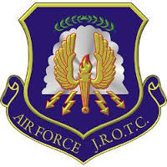

AIR FORCE JROTC BADGES, RANK INSIGNIAS

ATTACHMENT 1
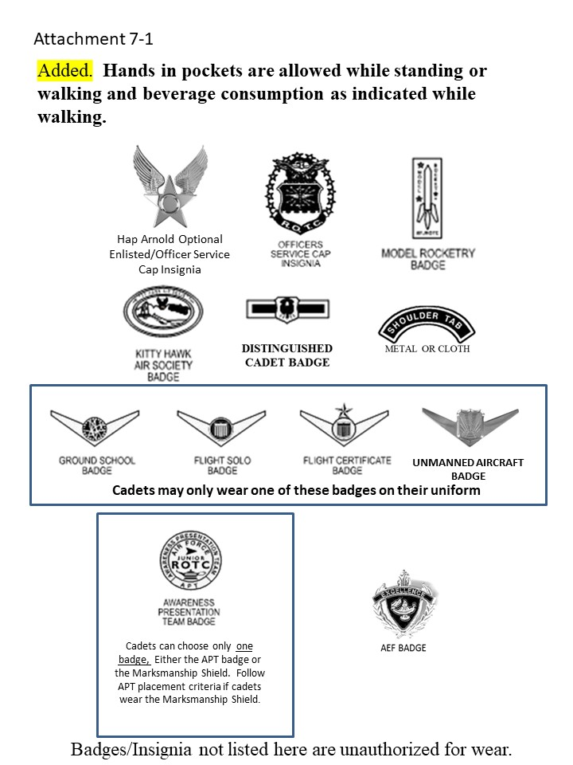

AIR FORCE JROTC BADGES, RANK INSIGNIAS

ATTACHMENT 1 (CONTINUED)
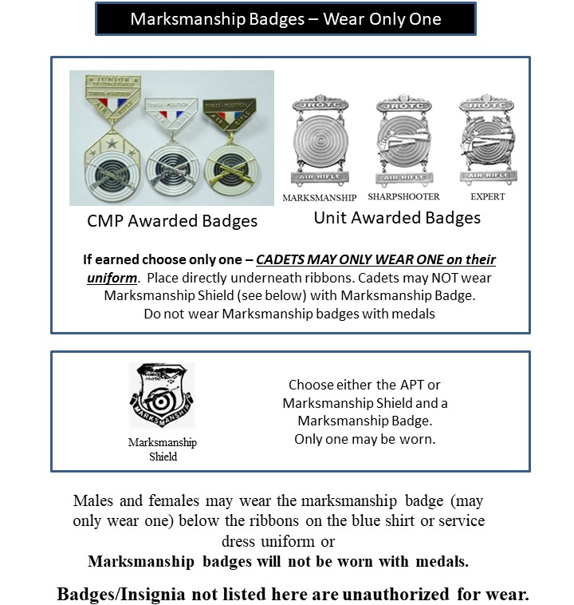

AIR FORCE JROTC BADGES, RANK INSIGNIAS

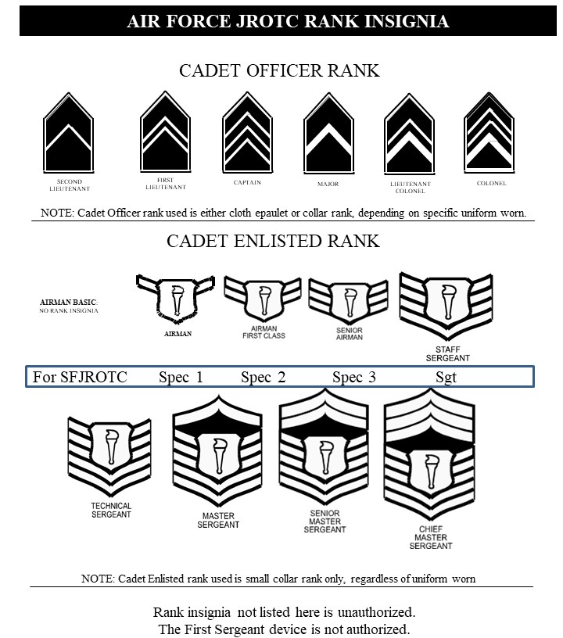
ATTACHMENT 1 (CONTINUED)

UNIFORM GUIDELINES – ATTACHMENT 2

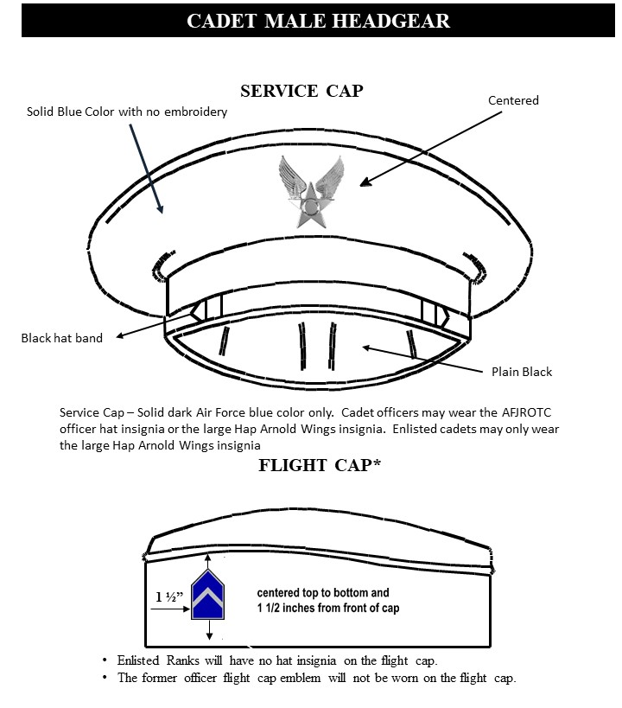

UNIFORM GUIDELINES – ATTACHMENT 2

(Continued)
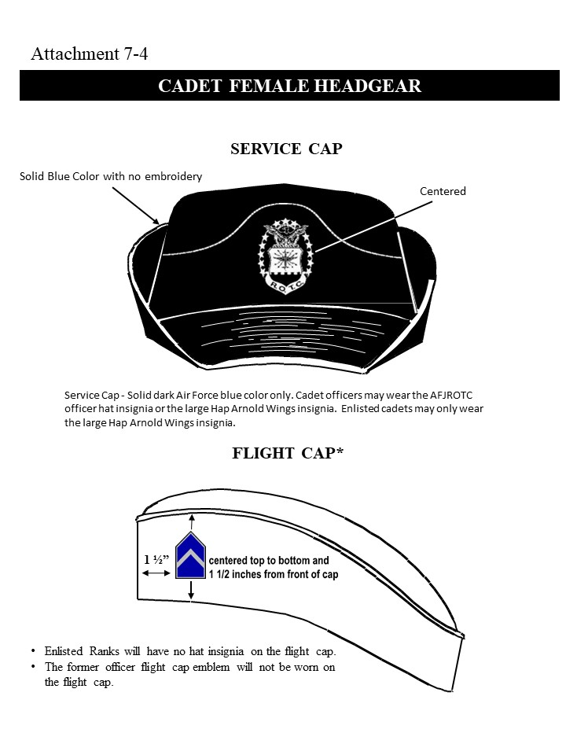

UNIFORM GUIDELINES – ATTACHMENT 2

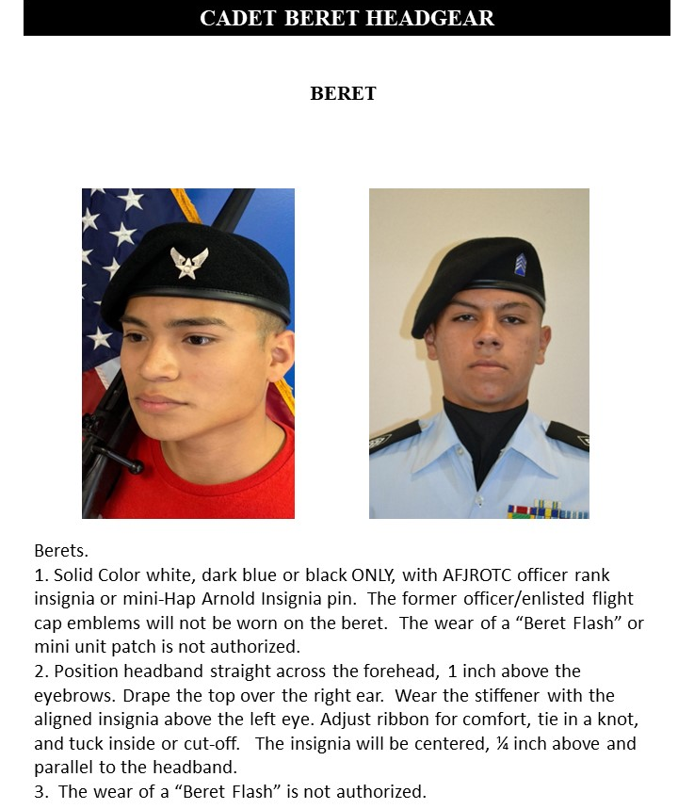
(Continued)

UNIFORM GUIDELINES – ATTACHMENT 2

(CONTINUED)
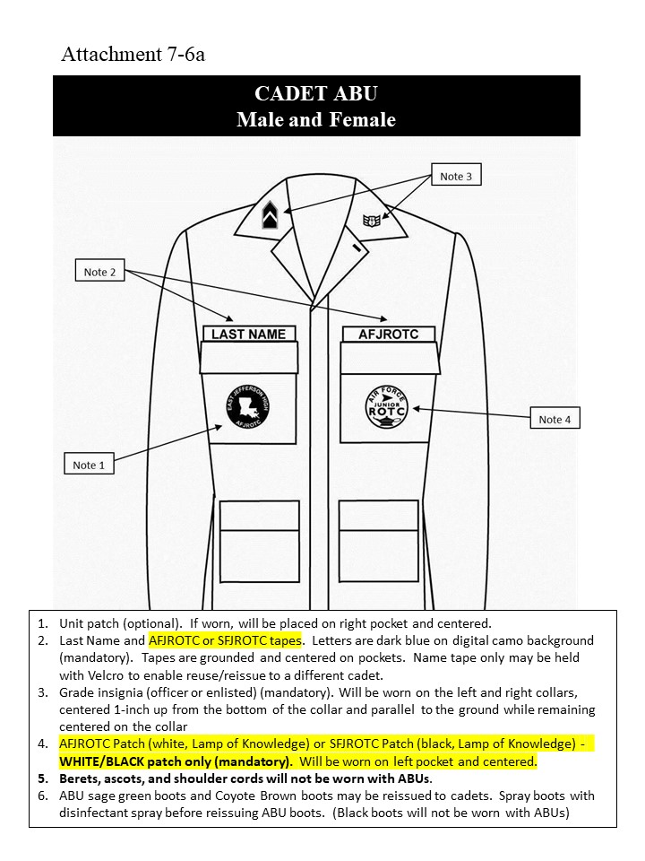

UNIFORM GUIDELINES – ATTACHMENT 2

(CONTINUED)
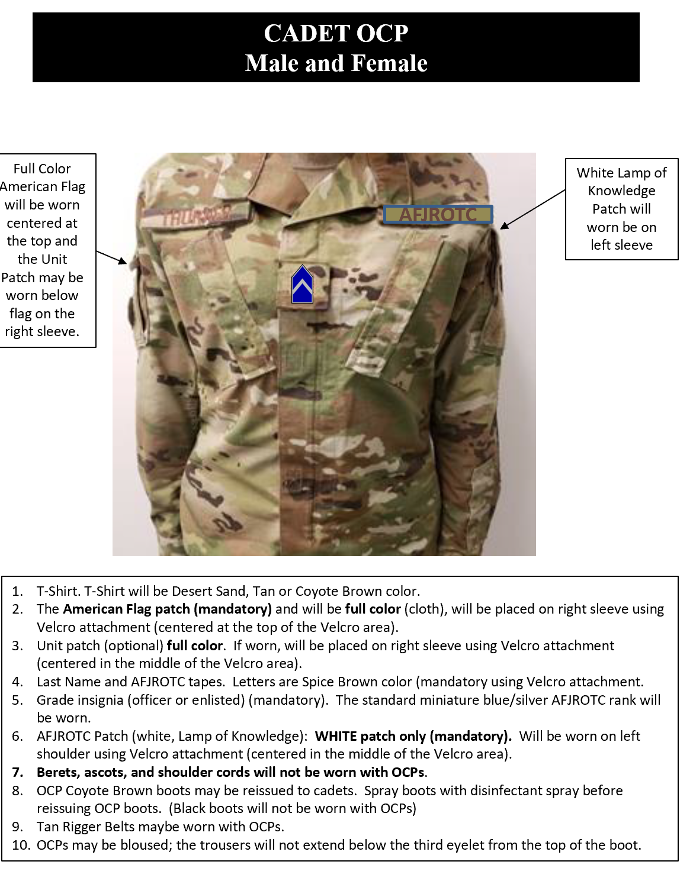

UNIFORM GUIDELINES – ATTACHMENT 2

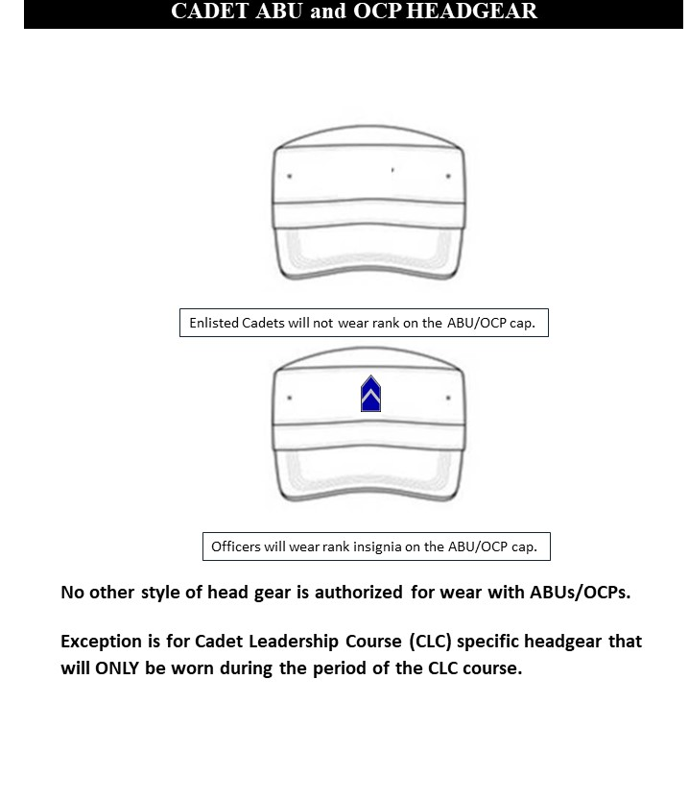
(CONTINUED)

UNIFORM GUIDELINES – ATTACHMENT 2

(CONTINUED)
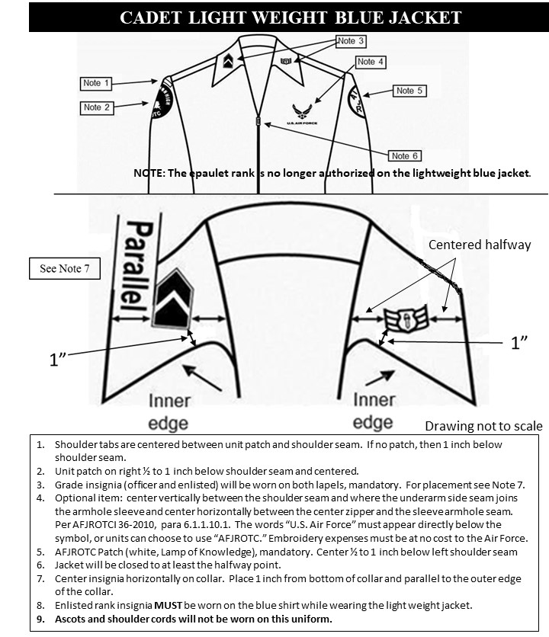

UNIFORM GUIDELINES – ATTACHMENT 2

(CONTINUED)
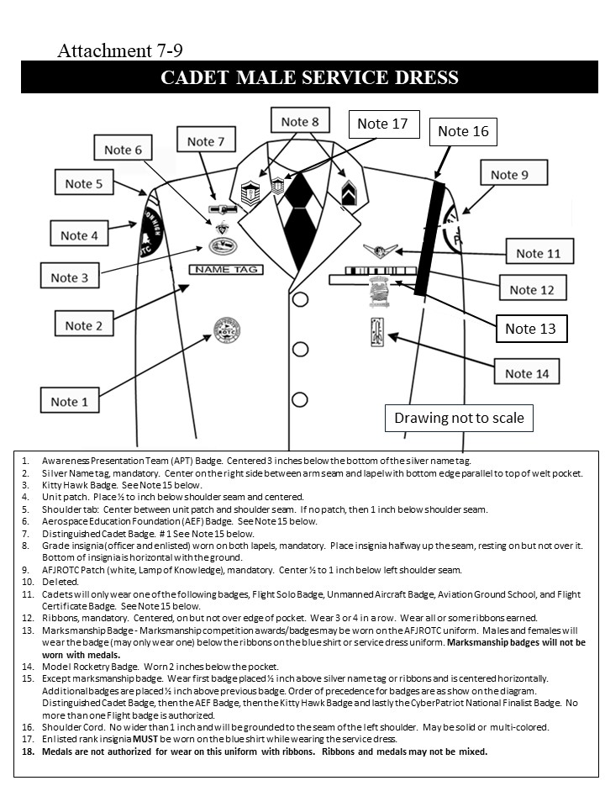
UNIFORM GUIDELINES – ATTACHMENT 2 (CONTINUED)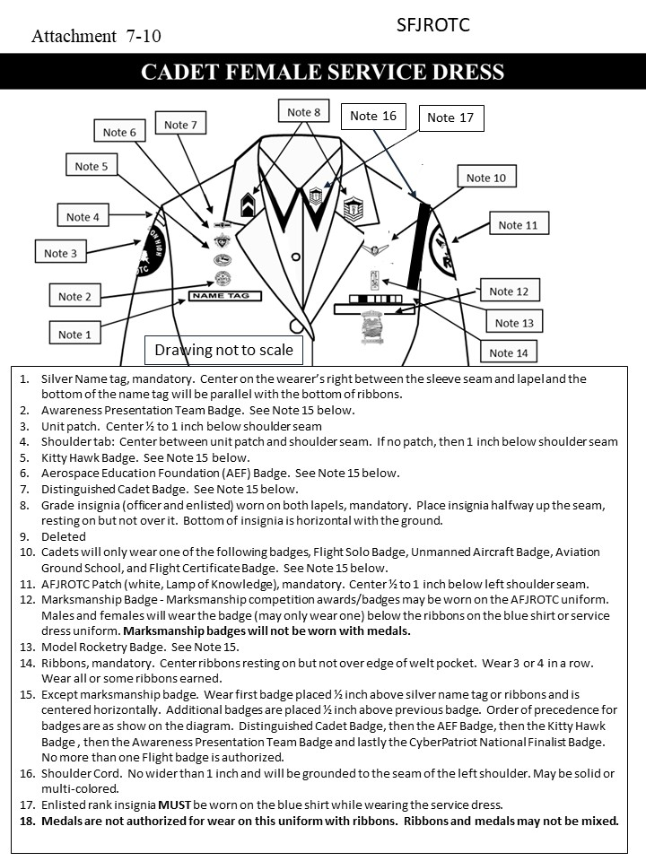

UNIFORM GUIDELINES – ATTACHMENT 2

(CONTINUED)
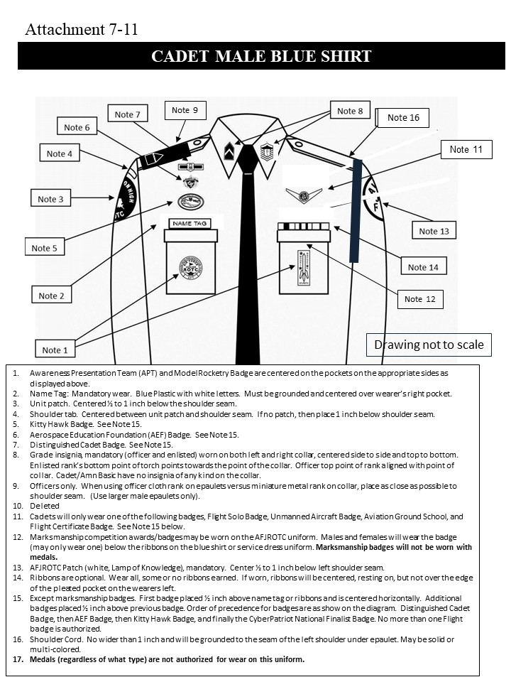

UNIFORM GUIDELINES – ATTACHMENT 2

(CONTINUED)
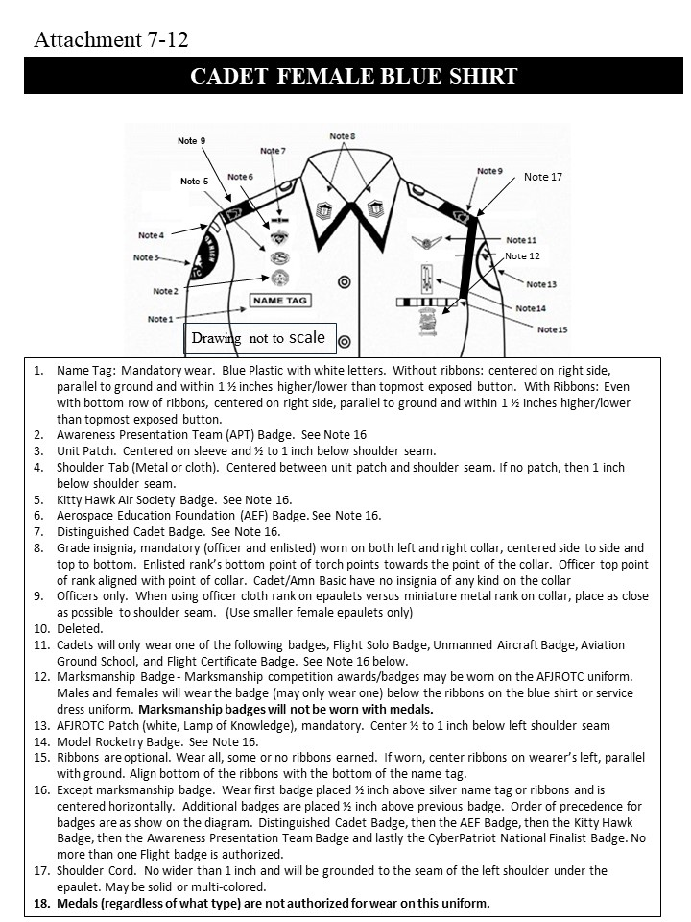

UNIFORM GUIDELINES – ATTACHMENT 2

(CONTINUED)
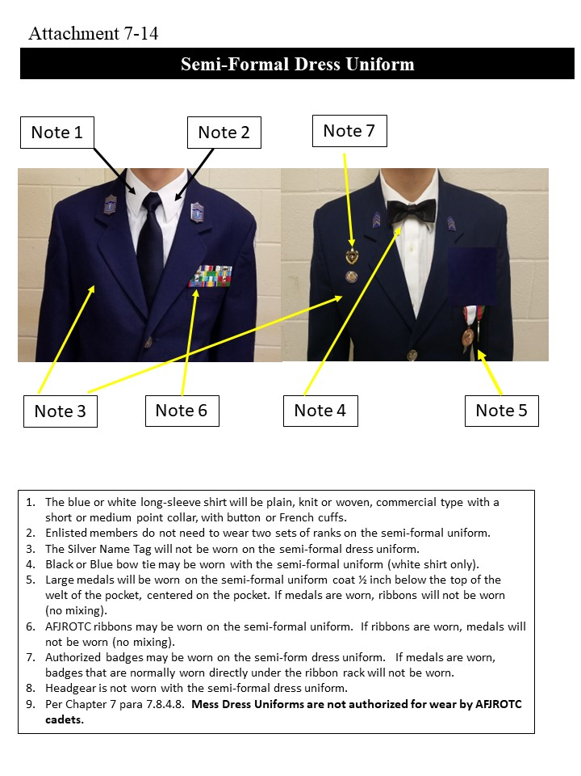

UNIFORM GUIDELINES – ATTACHMENT 2

(CONTINUED)
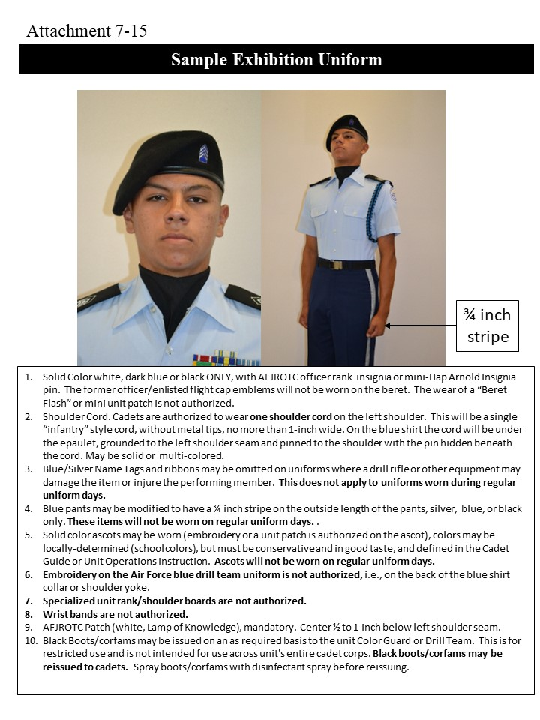

UNIFORM GUIDELINES – ATTACHMENT 2

(CONTINUED)
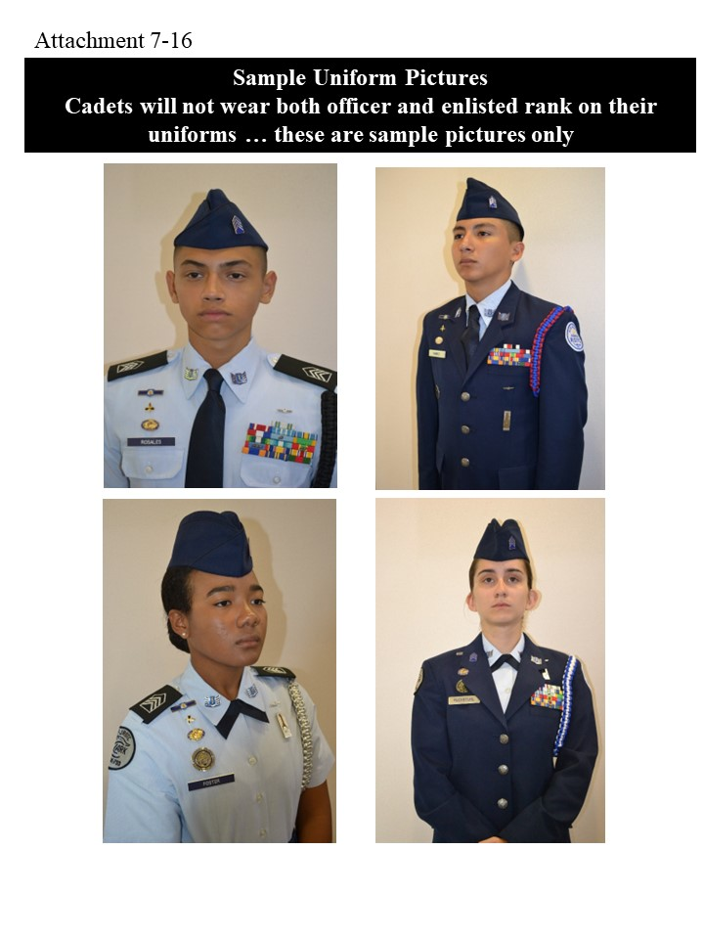

UNIFORM GUIDELINES – ATTACHMENT 2

(CONTINUED)

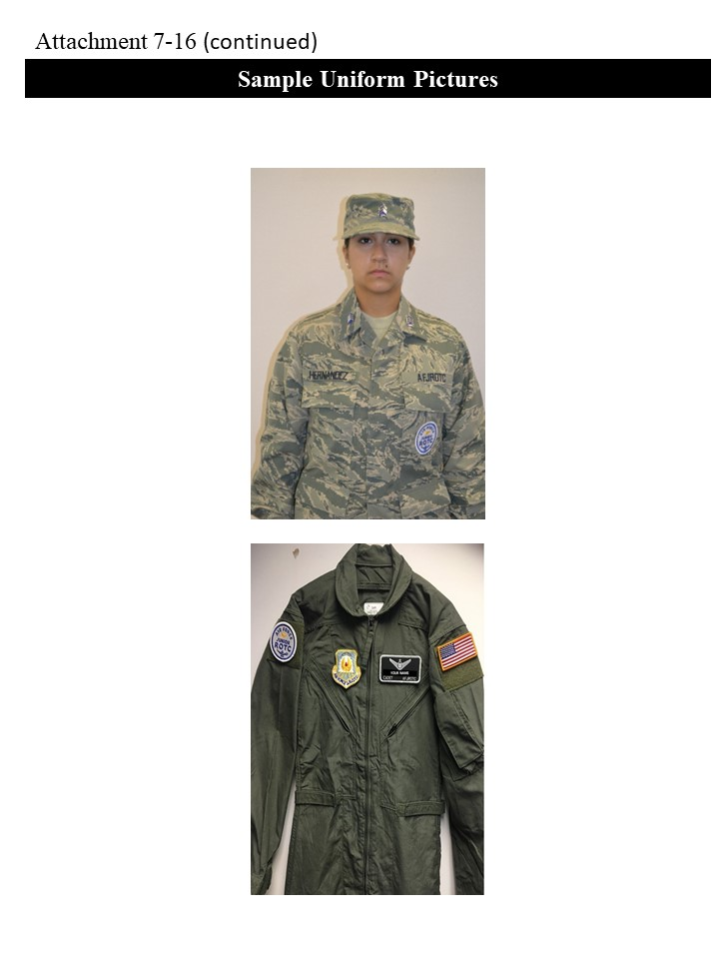

UNIFORM GUIDELINES – ATTACHMENT 2

(CONTINUED)

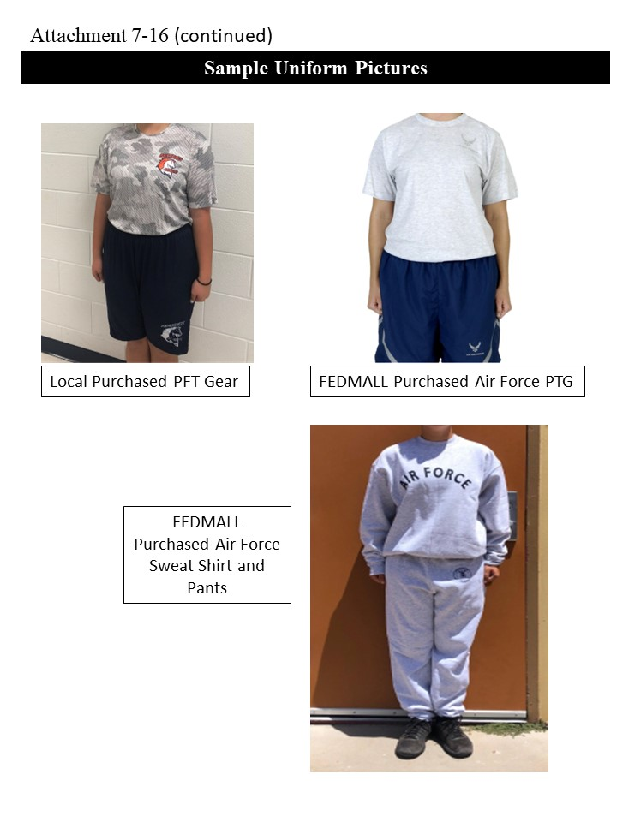

How to Tie A Tie – ATTACHMENT 3

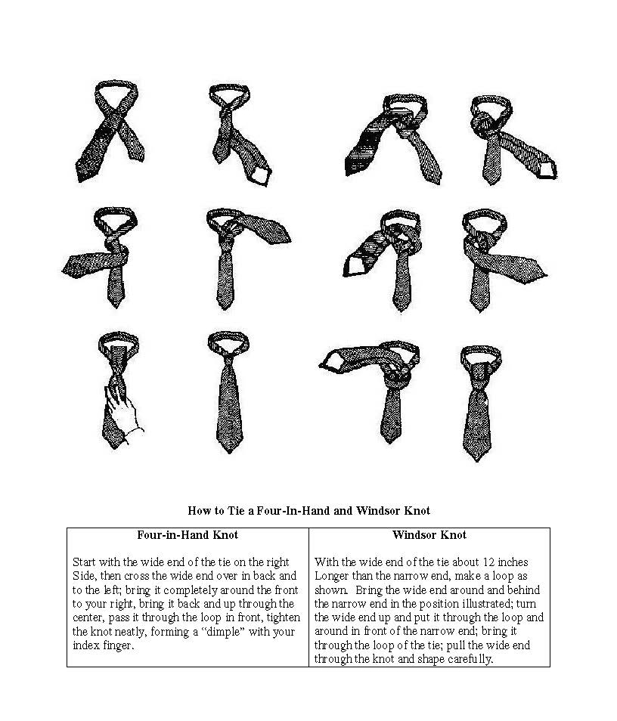

Drill and Ceremonies

ATTACHMENT 4
Air Force Junior ROTC has the mission and responsibility to “Develop Citizens of Character Dedicated to Serving Their Nation and Community.” We believe that the best citizen is one who can lead when necessary or work as part of a civilized society as a team member for the common good of his or her town, city, state and country. No one in AFJROTC is ever allowed to be a follower except when working as a team member. YOUR job is to become a leader; OUR job is to help you do that.
The best way to take your first step as a leader is to learn how to do everything in your unit from the ground up. That first step includes learning self-respect, self-discipline and self-reliance. The basis for any successful organization is team work, and the AFJROTC has found that the quickest, easiest way to learn this is through drill and ceremony.
We begin by teaching you teamwork in drill. Once you have learned the correct way to do everything, we place everyone in rotating positions of leadership. If you never learn the wrong way to do something, you are less likely to make leadership mistakes.

a. verbal commands
In order to begin any drill, you must be at a position of ATTENTION. This is much easier than it sounds. The first step is the command to bring people to this position. The command is called in a loud, clear voice, but in a different way. The words used are “TENCH-HUT!” rather than attention. The reason for this is that outside, with traffic noise, wind and other noises, soft consonants tend to be lost (the letter “n” tends to be unheard along with the vowel “a”). What we do is call the command while standing at attention ourselves and calling it in the manner shown in the image below.
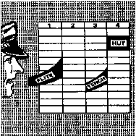
Every command is divided into two parts: the PREPARATORY COMMAND; and the COMMAND OF EXECUTION.
The first part prepares you to perform some function; the second part tells you to do it now. For practical purposes, any group of AFJROTC students is considered a FLIGHT.
So in the case of this command, the PREPARATORY COMMAND is “Flight”; the COMMAND OF EXECUTION is “Tench-Hut”.

